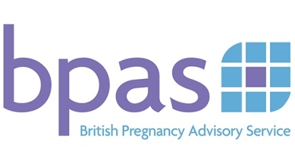
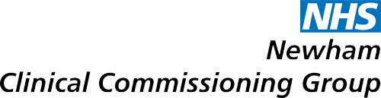

Referral

Please ring the number below to make an appointment on behalf of your patient, and have the information requested ready – this will take 5 minutes. Your patient will be offered contraception and STI screening. Offer to book your patient a follow up appointment at the surgery now.

Date Click here to enter a date.

Patient details:
Name Click here to enter text.
NHS number Click here to enter text. Date of Birth Click here to enter text.
Address Click here to enter text.
Postcode Click here to enter text.

Treatment:
Treatment will be funded X by NHS ☐ Privately

Patient referred for:

☐….Unplanned pregnancy  Date of LMP Click here to enter text.  HSA1 form signed and attached ☐ Yes ☐ No |  | ☐ Vasectomy

Significant medical history Click here to enter text.

Referrer/GP details:
Dr Name St.Bartholomew’s Surgery CCG Name Newham
Address 292a Barking Road
Post code E6 3BA

BPAS has a national network of clinics. Visit www.bpas.org to find your nearest location

Appointments and enquiries to:
Telephone 03457 30 40 30 anytime
Email info@bpas.org

To the patient:
- You can call to book a convenient appointment yourself
- Remember to bring this form with you, or you may be asked to pay for your treatment
- Bring all your medicines, and letters or paperwork from your GP or family planning clinic
- You may need to attend more than one appointment
- Our clinics are not suitable for children – please don’t bring them
- If your appointment is for treatment, take note of what you are told about eating and drinking. If you don’t follow the instructions given to you at the time of booking, it may not be safe to give you the treatment of your choice, or your treatment may be postponed.

