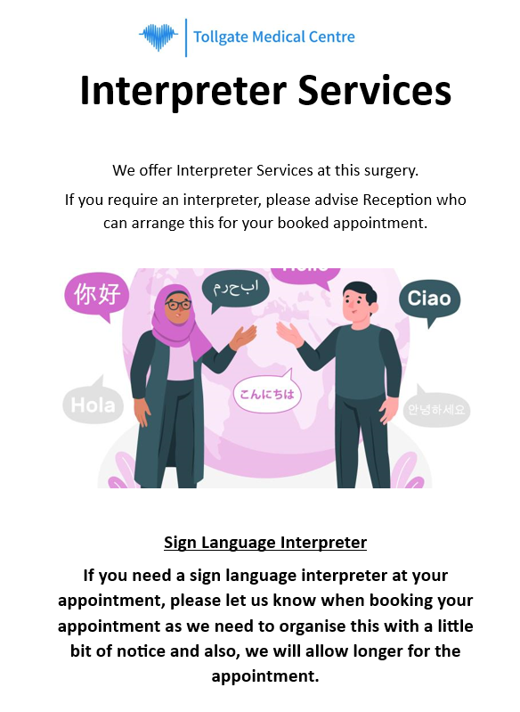

**For any of our patients whose first language is not English and who need the service of an interpreter at their GP appointment we offer a spoken language interpreter. If you require an interpreter, please advise Reception who can arrange this for your booked appointment.**

