25/04/2024 – PPG Meeting

Dr Steinberg welcomed the PPG and provided the house rules.
Practice Manager DK presented the slides. Key points below
Pharmacy First: Pharmacy First Scheme is for minor elements including but not limited to;
Sinusitis (age 12+)
Shingles (age 18+)
Sore throat (age 5+)
Urine infections in women (age 16+) (not eligible for more then 2+ within 6 months
Earache (age 1+)
Infected insect bites (age 1+)
Impetigo (age 1+)

The reception team may also refer you to the pharmacy first scheme if required.

Appointment Access:
More then 2,300 appointments open each month with only an estimated 30% allocated to on the day emergency appointments.
Within the estimated 2,300 appointments all face to face appointments are pre-bookable up to 8 weeks in advance through the patient access app.
All appointments excluding the emergency allocated appointments are pre bookable up to 8weeks in advance.
Telephone appointments are not available to book online. This was previously available, but we had patients booking incorrectly into these appointments thinking they where face to face and attending the surgery. The practice is happy to open these back up to the patient population if required.
Patients not attending the surgery for their appointment, and not cancelling in time.
Within the last month, the surgery has seen 200 non attended appointments. (DNA’s) these appointments were booked by patients and not cancelled.
The day before each appointment and automated message goes out to patients to remind them the time and date of their appointment and giving them the option to cancel if necessary.
WMC Q: Can you think of anything that we can do that may help reduce the DNA rate within practice?
WMC Q: Is there something we as a practice can be doing differently?
PPG Suggestions:
- Adapting the patient reminder message to advise/ state how much an appointment cost’s and to make it notable to the person who is receiving the reminder that someone may need the appointment, so if they cannot attend to cancel so it can be used.

Telephone Access:
The Surgery phone lines are busy especially at present. As we are at the beginning of the health year, all our long-term condition and other health check messages are being sent out to patients. This in return create quite a call que.
Westbury have had an upgraded telephone system where the call back function has been incorporated. For this function to work you must answer the phone on the call back. If this is left unanswered, the system doesn’t try to call back again.
WMC Q: Has anyone tried the call back function?
PPG (A) Yes
Other ways to access the surgery.
E-consult: e-consult is a patient triage platform that can be found on the surgery website or via your patient access app (subject to exclusion).
Below you will see an example of what this looks like on the website, as you will see you have the option to submit a health concern or submit into the administration team.
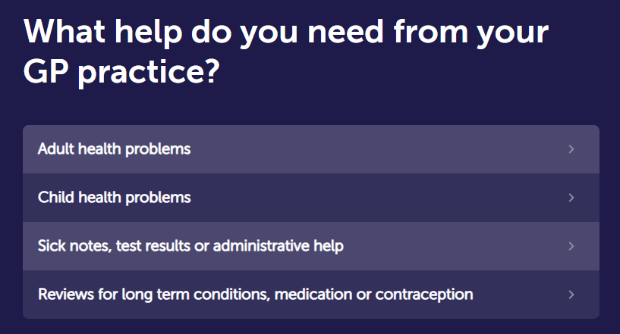
WMC Q: Do you think that other routes into the surgery are advertised enough?
PPG (A): Yes
Suggestion from PPG: Would it be possible to make a leaflet that patients who are unable to speak/ read English or have access to the internet can bring home to their relative of friend who can help them use these services?
- Westbury advised they would look into this and thanks the PPG member for the Idea.
WMC Q: Are the patient population happy with the music played in surgery?
PPG A: Yes,

WMC Q: Do you think people use the surgery website?
(A PPG member advised they don’t but should) Dr MS gave a demonstration how to find the surgery website.

WMC Q: Do you feel that the patient population know the difference between the clinicians they can see that isn’t just their GP.
PPG A: No.

The PPG asked how/ if there is a way they can compliment the surgery / reception team.
WMC stated that the best platform is google reviews and the team would welcome positive feedback, as many people who review, review for negative reasons. The positive feedback boosts the moral of the team.
WMC thanks the PPG member for their positive words towards the reception team and the feedback will be provided to the reception.
It was also mentioned that the practice comes up on the next-door app from time to time and that most of our patients stand by the surgery and challenge the negativity.

Haringey Services: ear irrigation.
The waiting times for the ear irrigation services are quite substantial, a PPG member asked if we could join with other GP services to provide this service at a collaborative level rather than secondary care.
WMC: Unfortunately, NHS have decommissioned this service for multiple reasons, so this is something that is at present out of the surgery’s hands.

Westbury Medical Centre thank all those who attended the virtual PPG meeting on 25th April 2024 at 15:00 hrs and look forward to seeing them and new members at the next meeting.

Patient Participation Meeting ended at 15:37 pm 24/04/2024

