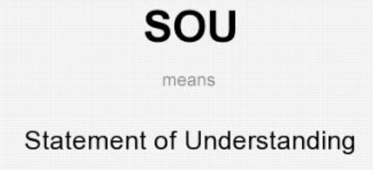

# 

**The Drive Surgery**

68 The Drive

Cranbrook

Ilford

IG1 3HZ

Tel. 020 8554 3014

[www.thedrivesurgeryilford.co.uk](http://www.thedrivesurgeryilford.co.uk)

The Drive Surgery

Statement of Understanding [SOU]

STATEMENT OF UNDERSTANDING

A statement of understanding provides documentation that the employee has read, understood, and agreed to the practice policy/s. This approach is particularly recommended where contravening the policy could result in harm to the employee or the patient (e.g., safeguarding, Duty of Candour, Complaints) or where disciplinary measures could result from not following the policy (e.g., harassment). If you take this approach, you must have a plan for consistently ensuring that all current and new employees receive a policy orientation and sign a statement and that they do this every time there are significant updates to the policy. A signed statement of understanding could form part of legal documentation.

I, ___________________________, hereby acknowledge and declare that:

Print Name [Employee]

1. I am aware that the policies in the practice are available to me from the shared drive, the employee handbook, upon request from the manager responsible for operation of the policies. It is my responsibility to familiarise myself with these policies.
2. In addition, I confirm that I have received a ‘*summary of healthcare policies’* document and confirm I have read and understood the document
   * + *[The document includes … Whistleblowing, Complaints, Duty of Candour, Chaperone, Mental Capacity, Infection Control, Health and Safety, Caldicott, Significant Events, Fire Safety, Grievance and many more protocols]*
3. I agree to conduct my activities in accordance with *The Drive Surgery’s* policies and understand that breaching these standards may result in disciplinary action up to and including termination or other legal remedy available to the practice.

*It is a requirement by the Care Quality Commission [CQC] that an healthcare provide MUST offer support, training and development to all its staff under the CQC Key Line of Enquiry, WELLED and we want to follow by this regulation to ensure we are doing what we have too to support our staff.*

Employee signature: ________________________ Date: ____________________

Print Name: ______________________________

[The Drive Surgery representative]

Sign: ______________________________

Please file this document in the employee’s staff File [Tab 8]