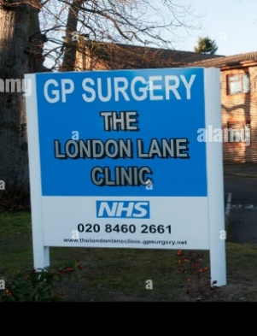

We’re working hard to look after you - From Jan to April 2023
- 5,275 e-Consults received
- 8,911 booked GP appointments
- 2,344 booked Nurse appointments
- 2,038 booked HCA appointments
- 6,595 prescriptions issued
- 3,668 blood tests

Patient Did Not Attends

- 173 patients did not attend their appointment with the GP.
  - Equates to 29 hours of doctor wasted time
- 205 patients did not attend their appointment with the nurse
  - Equates to 65 hours of nurse wasted time
- 144 patients did not attend their appointment with the HCA
  - Equates to 38 hours of HCA wasted time

Delivery Plan for recovering access to primary care
You may heard about the new NHS plan for primary care published recently. Please note that the initiatives in this plan have not started yet. They will come into effect over the coming months.

In the meantime, please continue to contact us via eConsult or by calling us, or use other NHS services, in the appropriate way. When you contact us, our practitioners assess how urgent your needs are and:

Urgent needs: if your need is clinically urgent, we will contact you and assess your needs on the same day, by a telephone or face-to-face appointment. If you contact us in the afternoon, we may contact you the following day but only if we decide it is appropriate to wait.

Non-urgent needs: if we decide that your need is not urgent but requires a telephone or face-to-face appointment, we will schedule this within two weeks.

Where appropriate, we will signpost you to community pharmacy and/or other local services.
London Lane Clinic: Together in partnership with you newsletter
London Lane Clinic Newsletter

If you need medical advice and treatment, the quickest way to access is via e-consult available during surgery hours Monday to Friday 8am to 6.30pm. All are triaged by a clinician.

Outside of surgery hours, if you have an urgent but non life-threatening medical need, please use the NHS 111 website first https://111.nhs.uk/ or call 111 rather than going straight to A&E.

You should dial 999 ONLY if you have a life-threatening illness or injury.

May 2023

London Lane Clinic Newsletter



Wanting to know your test results as soon as they are available without having to call us? You can use the NHS App to see them.
The NHS App is a simple and secure way to access a range of NHS services on your smartphone or tablet.
You can use the NHS App to:
- View part of your GP record including test results, information about medication, allergies, vaccinations
- Order repeat prescriptions and nominate a pharmacy where you would like to collect them
- Register your organ donation decision
- Choose how the NHS uses your data

To use the NHS App you must be:
- Aged 13 or over
- Registered with an NHS GP surgery in the England or the Isle of Man

Sign up to the NHS App and save a phone call

London Lane Clinic newsletter
Page 2 of 3

Page 3 of 3
London Lane Clinic newsletter

Staff News


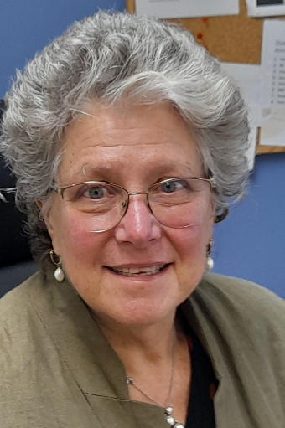
We are delighted to welcome to the LLC team Dr Anam. She joins us as a salaried GP.
We are sure you will make her welcome.


After 25 years, Dr Taylor is retiring.
She wishes to thank all the patients she has seen over the years who have made her career at London Lane Clinic London Lane Clinic such a pleasure.
Dr Taylor is pleased to note that there is strong and vibrant team in place to carry on supporting LLC’s patients.
She will be sorely missed.


