**Forge Close Patient Group**

**Meeting Minutes**

**Forge Close Surgery**

**13th September 2022, 7pm**

**Attendees:**

Stanley Bradshaw (Chair) SB, Orla Penruddocke OP (Secretary), Dr Mano Mageson, Doreen Hobbs DB, Joy Halligan JH, Claire Smith CS, Gail Hilder GH, Patricia Bacca PB

**Apologies:** Eimear Penruddocke, Harry Shannon, Andrew Ramsey, NicoleHoskin, Mary Mills

Janet Ricks JR

1. **Introductions and new members**

SB welcomed everyone to this the first post Covid face to face meeting. Everyone introduced themselves and stated their reason for joining the group

1. **Minutes of the previous meeting**

The minutes were agreed and the following action point/ was discussed:

The email address for ordering prescriptions is [selicb.forgecloseprescription@nhs.net](mailto:selicb.forgecloseprescription@nhs.net) and the various different ways that you can order repeat prescriptions is on the website

<https://forgeclosesurgery.co.uk/prescriptions/repeat-prescriptions/>

1. **Dr Mageson’s Surgery Update (including local Covid update)**

Patients should wait to receive an invitation to book their booster Covid vaccine. Flu jabs are now available and eligible patients are receiving invitations to have these also.

1. **Enhanced access to GP Practice Survey**

The group discussed their experience of completing the form and the comments included the fact that it will be good to have more available hours to see a GP and that it is a initiative that will benefit those unable to see a GP during working hour. Some had problems accessing the form and found some of the questions confusing.

1. **Charity Fundraiser**

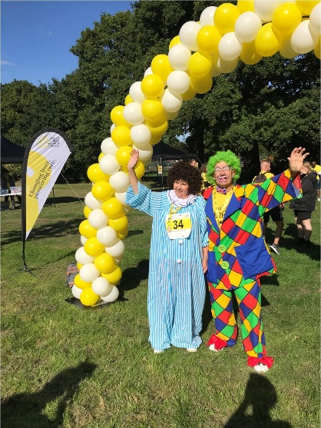Stan dressed as a clown and completed the Kings Charity Walk in aid of the Chartwell Unit as part of the Patients Group activity to support a charity. Faith the practice nurse also participated completing a longer walk.

Great achievement both for a great cause!

1. **Positive ideas to encourage new members**

Since the last meeting five patients have expressed an interest in joining the group and Vicky Kelham has decided to step down due to other commitments. (OP has emailed Vicky to thank her for her time and input).

**Action point: Group to discuss again in the next meeting and there is still a need for more diverse representation.**

1. **Patient questions**

There are a number of ways to get an appointment and some feedback from the recent health promotion event at the Hayes Fair indicated that some patients were unsure about the best way to make an appointment.

OP asked about how decisions are made about the type and number of appointments to offer patients e.g. how many face to face appointments to offer versus eConsult appointments. Dr Mageson explained that there were a number of factors at play including clinician preference and that there are 2500 patients at the surgery and each GP has 8 sessions a week.

The group discussed how it was still problematic getting through on the phone line – Dr Mageson explained that although we have two lines one is only used for patients to access the surgery, the other line is kept free for other incoming calls.

In addition routine appointment are now up to a month in advance rather than two weeks in advance.

Patients have also said that another issue regarding access is when a telephone appointment is booked but the patient actually needs a face to face appointment. It was suggested in this instance that an eConsult be completed in order for the GP to make that decision.

The patient group are keen to assist with the surgery on behalf of patients in order to make the patients journey a straightforward one.

**Action points: Dr Mageson to draft a document for patients on how to decide which booking is appropriate for which condition/situation.**

**(Previous action point): Dr Mageson to invite the social prescriber to a future meeting or ask him to provide a sheet detailing what he does.**

1. **Communication – Website feedback and update**

The surgery email address has changed and is now: [selicb.forgeclosesurgery@nhs.net](mailto:selicb.forgeclosesurgery@nhs.net)

On 1 July 2022, South East London Integrated Care Board (ICB) was established, as a newly created statutory body that replaces the former NHS South East London Clinical Commissioned Group. For more information:

[NHS South East London - Integrated Care Board (selondonics.org)](https://www.selondonics.org/icb/)

New members are encourage to explore the surgery website and give any feedback

The appendix items need to be added to the website if they are not already there.

**Action points: All - to discuss the remaining Appendix items for the website (see below) at the next meeting.**

1. **Forge Close PG Talks**

No date has been set for the dermatology talk.

**Action point : Dr Mageson to arrange for a dermatologist to give a talk on skin care.**

1. **Development of the Patient Group**

Stan suggested that the group should think about where we would like be in 6 months’ time. There followed a discussion of how to best support the practice and there were differing views on whether it would be useful to talk to the receptionists to find out their challenges based on their calls with patients and see if we can help.

**Action point: Further discussion needed on the role and development of the PG**

1. **AOB**

None.

**Next meeting : Wednesday 30th November, 7pm, Forge Close Surgery**

**APPENDIX 1**

**Website Checklist**

|  |  |
| --- | --- |
| **To do** | **Completed** |
| Friends and family test to be moved to another part of the site. | Y |
| Names of existing members of PG added to the PG page. | Y |
| Role of social prescriber to be added to the site. |  |
| Minutes of all PG meetings to be added to the site. | Y |
| Dr Mageson to arrange for all talks to be uploaded to the PG section of the website and remain there. |  |
| Add explanation of post Covid opening hours |  |