Forge Close Patient Group
Teams Meeting Minutes
13th July 2022, 7pm

Attendees:
Stanley Bradshaw (Chair) SB, Orla Penruddocke OP (Secretary), Dr Mano Mageson, Doreen Hobbs DB, Eimear Penruddocke EP and Joy Halligan JH

Apologies: Harry Shannon, Nicola Mushet and Gail Hilder

- Minutes of the previous meeting

The minutes were agreed and action points were discussed:
The phone message has been shortened and the music has been changed – Doreen noted that it was not to everyone’s taste and Dr Mageson said there was a range of music to choose from so it could be changed again at a later date.
Sarah was very helpful while Dr Mageson was away organising Microsoft Teams for the meetings and helping with the planning of the Hayes Fair.
The ability or order repeat prescriptions using the dedicated email address needs to be communication to patients (see action below)

- Local Covid data/Update

Dr Mageson reported that numbers for Covid were increasing but severe cases of illness were not increasing which is encouraging. 4th vaccine is being offered to over 75’s and those who are immune suppressed.

- Patient questions
None received

- Website
All the information about the group is now on the website
https://forgeclosesurgery.co.uk/patient-participation-group/

Dr Mageson has added the names of the members of the group, the minutes of the meetings and terms of reference and information about the group talks.

Action points: All - to discuss the remaining Appendix items for the website (see below) at the next meeting.

- Dr Mageson Update
broccg.forgecloseprescription@nhs.net
The new prescription email address needs to be advertised to patients and Dr Mageson asked how best this could be done. OP suggested that it first goes in as a news item and also a printout with the address placed in front of the reception desk will be seen by the increasing number of patient who are now attending the surgery. This will alleviate pressure on the reception staff who should no longer need to answer prescription related question and will make it easier for patients order repeat prescriptions.

SB reflected how it was very interesting to find out more about Faith’s work as a nurse in the surgery during the Hayes Fair. OP said that it would be very useful to invite some members of the patient group meeting so that the group can learn about the different roles and practice staff can learn more about the group. The social prescriber would be a good role to start with as it is a relatively new role.

Dr Mageson updated the group about the new initiative starting in October which will allow patients to make appointments until 8pm in the evening and from 9-5pm on Saturdays. Patient feedback is being sought in order to plan for the roll out and Dr Mageson asked if members are happy to be contacted about this – all present were happy to do so.

Action point:
Dr Mageson to add a news item to the website advertising the prescription email address
Dr Mageson to invite the social prescriber to a future meeting.
Dr Mageson to pass on contact details of group members who will be contacted to provide feedback about how extended opening hours could work best for patients.

- Forge Close PG Talks

Dr Mageson in conjunction with BMI Healthcare arranged two talks recently:

Bowel Cancer – Dr Sukh Chatu – Consultant Gastroenterologist (15 people attended)
Menopause and HRT – Ms. Ritu Rana – Consultant Gynaecologist (35 people attended)

The talks were a success and allowed patients to ask questions – for this reason – patient confidentiality they could not be recorded
Dr Mageson asked for future topics and EP suggested one on keeping skin safe in the sun. It is also hoped that the talks can be made available to other surgeries across the Primary Care Network.

Action point :
Dr Mageson to arrange for a dermatologist to give a talk on skin care in the sun.

- Development of the PG
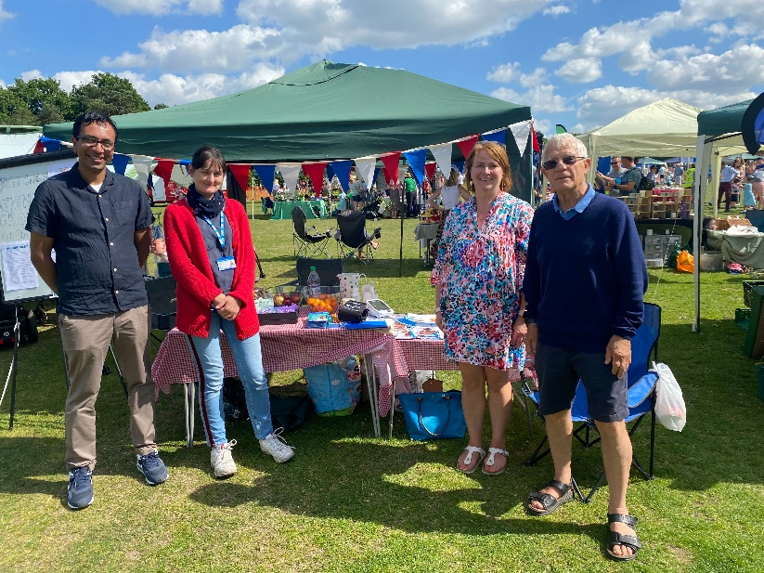
The Hayes fair was a great success and all those involved were thanked. It didn’t directly lead to new members for the Patient Group but it served to raise awareness amongst those who came to the stall that the surgery was open and many of the surgery’s patients approached the stall and asked questions. The blood pressure monitoring was very successful. It is hoped that the Patient Group can attend the Fair next year.

Dr Mageson asked whether the money raised from selling the lavender bags could be used to support a charity and Stanley said he would look into this.

Action point: SB to look at a possible charity that the surgery and patient group could support.

AOB
None.

Next meeting : This will be a face to face meeting

Wednesday 14th September 7pm, Forge Close Surgery
APPENDIX 1
Website Checklist

To do | Completed
Friends and family test to be moved to another part of the site. | Y
Names of existing members of PPG added to the PPG page. | Y
Role of social prescriber to be added to the site.
Minutes of all PPG meetings to be added to the site. | Y
Dr Mageson to arrange for all talks to be uploaded to the PPG section of the website and remain there.
Add explanation of post Covid opening hours

