What we can help you with?

* Helping you connect with social groups
* Befriending and Bereavement Services
* Funding support including Social Services
* Sensory services (For hearing and sight)
* Contingency planning
* Dementia and Alzheimer’s support
* Support for Carers
* Housing support
* Activity centres
* Mental wellbeing support
* Meals on wheels
* Safety in the home including security and fire safety
* Getting involved with your community
* General advice and information

And much more



What next?

If you would like a chat to find out more about what we can help with, please just ask for **Amelia** or **Debbie** at reception or have a chat with your GP or nurse

**01273 834388**

Or email us at:

Sxicb-wsx.mshc.socialprescribers@nhs.net

*We really would love to hear from you!*

*www.midsussexhealthcare.co.uk*

For more information about social prescribing visit www.england.nhs.uk/personalisedcare/social-prescribing/

Social

Prescribers

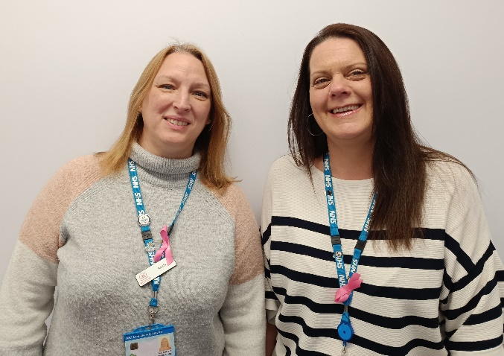

About us

What is social prescribing?

Many things affect your health and wellbeing. GPs tell us that a lot of people visit them feeling isolated or lonely. Or they might be stressed out by work, money and housing problems. Sometimes it’s the stress of managing different long-term conditions.

That’s where social prescribing comes in. It starts with a conversation. It might be the conversation you’ve just had with your doctor. Or with another person in the practice team. They will refer you to a social prescribing link worker.

The link worker is there to listen to you, and put you in touch with the people and activities that might help you to feel better

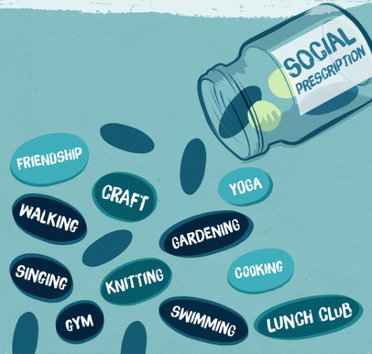

[](http://www.google.co.uk/url?sa=i&rct=j&q=&esrc=s&source=images&cd=&cad=rja&uact=8&ved=0CAcQjRxqFQoTCKfSiurn-cgCFUkfGgodPEcDOQ&url=http://www.elmoreco.com/Default.asp?PN%3DPages%26SubP%3DLevel1%26PageID%3D'24926'&bvm=bv.106923889,d.d2s&psig=AFQjCNFP7wTzrNJGAQll0kBstlyVqNoyYg&ust=1446831026978096)

What can we do to help you?

Your link worker might introduce you to a community group, a new activity or a local club. If you are feeling nervous about doing these things, don’t worry, they are here to support you while you settle in.

They might help you find legal advice or debt counselling. They might just help you find information and guidance: a bit of inside knowledge on your situation or what local resources there are. They could even support you to create something new such as a gardening club, a fishing group, a ‘men’s shed’ or knit and natter group.

Social prescribing can help you to have more control over your own health and find ways to improve how you feel in a way that suits you.

Studies show that people get better and feel better faster than those treated with medicine alone. And because it works, it’s happening more and more – including here in this area.

