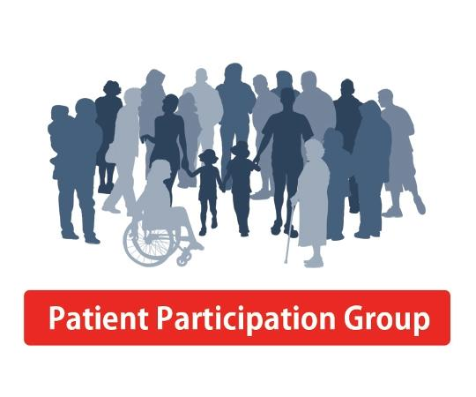

**Minutes of the patient of the consultative group meeting**

**June, 2021**

|  |  |  |
| --- | --- | --- |
| Dr Dutta | Bharti Koteche (Lead) | Chandrima Dutta |
| Juleen Stewart | Asha Pujamula | Tim Pearce |
| Raj Sood (apologies) | Juleen Stewart | Agnello Desouza |

The above members were invited both face to face / virtually to feedback their opinions regarding the practices performance over the past 12 months.

Firstly, the group took time to acknowledge the additional work and effort that has gone into maintain GP healthcare services during the pandemic. They expressed their opinions regarding the way the practice has maintained its core services during this challenging period for the practice and Primary Care as a whole. Some members wished to go on record, namely Mr DeSouza and Mrs Kotche to express their personal gratitude to the clinical and no-clinical teams. They both mentioned access and service levels for the Open Door Surgery has been excellent when they compared to some of the comments they have heard and seen in the media.

**Meeting Commentary**

* PPG expressed their concern some Referral letter are taking longer than normal. This was acknowledged and in some ways to be expected as a consequence of the Pandemic
* The participants were updated that the Practice has been fortunate to remain fully operational during the pandemic and achieved 100% of its operational commitments, albeit at times offering a fully telephone triage.
* The group was also informed that no major complaints had happen during this reporting period and the practice on average receives one written appreciation a month.
* There was discussion about NEW services / care pathways as a result of the Pandemic such as using Blue tooth technology for Spirometry and post covid clinics. It was thought any new service should be advertise both in the practice and on the website.
* PPG commented that they were able to book appointment as normal but mentioned that at times the telephone lines were busier than usual, particularly in the mornings. This is something the practice is aware of and have actual increased the number of available incoming lines to meet demand. Additionally, new mobile phones are used for outgoing calls to keep the lines free. This is an areas to monitor re high volumes of covid enquiries as the vaccination is being managed local. This should now improve as the service is now being centrally managed.
* PPG members have positively mentioned they are now using technology to access primary care records / services and moreover there was positive discussion regarding the Patient Access App the practice is using.
* Brexit was mentioned and this does not seem to be having any impact on NHS services yet.
* Surgery is in process of recruiting new GPs and had a new social subscriber and pharmacist
* Comments about the way covid vaccination programme worked was generally upbeat. The Patient group would have preferred to have been vaccinated in their own GP surgery but understood the reasons why this was coordinated locally. TP commented that the priority groups eg age65 to 80+ have mostly been vaccinated 99%. And, the remaining practice populations is approximately 45% vaccinated

*Next Meeting will be held in June 2022.*