

Veteran’s Information Pack

Please be advised that this list of local activities and support services for those who are Military Veterans and their families and is provided by the Wellbeing Team at the Blackmore Vale Partnership.
Please note that whilst every effort has been made to check this information for accuracy it is not possible to guarantee that all details are up-to-date. You are advised to contact the provider before attending any activity.
We hope this information is helpful to you and your family.
Further copies are available from the GP Practice or call the Wellbeing Team on 01747 856 786.
National offers, services and charities:
SSAFA  SSAFA’s focus is on providing direct support to individuals in need of physical or emotional care. Addiction, relationship breakdown, debt, homelessness, post-traumatic stress, depression and disability are some of the issues that can affect our members of our Armed Forces community. Many only become apparent when an individual has joined ‘Civvy Street’. SSAFA is committed to helping people overcome these problems, and rebuild their lives.  www.ssafa.org.uk/dorset |   Forcesline 0800 260 6767  Helpline & Live Chat. Free & confidential.  SSAFA Dorset  0204 566 9131  Monday to Friday, 09.00-17.30  Website link: www.ssafa.org.uk/dorset  SSAFA Office, 23 Church Road, Parkstone, Poole

Combat Stress  For serving personnel, veterans and armed forces families.  The charity Combat Stress provides self help advice on their website. They offer mental health helplines for 24/7 confidential advice and support.  www.combatstress.org.uk/ |   Veterans and their families helpline: 0800 138 1619  You can also text on 07537173683 and email helpline@combatstress.org.uk

Defence Medical Welfare Service (DMWS)  For serving personnel, veterans and armed forces families.  Defence Medical Welfare Service (DMWS) provides practical and emotional support to military personnel, veterans, their families, and other entitled civilians when they're in hospital, rehabilitation, or recovery centres.  www. dmws.org.uk | The Helpline is free to call and available Monday-Friday 9am-5pm. Please note this is not an emergency line.  0800 999 3697  Email: referrals@dmws.org.uk

Help for Heroes  For wounded, injured and sick serving personnel and veterans, and their families.  The Help for Heroes charity provides physical, psychological, financial and welfare support to wounded, injured and sick service personnel and veterans, and their families. Contact Help for Heroes through their website to see how they can support you.  www.helpforheroes.org.uk/get-help/ |   www.helpforheroes.org.uk/application/  Apply for support through the webpage or ask a Social Prescriber at the surgery for help to do this by calling 01747 856786.

Veterans’ Gateway  The Veterans’ Gateway is the first point of contact for veterans and their families providing information, advice and support. The Veteran’s Gateway is available for you to contact 24/7 for help across housing, mental wellbeing, finances and more. The Veterans Gateway can also refer you directly to any of their Referral Partners for other service offerings. If you would like some help to utilise their friendly helpline team by phone, chat, text and email. |   0808 802 1212 or text 81212 or visit www.veteransgateway.org.uk

Op Courage  Op Courage is an NHS service looking after Veterans’ Mental Health and Wellbeing.  OP Courage is for serving personnel approaching discharge, and for veterans. The service provides a range of treatment, from access to early support, to therapeutic treatment for complex mental health difficulties, and psychological trauma. | 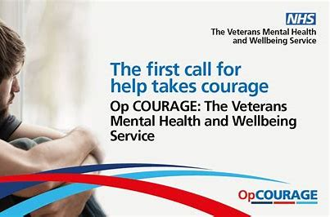  Ask the Wellbeing team at the Blackmore Vale Partnership to refer you on 01747 856786.

Royal British Legion  Blandford and District Branch Committee meets at 7.30pm every second Wednesday of the month at The Royal British Legion in Blandford. 01258 920639. Blandford.Secretary@RBL.Community  Shaftesbury and District Branch meets at 10.00am every Thursday at the Legion Hall in Coppice Street for refreshment and warm friendship. robin.miller4@btinternet.com  Sturminster Newton branch meets at 8pm on the Second Monday every January, March, May, July, September, November at the Sturminster Newton RBL Club in Bath Road, Sturminster Newton. SturminsterNewtonRBL@gmail.com |   www.britishlegion.org.uk  Tel 0808 8028080  If you can’t find a service near you, please call their helpline on 0808 802 8080. They’re open seven days a week, from 8am to 8pm

Op Fortitude  Op Fortitude is funded by The Armed Forces Covenant Fund to deliver a centralised referral pathway to end veteran homelessness. The remit of the team will be to work with individual veterans at risk of or experiencing homelessness, supporting them either into suitable accommodation, or supporting them to maintain their current home. |   Referrals can be made by calling 0800 952 0774  Eligible veterans can self-refer and emergency accommodation will be sourced for veterans actively sleeping rough at the point of referral.

Local offers, services and charities:
Andy’s Man Club  Andy's Man Club are a men's suicide prevention charity that provide free-to-attend peer-to-peer support groups for men 18 and over. These groups are a safe and open space to chat with others - without judgement.  If you would benefit from meeting and connecting with other like-minded Men, consider joining Andy's Man Club. Group’s operate in Bournemouth, Weymouth and Portland to chat over a cuppa, or online, every Monday evening at 7pm. |   www.andysmanclub.co.uk  BOURNEMOUTH- Henry Brown Youth Centre Cunningham Cres, Bournemouth BH11 8DU  WEYMOUTH- Dry Dock, 6-7 St Thomas Street, Weymouth, DT4 8EW  PORTLAND- The Beehive, Unit 1, Victoria Park, Lerret Road, Portland DT5 1GB  Mondays at 7pm

Veterans Hub  The Veterans Hub is a community project that was set up as a part time venture in late 2017 with the intent of providing a safe and secure location for veterans and their families to come together in an environment that would enable them to socialise in a non-clinical setting in order to provide peer to peer support for each other. The Hub is a staging post for other Hub services such as the Café, Community Allotment, Fully fitted gym and wellness rooms, as well as offering drop in clinics and advice services from mainstream charities and local government services. | 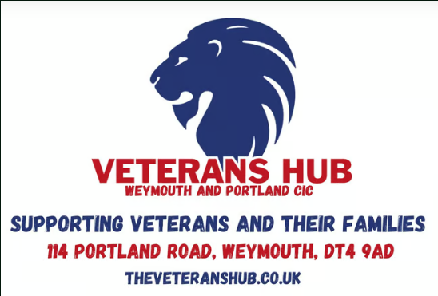  114 Portland Road, Weymouth, Dorset  01305 777788  theveteranshubweymouth@outlook.com

Got your Six UK  Got your Six UK promotes and supports the mental health and wellbeing of the military community in a variety of ways, including providing a free, confidential military specific counselling service to veterans and their families, supporting with a range of issues, including depression, anxiety, bereavement, loss, grief, addictions, trauma, relationship breakdown, service-related issues, difficulties transitioning to civvy street, self-esteem and self-worth, guilt, shame, identifying emotions, and much more. |   Gotyoursixuk@outlook.com  5 South Street, Wincanton, Somerset, BA9 9DJ

Paws 4 Thought  This is a popular drop-in session for service users and their dogs. Relax and have a brew with Jimmy for half an hour while the dogs sniff around off lead and enjoy some treats!  Appointments can be made via the Hub. |   114 Portland Road, Weymouth, Dorset  01305 777788  theveteranshubweymouth@outlook.com

Funding options
Veterans’ Mobility Fund  Do you need mobility equipment that isn’t available via the NHS? And have mobility issues as a result of your service?  You can now apply for a grant via the Veterans’ Mobility Fund (VMF) which supports those ex-service personnel with physical disabilities.  The VMF provides grants for mobility equipment such as specialist wheelchairs and mobility scooters. | 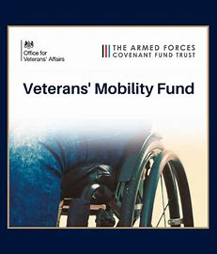  To apply you will need to use the following form which can also be found on the Help for Heroes website.  www.helpforheroes.org.uk/get-help/veterans-mobility-fund/

Army Benevolent Fund  The Army Benevolent Fund offer assistance when all statutory funding has been exhausted.  Assistance is provided for: Priority debt, Essential household goods, Funeral costs, Essential Family needs, Elderly care, Mobility equipment, Applications for tuition fees, and Counselling sessions.  All applications are means tested. |   Call 020 7901 8900 for help.  www.armybenevolentfund.org

The services below, whilst not specifically aimed at Veterans, we find that Veteran’s are particularly welcomed, and the organisers would be happy to see you:

Coffee Companions is a social enterprise founded in 2016. The scheme offers people the opportunity to strike up a friendly conversation and maybe make a new friend whilst enjoying a nice hot drink and maybe even a slice of cake!  You will find a friendly volunteer hosting each event who will welcome and introduce you to everyone.  Booking is not necessary, just turn up and join in! |   Shaftesbury  The Royal Chase; Mondays 2-3pm  Stalbridge  Guggleton Farm Arts; Thursdays 11-12pm  Sturminster Newton  Country Market at The Exchange, Tues 10am-11am

Countrymen UK at Rylands Farm, near Sherborne is home to the first Countrymen UK Group and provides a range of services and activities to men with long-term health and social conditions and to their family carers.  Activities for the men include farming, horticulture, crafts and leisure activities.  01963 210 789 admin@countrymenuk.org | 
Funded by Public Health, LiveWell Dorset supports you on your journey to a happier, healthier you through FREE advice and coaching. Want to become more active, lose weight, quit smoking or drink less alcohol? Talk to us.  CALL US TODAY  0800 840 1628  Monday - Friday 9am - 6:30pm  FREE OF CHARGE | 

The Men’s Shed’s  Sturminster Newton  The Men’s Shed Sturminster Newton is a great place to socialise, share and learn new skills. Open on Tuesdays and Thursdays between 9-3 at Stour Connect (in the Car Park area). If you are interested in joining the group, you will be made very welcome. So why not pop in, use any of the facilities, you do not need to be referred, and there is no charge.  Gillingham  Gillshed offers a place for men who are retired, lonely or at a ‘loose end’ to pursue practical interests at leisure, and to practice skills, as well as enjoy making and mending. Gillshed offers opportunities for building connections and making friends, as well keeping you busy. Held at The Orchard Park Garden Centre on Tuesdays and Thursdays 11-1. Gillshed is a free activity, no booking necessary, just go along during opening hours.  Marnhull  Marnhull Men’s Shed is a community organisation where members can gather to share skills, get involved in village projects or just a have chat and a cup of tea. There is plenty of help and encouragement available for those who are new to the craft or need to brush up their skills. The Shed is in session on Wednesday afternoons. | 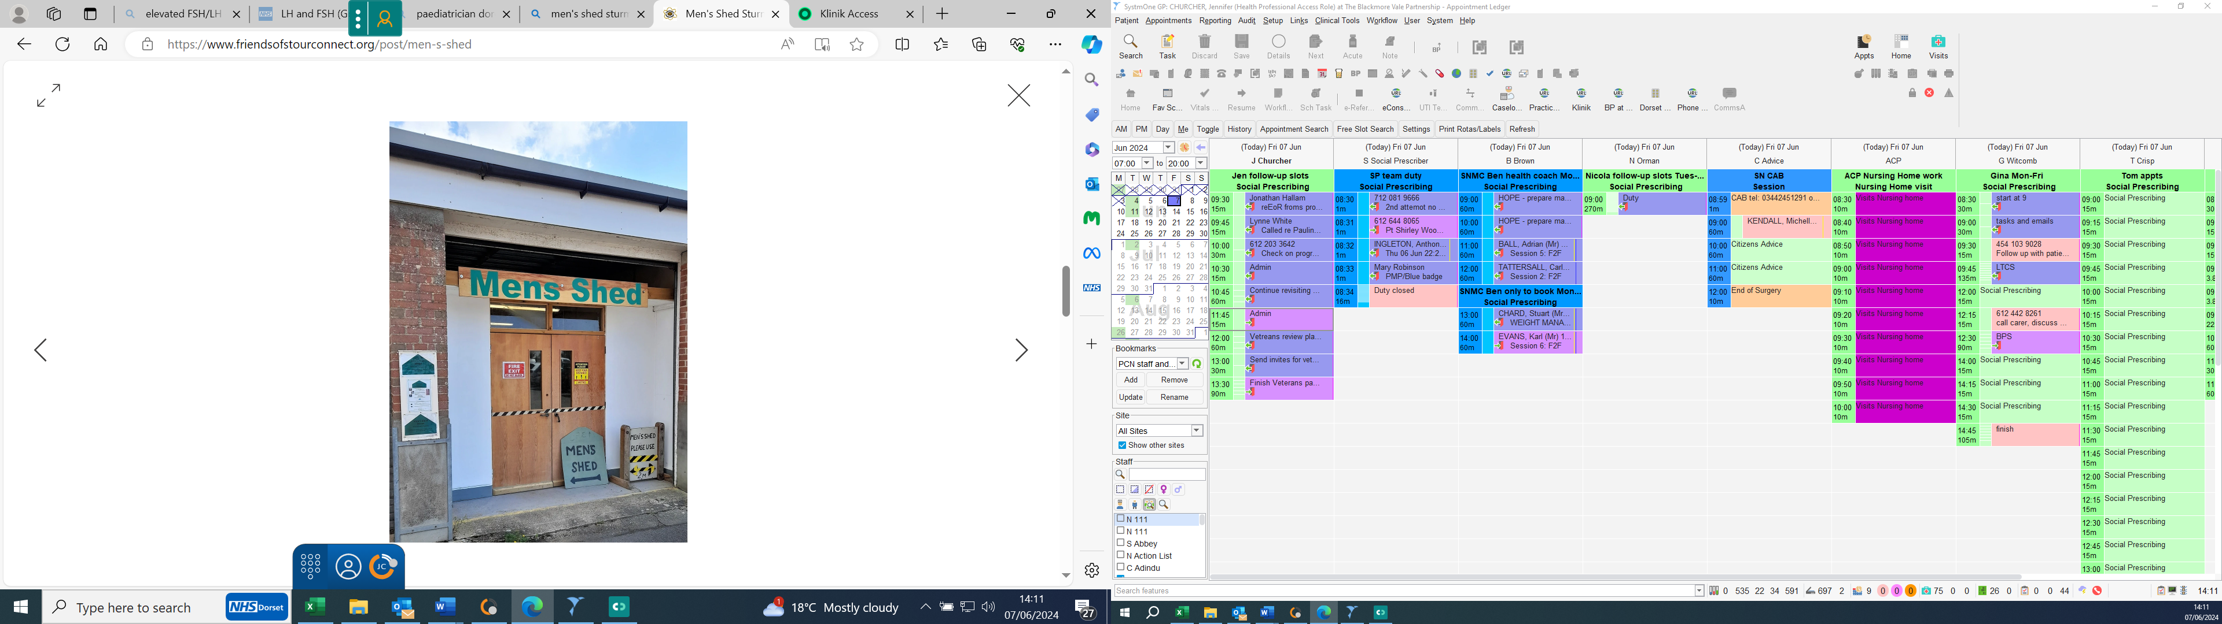  For further details please call 01258 471359 or email George on georgefuller@icloud.com or Tim on m_t_wilson@yahoo.co.uk    No booking necessary just pop along to Orchard Park Garden Centre during opening hours  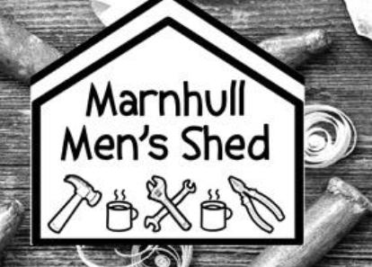  Hill View  New Street  Marnhull  Sturminster Newton  DT10 1PX  Phone: 01258821456  Email: chairman@marnhullmensshed.org.uk

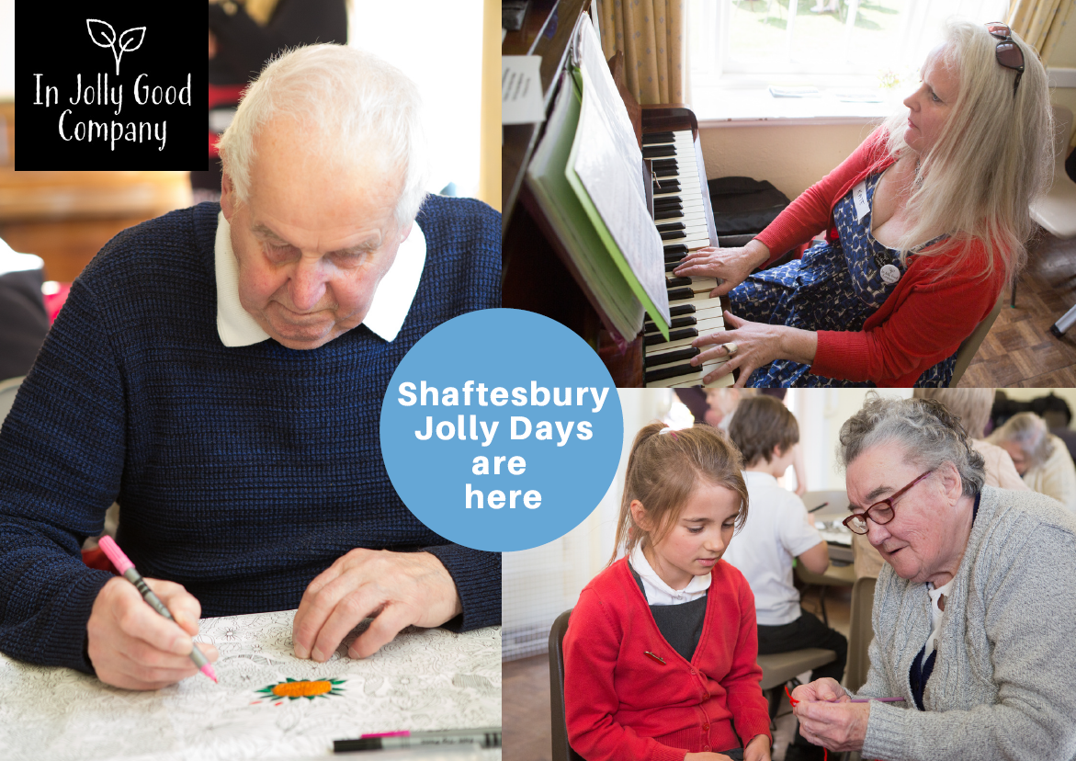

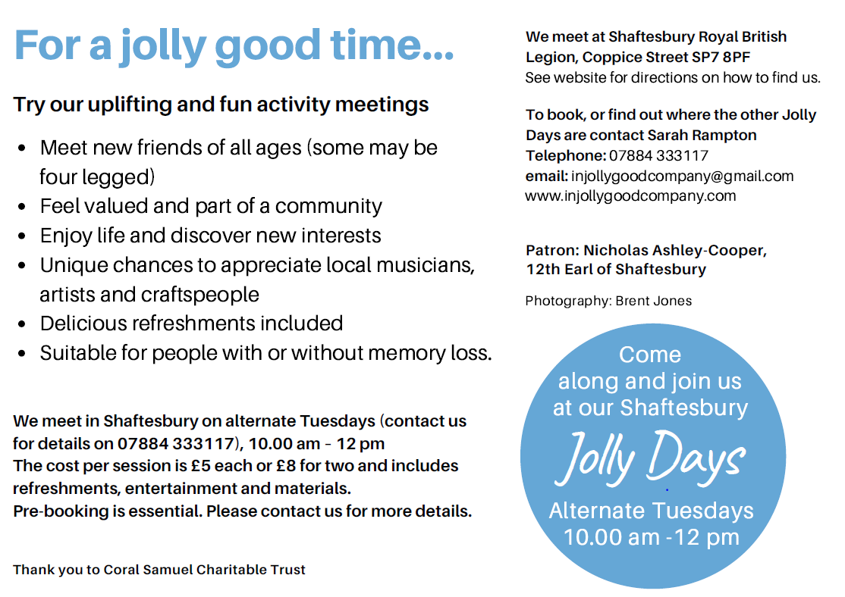


Tricuro provide community support services for Dorset Council. They have two local community centres offering lots of activities and opportunities:

- Shaftesbury Plus (Bimport) is in the old Trinity Church, close to Shaftesbury town centre. The entrance is from the rear of the building and overlooks the grounds and an avenue of lime trees.

- Stour Connect (Bath Road, Sturminster Newton) provides a café, Mens Shed, hot meals delivery service and lots more.

Both of these community centres offer:

- person-centred support to people with dementia to promote individuality and independence and to prevent loneliness and isolation.
- chair based exercises or tai chi for clients to encourage movement and muscle tone.
- daily activities that anyone from the local community are welcome to join in with, most of which are free. Activities include a Mens Shed, arts and crafts; a games café where table top games such as scrabble; dominoes; cards; and other board games are played. Cooking sessions in the well-equipped kitchen are also available.
- We enjoy singing; large group games such as skittles; golf and
cricket; bingo; quizzes and jigsaws. Visits out to the local town are
frequent.

Subject to Covid-19 guidance, we link up with local community activities, visit garden centres and coffee mornings. Our lunch club / community café is open to all every weekday - an excellent way to build new friendships. Other services offered are bathing; fingernail cutting; laundry services. Footcare and hairdressing can be arranged if required (these services incur a cost).

Come and see what we have to offer you anytime!

Contact Details
Shaftesbury Plus Stour Connect
Trinity Centre Stour View Close
Shaftesbury Sturminster Newton
SP7 8BW DT10 1JF
01747 854 959 01258 472957
shaftesburyplus@tricuro.co.uk stourconnect@tricuro.co.uk

Useful Contacts

Adult Social Care | 01305 221 016
Age Concern (Sturminster Newton area) | 01747 853 966
Age UK (Shaftesbury area) | 01747 853 966
Blackmore Vale Foot Care (private) | 01258 820 203
Blackmore Vale Partnership (Sturminster Newton area) | 01258 820 203
Blackmore Vale Partnership (Shaftesbury area) | 01747 856 700
Blandford area Hub | 01258 394 018
Blandford Community Hospital | 01258 456 541
Carer Support Dorset | 0800 368 8349
Citizens Advice | 0344 245 1291
Dorset Open Door (Bereavement support) | 01305 361 361
Finding the right care (CHS) | 0800 0564 103
Good Life Sorted (Help at home) | 0808 164 8338
Hospital Transport | 01278 727 457
Livewell Dorset (lifestyle support) | 0800 840 1628
Marnhull Village Car Service | 07434 638 485
Meals on Wheels | 01258 471 359
Mindful (North Dorset) | 07840 424 148
Nordcat | 01258 472 164
Out of Hours (Urgent Medical Help) | 111
Podiatry (NHS) | 0300 303 8630
Police Station- Shaftesbury | 01747 852 231
Police Station- Sturminster Newton | 01258 472 307
Rethink Mental Health | 0808 801 0525
Shaftesbury Car Link | 07760 426 664
Shaftesbury Plus Centre | 01747 854 959
Stalbridge Car Scheme | 07746 100 299
Stour Connect Centre | 01258 472 957
The Vale Hub (Shaftesbury area) | 01747 475 253
Volunteer Responders | 0808 196 3646
Westminster Memorial Hospital | 01747 851 535

