**Gudge Heath Lane Surgery-Patient Update**

@GudgeHeathLaneDoctorsSurgery

[www.gudgeheathsurgery.co.uk](http://www.gudgeheathsurgery.co.uk)

[www.farehamandportchesterpcn.gpweb.org.uk](http://www.farehamandportchesterpcn.gpweb.org.uk)

**11th July 2022**

**IMPORTANT**

You said:

‘We would like more face to face appointments’

We Did:

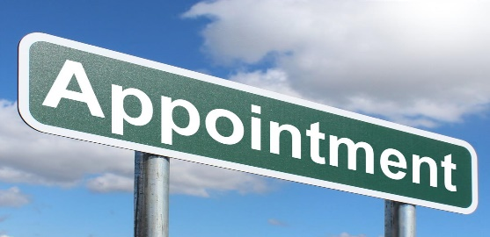

[This Photo](https://www.picserver.org/highway-signs2/a/appointment.html) by Unknown Author is licensed under [CC BY-SA](https://creativecommons.org/licenses/by-sa/3.0/)

**New appointment system:**

* **ALL on the day urgent appointments** will be dealt with by the Duty Triage GP commencing Monday 11th July 2022.
* **If your need DOES need to be dealt with on the day**- the GP may text you information ie; advice or notification of what action has been taken for example a prescription/ an appointment booked for that day; either call or face to face or a future appointment
* If your need is **not urgent for today** you may be asked to book a routine appointment, directed to the pharmacy or booked with another healthcare professional that can best deal with your need. We work with a multi-disciplinary team both in the practice and within our Primary Care Network ( Fareham and Portchester PCN). [www.farehamandportchesterpcn.gpweb.org.uk](http://www.farehamandportchesterpcn.gpweb.org.uk)

**MORE ROUTINE APPOINTMENTS**

* there are a selection of face to face and telephone appointments now opening at 2 days and 7 days. That means every day there will be routine appointments available at 1 weeks notice. We were originally going to have all of these face to face with patients being able to request a telephone instead. However, due to a rise in covid cases we are mindful of keeping a balance.

**PLEASE MAKE SURE YOU KEEP US UP TO DATE WITH YOUR NEW MOBILE NUMBERS**



[This Photo](https://www.privateinternetaccess.com/blog/2019/10/millions-of-smartphones-vulnerable-to-simjacker-mobile-phone-exploit/) by Unknown Author is licensed under [CC BY-SA](https://creativecommons.org/licenses/by-sa/3.0/)

**FACE MASKS**

: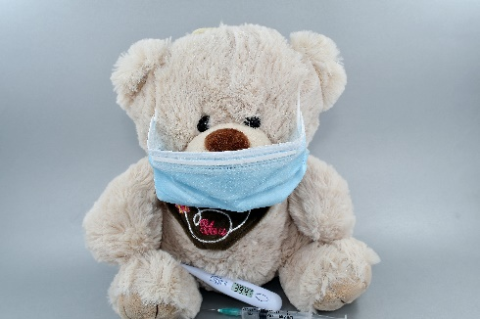

Please do wear a face mask if you can. We all know this can be frustrating especially in the hot weather however, if a clinician gets covid- they are not allowed to work for 10 days/until 2 negative tests which severely impacts our operation.

Thank you so much for your cooperation with this.