NEW! SurgeryPod
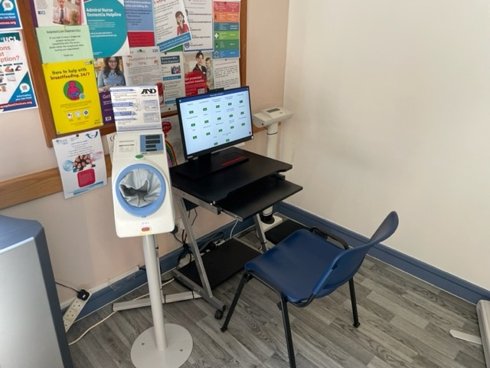

Want to take greater control over your health?
In order to give you more quality face-to-face time with your doctor we at the Gudge Heath Lane Surgery have invested in innovative technology called SurgeryPod. This newly installed equipment is designed to give you greater control and flexibility over your health as well as allowing our medical staff to utilise their expertise more efficiently.
What is SurgeryPod?
SurgeryPod is a secure computer system which has the capability to accurately record patient data and take readings, such as weight and blood pressure measurements. It is not a replacement for your doctor or nurse but an addition to the practice.
Why do we have it?
We want to give our patients greater freedom and the opportunity for you to monitor your health without having to wait for an appointment. Primarily this will be used as an extension to your consultation with your GP or nurse. It will accurately record key data and send it directly to your GP. This means that when you start your face-to-face consultation your doctor will already have this key information giving you more time to discuss your health.
How does it work?
Using SurgeryPod is very simple. You interact with a touchscreen computer which will guide you through the process. After you enter your name and date of birth you simply follow the step-by-step instructions! If you are an existing patient then here is the typical process you will go through prior to your GP appointment:
1. Enter your name and date of birth
2. Select ‘Standard Checks’
3. Follow the onscreen instructions
4. After you complete the session your results are automatically saved on your patient records
Who can use it?
Every patient can use it. From those who rarely visit the doctor to those who are regular patients. Due to its simple user interface, regardless of your technical knowledge, you will easily be able to use SurgeryPod.

