**St Helens Medical Centre Newsletter**





**Christmas Message from Dr Cooney (Senior Partner)**

2023 has not been without challenges for us at St Helens Medical Centre. We have welcomed a new management team and have faced challenges with recruitment of GPs. We have embraced a new model of working, expanded our team, and offered our patients appointments with our GPs, Advanced Nurse Practitioners, Paramedic, Practice Nurses, Health Care Assistants, Care Coordinators, Social Prescriber, Health and Wellbeing Coach, Mental Health Team, and our Musculoskeletal Practitioner. As we look to 2024, we remain confident with our team and our ability to manage an ever-increasing demand, and welcome Dr Poole to our team at St Helens.

We are proud of our team for their resilience to remain focused on St Helens Medical Centre's ethos, to provide the best possible standards of service to our patients. During this festive season, we encourage you to take a moment to cherish the precious moments with your family and friends. It is a time to reflect on the blessings we have and express gratitude for the love and support we receive.

As the holiday season approaches, we wish to extend our warmest greetings to each and every one of you and we would like to express our gratitude for your continued support throughout the year. We look forward to the new year with optimism and wish you a happy and healthy year ahead.

From all of us at St Helens Medical Centre, we wish you a Merry Christmas and a Happy New Year!



Although more expensive than a standard alarm clock, there are alarm clocks that can help aid your sleeping pattern. If you struggle with SAD (seasonal affective disorder) the [Lumie Bodyclock Active 250](https://www.lumie.com/products/bodyclock-active-250) wakes you with a gradually brightening sunrise to help boost mood and energy levels.

**Have seasonal fruit and veg**



This time of year there is an abundance of fruit and veg in season that will help boost your immune system. Oranges, blueberries, persimmon, beetroot and kale to name a few, are great for vitamin C and antioxidants, so it’s a good idea to incorporate more fruit and veg into your diet.

**Don’t skip breakfast**

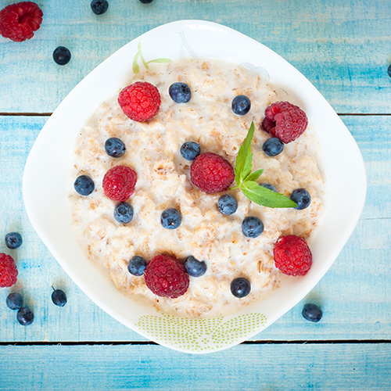

Breakfast is important all year round but even more so in these months. Porridge is perfect as it is warming, makes you feel fuller for longer and is packed full of fibre. Plus if you eat breakfast you are less likely to reach for unhealthy snacks.

**Get some vitamin D**



The weather is an obstacle for many of us but if you can, wrap up warm and go for a walk to try and get some much needed vitamin D in natural daylight. It can also help with energy levels and is a great way to keep fit and keep your mood up.

**Take time out**



If you feel more tired in these months, this can lead to you feeling more stressed out, particularly in the run up to Christmas and the New Year. Take some time out and practice mindfulness or meditation, exercise is also a great way to relieve stress.

**Try and limit caffeine**



Of course for many, caffeine is a must to get through these months. However it can cause dehydration and affect sleep, so don’t overload on caffeine and try to limit your intake. You could swap your cuppa for a nutrient packed smoothie instead.

**Keep skin moisturised**

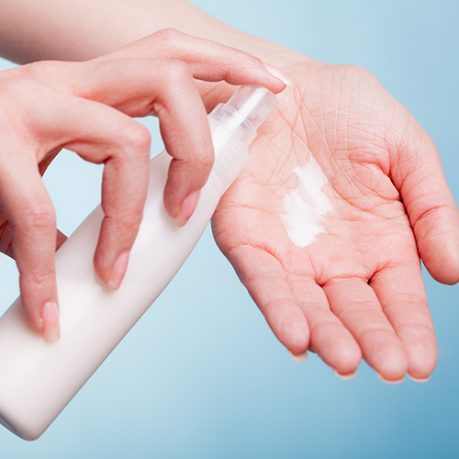

Even though we wrap up warm, with the cold and blustery weather, our skin can become very dry. Moisturise your hands and face to protect from the elements and lips too to prevent them from becoming chapped.

**Add some spice**



Add warming spices like ginger, turmeric and chillies to your foods, which have great health benefits to help keep winter bugs at bay. They are also great for flavour and warm our bodies up from the inside which is much need on a cold winter day.

**Go to bed early**



It goes without saying that if you only get a short amount of sleep, you are going to be restless and exhausted in the day. Try to go to bed early and get the full eight hours so you can get a proper rest and quit screen time an hour before you go to bed.

**Here are ten (10) simple events to add to your daily routine, contributing to a healthier, fitter YOU!**

**Follow these guidelines to achieve optimal health and well-being.**

**DECEMBER 2023 ISSUE 7**

# **Keeping Warm and Well in Winter**

Keeping warm in winter is important to everyone, especially those getting older as changes to our bodies often mean cold weather and winter bugs affect us more than they used to. The good news is there are things you can do to stay warm and well.

**Keep moving**

A little bit of activity now and then is a great way to help you keep warm, as well as help you maintain strength and mobility. So, try not to sit still for more than an hour at a time.

There's no one size fits all approach when it comes to keeping moving, so it's important you do something that feels right and safe for you.

**Eat well**

It can sometimes be difficult to keep up the motivation to prepare meals. But it's good to try and keep to a routine where you can. Hot food and drinks can help you to keep warm, so try to have one hot meal a day and as many hot drinks as you can.

Try to have a range of foods in your diet and try to eat fruit and vegetables each day, frozen and tinned vegetables can be just as good as fresh. It's also a good idea to keep your cupboards stocked with some basics just in case you can't get out to the shops, whether due to illness or bad weather.

**Make sure your home is warm enough**

Try to heat your home to a steady and comfortable temperature throughout the day in the rooms you use most, such as the living room and bedroom, usually around 18°C (64°F) is ideal. If there are rooms you don't use, like a spare bedroom, turn off the radiators in that room and close the doors. This will help you save on energy costs while keeping warm in winter.

At dusk, close all the curtains and keep the windows closed to help keep heat in when the weathers at its coldest. O

**Wrap up well**

Wearing plenty of layers is the best way to keep warm in winter. If you're heading out, make sure you take some extra layers – even if you don’t need them immediately. It's a good idea to be prepared because the temperature can drop significantly when the sun goes in.

Wearing several thin layers will keep you warmer than wearing one thick layer, as layers trap warm air between them. Our bodies react to the cold by redirecting our blood away from our hands and feet and towards our vital organs.

It's important to be careful when out and about. In the autumn, fallen leaves and rain can make the ground very slippery. In winter, ice and slow can seriously increase your risk of falls. You might find that shoes with non-slip soles are helpful.

r Andan.

**Below is a reminder of the purpose of the PPG at St Helens Medical Centre**

The Patient Participation Group consists of a group of patients who try to make a positive contribution to the services offered to patients at the surgery. The PPG meet every other month and are joined by representatives of the practice staff. The PPG does not discuss any patient’s personal health details.

The objectives of the PPG are:

* To form a two-way communication bridge between patients and the practice.
* To contact patients for their views and provide regular feed back to the practice.
* To highlight any services that could be improved.
* To promote health events and awareness days. This is done with posters, leaflets and information packs displayed on the Patients' Notice Board and tables throughout the waiting areas of the surgery.
* To influence the provision of local Health and Social care.

Any patient wishing to contact member of the PPG will find details at the end of the Newsletter.

**NHS appointment discount**

Did you know, if you’re travelling by foot, ticket prices are fixed starting from £10.50.

If you travel with a vehicle, you get 50% off your travel with a price cap of £35. You won’t pay more than £35 and your fare will frequently be less than this. The cap is in place to ensure a lower fare even at peak times of travel.

There is as assisted travel phone line (0800 093 8236).



**Patient Group Members**

* **Chairman** - Keith Bradford - 07421 826150 or [keithbradford18@yahoo.com](mailto:keithbradford18@yahoo.com)
* **Vice Chair -** Patricia Jepson - [triciajepson@gmail.com](mailto:tricia.jepson5@btinternet.com)
* Susan Atwell
* Maurice Dix
* Lorraine King
* Loraine Whelan
* Gay Allen – [gayallen@outlook.com](mailto:gayallen@outlook.com)
* Diana Tuson
* Derek Burt
* George Weech
* Pam Hogg – [pamhogg57@gmail.com](mailto:pamhogg57@gmail.com)
* Peter Dodds – [peterdodds46@gmail.com](mailto:peterdodds46@gmail.com)
* **Secretary** – Jolie Hurst
* **Business Manager** – Megan Odell
* **Operations Manager** – Summer Wearn