**ST HELENS, ISLE OF WIGHT PPG**

***NEWSLETTER***

**Happy June!**

The weather is hot, humid, and dry during this season (fingers crossed) and temperature can rise extremely high in certain places, as the earth tilts itself towards the sun. As the sun shines brightly in summer, this season is suitable for farmers to prepare for cultivation, and we get many seasonal fruits and vegetables.

The greatest joy of eating seasonally is the opportunity to reconnect with nature's cycles, the passing of time and the tremendously diverse and delicious foods that our seasonal climate provides.

Eating British fruits and vegetables in season is good for you. Foods in season contain the nutrients, minerals, and trace elements that our bodies need at particular times of the year. Food in season is cheaper because you are buying it when it is in abundance, and it has not travelled a long way. Seasonal food is fresher and so tends to be tastier and more nutritious: fresh asparagus, for example, taste more special than asparagus flown in from South America.

**What is in season** 

**A day in the life – Care Co-ordinator Amy**



I have worked within health and social care for 16 years, working in Nursing & Residential Care Homes. I worked my way up to a supervisor, with a Level 3 Diploma. I joined St Helens Medical Centre in 2022 and have been able to put my experience and skills to good use within the practice. I work as a Care Coordinator, supporting our local care homes, working with them to ensure they have all the appropriate patient documentation.

I also work within the surgery carrying out blood tests, BP readings and ECGs. I visit patients for welfare checks, carry out memory assessments in the practice and the community, complete dementia reviews, help patients to access support in the community and make any necessary referrals to local services.

I work closely with the clinicians at the surgery and attend monthly multidisciplinary meetings alongside teams from the community.

**Conditions which can be managed by Pharmacy Services**

|  |  |
| --- | --- |
| **Uncomplicated UTI**  **Shingles**  **Impetigo**  **Infected Insect Bites**  **Sinusitis**  **Sore Throat**  **Acute Otitis Media** | Women 16-64 years  18 years and over  1 year and over  1 year and over  12 years and over  5 years and over  1 to 17 years |

**St Helens Health Walks 2024**

• St Helens Health Walks take place every Wednesday from 10am and usually ends around 1pm.

• Walkers meet by the sports pavilion on St Helens Green.

• The varied walks take place around the St Helens, Seaview, Bembridge and Brading areas and the distance is normally between 4 and 8 miles.

• A shorter walk for those requiring one is offered.

• The aim of the friendly walks is to help provide opportunities for physical exercise as well as positive social opportunities.

• The walks have a leader and a back marker to provide support for walkers.

• If you need further information, please contact Maurice Dix Tel: 07854 368 419 or by email at [maurice.dix@btinternet.com](mailto:maurice.dix@btinternet.com)

**Introducing our Patient Participation Group**

Their aim:

- To improve communication between the service providers, the group, and the wider population.

- To promote a patient perspective and enable patients to access and make the best use of available care.

- To develop and sustain effective communication between patients and the Practice to ensure services provided meet the needs of all patients.

- To provide information to the Practice on broader local and national issues to help develop future services.

- To provide information to patients about services provided by the Practice through a quarterly newsletter and the website.

To find out more, or to contact a member of the PPG, please visit: [www.sthelensmedicalcentre.org/ppg/](https://gbr01.safelinks.protection.outlook.com/?url=http%3A%2F%2Fwww.sthelensmedicalcentre.org%2Fppg%2F&data=05%7C02%7Cjolie.hurst%40nhs.net%7Cfd338db471694fd7a97408dc7f004ef4%7C37c354b285b047f5b22207b48d774ee3%7C0%7C0%7C638524886493573448%7CUnknown%7CTWFpbGZsb3d8eyJWIjoiMC4wLjAwMDAiLCJQIjoiV2luMzIiLCJBTiI6Ik1haWwiLCJXVCI6Mn0%3D%7C0%7C%7C%7C&sdata=Kh%2BcBaS4ebPhKoU8ELf%2BPKUW0BlyHJEQzL30psyrnFM%3D&reserved=0)

**Do you suffer with Hay Fever?**

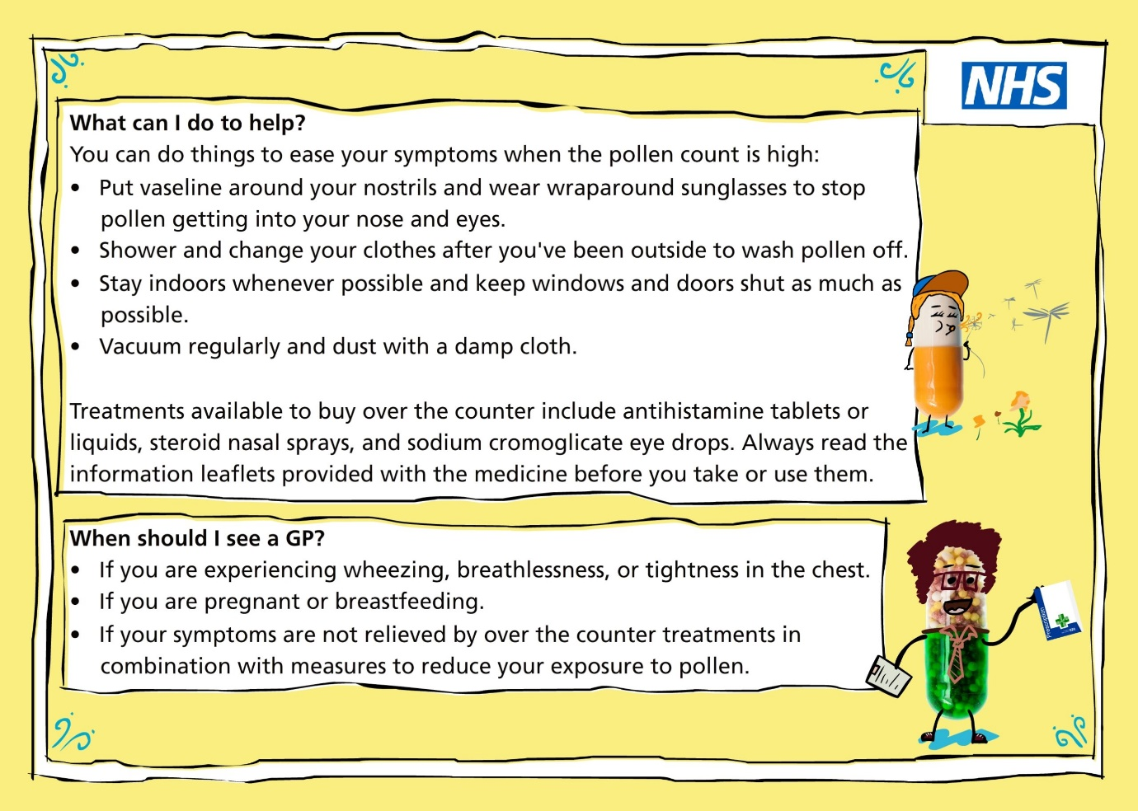

**Patient Group Members**

* **Chairman** - Keith Bradford - [keithbradford18@yahoo.com](mailto:keithbradford18@yahoo.com)
* **Vice Chair -** Patricia Jepson - [triciajepson@gmail.com](mailto:tricia.jepson5@btinternet.com)
* Susan Atwell
* Maurice Dix – [maurice.dix@btinernet.com](mailto:maurice.dix@btinernet.com)
* Gay Allen – [gayallen@outlook.com](mailto:gayallen@outlook.com)
* Diana Tuson – [dianatuson52@hotmail.com](mailto:dianatuson52@hotmail.com)
* Derek Burt
* George Weech
* Pam Hogg – [pamhogg57@gmail.com](mailto:pamhogg57@gmail.com)
* Peter Dodds – [peterdodds46@gmail.com](mailto:peterdodds46@gmail.com)
* Anthony Smart – [tonysmart.iow56@yahoo.com](mailto:tonysmart.iow56@yahoo.com)
* Lorraine King
* **Business Manager** – Megan Odell
* **Operations Manager** – Summer Wearn
* **Secretary** – Jolie Hurst