**ST HELENS, ISLE OF WIGHT PPG**



***NEWSLETTER***



**Welcome to Dr Westmore**

St Helens Medical Centre are very pleased to welcome to Dr Westmore working as a Salaried GP, on a Tuesday morning, Thursday and Friday.

**AUTUMN**

By the meteorological calendar, the first day of Autumn is always the first day of September and ending on 30th November. It is the third season of the year, when crops and fruits are gathered, leaves begin to fall, and the countryside is ablaze with colour.

As we head swiftly into the cooler weather and shorter days, food becomes more of a focus as we often start to crave warming sustenance.

Eating a diet rich in fruit and vegetables is one of the simplest ways to boost our well-being.

**Packed with fibre and essential nutrients, fruit and vegetables are a must have in any healthy diet.**

**Food to Consume**

There are some great food choices in the fall, such as the following, listed below:

* Apples: improve brain health
* Pears: Great source of fibre
* Cranberries: Helps reduce Oxidative stress
  + Oxidative stress is a condition in the body when antioxidant levels are low
* Winter Squash: Source of vitamin A (Good for strengthening your eye health)
* Pumpkin: Carve them to get a rich source of vitamin A
* Leeks: help fight off diseases
* Brussels Sprouts: contain lots of fibre and antioxidants
* Sweet Potatoes: are loaded with vitamins A and C
* Parsnips: provide vitamin K to bones
* Broccoli: Is a cancer-fighting food because of the high amount of a phytochemical called sulforaphane

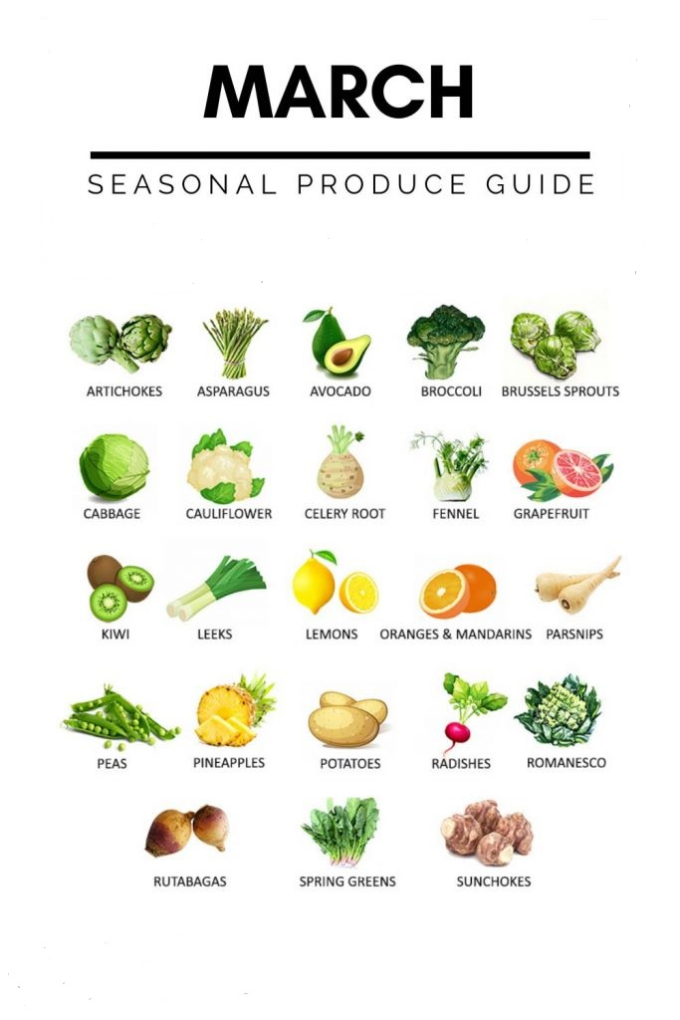

Although more expensive than a standard alarm clock, there are alarm clocks that can help aid your sleeping pattern. If you struggle with SAD (seasonal affective disorder) the [Lumie Bodyclock Active 250](https://www.lumie.com/products/bodyclock-active-250" \t "_blank) wakes you with a gradually brightening sunrise to help boost mood and energy levels.

**Have seasonal fruit and veg**

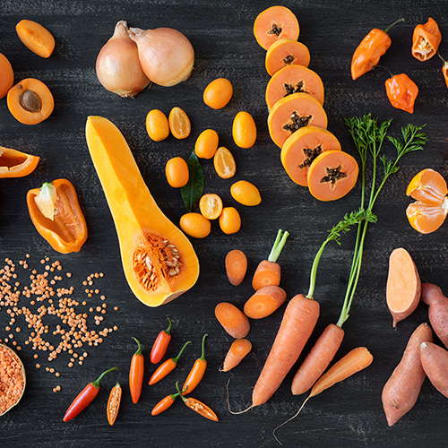

This time of year there is an abundance of fruit and veg in season that will help boost your immune system. Oranges, blueberries, persimmon, beetroot and kale to name a few, are great for vitamin C and antioxidants, so it’s a good idea to incorporate more fruit and veg into your diet.

**Don’t skip breakfast**

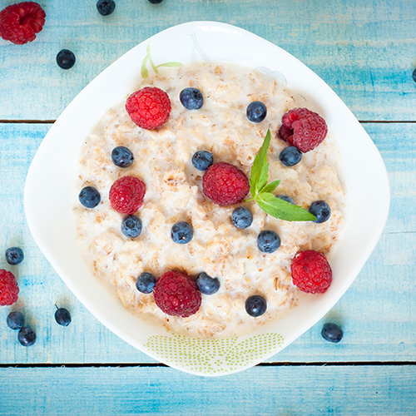

Breakfast is important all year round but even more so in these months. Porridge is perfect as it is warming, makes you feel fuller for longer and is packed full of fibre. Plus if you eat breakfast you are less likely to reach for unhealthy snacks.

**Get some vitamin D**



The weather is an obstacle for many of us but if you can, wrap up warm and go for a walk to try and get some much needed vitamin D in natural daylight. It can also help with energy levels and is a great way to keep fit and keep your mood up.

**Take time out**



If you feel more tired in these months, this can lead to you feeling more stressed out, particularly in the run up to Christmas and the New Year. Take some time out and practice mindfulness or meditation, exercise is also a great way to relieve stress.

**Try and limit caffeine**



Of course for many, caffeine is a must to get through these months. However it can cause dehydration and affect sleep, so don’t overload on caffeine and try to limit your intake. You could swap your cuppa for a nutrient packed smoothie instead.

**Keep skin moisturised**



Even though we wrap up warm, with the cold and blustery weather, our skin can become very dry. Moisturise your hands and face to protect from the elements and lips too to prevent them from becoming chapped.

**Add some spice**



Add warming spices like ginger, turmeric and chillies to your foods, which have great health benefits to help keep winter bugs at bay. They are also great for flavour and warm our bodies up from the inside which is much need on a cold winter day.

**Go to bed early**



It goes without saying that if you only get a short amount of sleep, you are going to be restless and exhausted in the day. Try to go to bed early and get the full eight hours so you can get a proper rest and quit screen time an hour before you go to bed.

**Here are ten (10) simple events to add to your daily routine, contributing to a healthier, fitter YOU!**

**Follow these guidelines to achieve optimal health and well-being.**

**SEPTEMBER 2024 ISSUE 10**



**FOOD TO CONSUME**

**Eating seasonally over the Autumn**

* **Root vegetables:** carrots, squash, pumpkin, and sweet potato
* **Whole grains:** brown rice, quinoa, oats, and millet
* **Legumes:** beans, chickpeas, lentils, soybeans.
* **Green vegetables:** broccoli, spinach, kale, celery, rocket, and artichokes
* **Fruit:** apples, pomegranates, citrus fruits, and pears
* **Fish:** sea bass, cod, sole and haddock
* **Herbs:** ginger, turmeric, cinnamon, rosemary, thyme, basil, and dill

## ****Tips for eating seasonally this Autumn****

* Focus on in-season produce such as sweet potatoes, squash, apples, dark leafy greens, beets and cook comforting foods like homemade soups and stews. These will help curb unhealthy cravings while providing plenty of nourishment.
* Sneak as many fibre-filled vegetables into your autumn diet as you can with hearty soups.  Add any greens, beans, lentils, whole grains, and veggies you may have along with protein, like chicken, prawns, or tofu.
* Get your vitamins with the citrus fruit that’s abundant in the colder months. Snack on oranges or make a delicious salad with some citrus and winter greens and cheese can be made healthier by switching to a wholegrain pasta and adding a variety of roasted winter vegetables.
* Make sure to drink plenty of water. Dehydration is common in cooler months as the lack of hot weather can fail to signal our thirst and ensure we’re drinking enough.
* Like kale.
* While craving carb-rich food is natural and you shouldn’t deprive yourself, try and make healthy swaps when you can. For instance, a warming bowl of pasta.

**Why is eating seasonally so important?**

**It’s more environmentally friendly and sustainable**

When food has to travel a long way to get to the UK, it often comes with a larger carbon footprint. When you buy seasonal food, you’re helping to reduce the demand for out-of-season produce that needs to be transported from other countries. This helps to reduce the energy and greenhouse gases released through refrigeration, transportation, artificial hothouses, fuels and much more.

When you eat seasonally, the food you eat is more likely to have been produced locally. This means that not only does it have a much shorter distance to travel (making it more environmentally friendly and sustainable), but it is fresher and more nutritious. Additionally, you are also helping to support local farmers and the local community.

**It tastes better**

Food that is grown and picked in season will taste much riper, fresher, and sweeter. Food transported long distances is often picked ahead of its ripeness so that it doesn’t arrive in the UK overripe and unusable – this means it isn’t picked at its optimal stage and won’t taste as good.

When you eat locally, the time it takes for food to get from the ground to your table is drastically lower, meaning it’s fresher and tastier.

**It’s more nutritious**

As many nutrients in produce decline over time, long transportation means that by the time you receive it, many of the nutrients have been lost. By eating seasonal foods, you are more likely to get the full nutritional benefits.

**It’s more affordable**

Eating local food that’s in-season pushes down the cost of food as there’s no large transportation or storage costs. Usually when there’s a large harvest of in-season produce, cost naturally decreases.

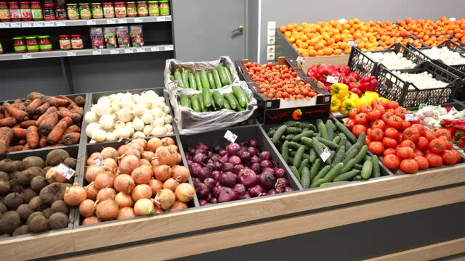

**Patient check in screen**

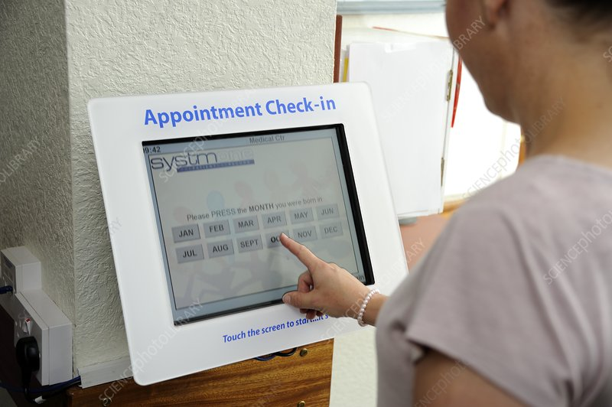

In the foyer at St Helens Medical Centre there is ‘Touch Screen Technology’ (check in screen) where patients can quickly and easily check themselves in for their appointments. Within seconds, the patient's identity is verified, and confirmation of the patient's appointment is displayed. This is to help avoid queues at the reception desk.

**It's that simple!**

**A day in the life – General Practice Assistant Hannah**



Hannah carries out welfare checks, dementia reviews, blood pressures, blood tests, ECGs, patients ACPs (advanced care plan) and DNR (do not resuscitate) forms on her two clinical working days a week.

Hannah has three admin days a week where she processes all of the insurance requests. This includes DVLA fitness to drive forms, life insurance medical forms, holiday cancellation forms, benefit claims, GP letter requests, solicitor’s requests and medical records requests either form patients or a third party.

Hannah works alongside the clinicians at the surgery and attends monthly multidisciplinary meetings alongside other health professionals.

**St Helens Health Walks 2024**

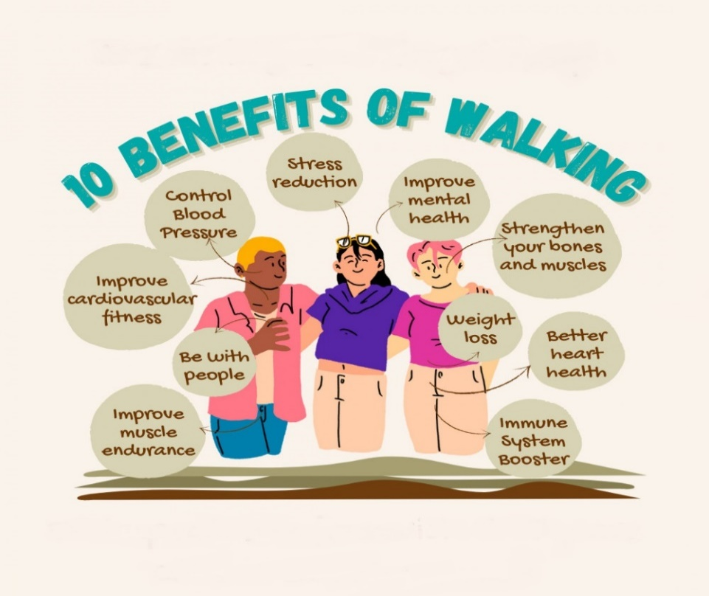

• St Helens Health Walks take place every Wednesday from 10am and usually ends around 1pm

• Walkers meet by the sports pavilion on St Helens Green

• The varied walks take place around the St Helens, Seaview, Bembridge and Brading areas and the distance is normally between 4 and 8 miles

• A shorter walk for those requiring one is offered

• The aim of the friendly walks is to help provide opportunities for physical exercise as well as positive social opportunities

• The walks have a leader and a back marker to provide support for walkers

• If you need further information, please contact Maurice Dix Tel: 07854 368 419 or by email at [maurice.dix@btinternet.com](mailto:maurice.dix@btinternet.com)



**WANTED**

Patients of St Helens Medical Centre to tell us their concerns.

We are the St Helens Patient Participation Group (PPG).

We meet 6 times a year with the surgery staff. We are a friendly bunch of volunteers who liaise with the Surgery to raise matters of patient interest and to provide feedback.

Have you got a subject you’d like to air?

If so, please contact any of the committee below:

* **Chairman** - Keith Bradford - [keithbradford18@yahoo.com](mailto:keithbradford18@yahoo.com)
* **Vice Chair -** Patricia Jepson - [triciajepson@gmail.com](mailto:tricia.jepson5@btinternet.com)
* Maurice Dix – [maurice.dix@btinernet.com](mailto:maurice.dix@btinernet.com)
* Gay Allen – [gayallen@outlook.com](mailto:gayallen@outlook.com)
* Diana Tuson – [dianatuson52@hotmail.com](mailto:dianatuson52@hotmail.com)
* Pam Hogg – [pamhogg57@gmail.com](mailto:pamhogg57@gmail.com)
* Peter Dodds – [peterdodds46@gmail.com](mailto:peterdodds46@gmail.com)
* Anthony Smart – [tonysmart.iow56@yahoo.com](mailto:tonysmart.iow56@yahoo.com)

**Flu open days**

Our walk-in flu clinics (no appointment needed) for registered patients aged over 65 and

at-risk patients will be held on:

* **Thursday 3rd October, 8.30am-12pm at St Helens**
* **Thursday 3rd October, 5pm-7pm at St Helens**
* **Friday 4th October, 8.30am-12pm at Bembridge**

If you are unable to make these dates, we will have bookable clinics available from October onwards. Please contact the medical centre on 01983 871828 if you would like to book an appointment for your flu jab.

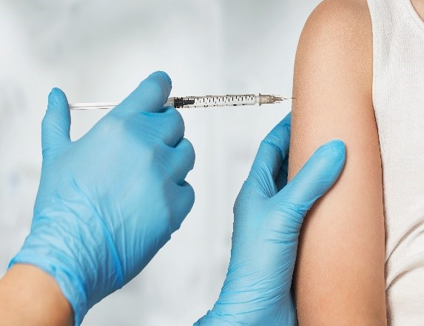

**Patient Group Members**

* **Chairman** - Keith Bradford - [keithbradford18@yahoo.com](mailto:keithbradford18@yahoo.com)
* **Vice Chair -** Patricia Jepson - [triciajepson@gmail.com](mailto:tricia.jepson5@btinternet.com)
* Susan Atwell
* Maurice Dix – [maurice.dix@btinernet.com](mailto:maurice.dix@btinernet.com)
* Gay Allen – [gayallen@outlook.com](mailto:gayallen@outlook.com)
* Diana Tuson – [dianatuson52@hotmail.com](mailto:dianatuson52@hotmail.com)
* Derek Burt
* George Weech
* Pam Hogg – [pamhogg57@gmail.com](mailto:pamhogg57@gmail.com)
* Peter Dodds – [peterdodds46@gmail.com](mailto:peterdodds46@gmail.com)
* Anthony Smart – [tonysmart.iow56@yahoo.com](mailto:tonysmart.iow56@yahoo.com)
  + **Business Manager** – Megan Odell
* **Operations Manager** – Summer Gomm
* **Secretary** – Jolie Hurst