
ST HELENS, ISLE OF WIGHT PPG


NEWSLETTER

Winter
For many, the prospect of Winter is fraught with the idea of cold, miserable weather and shorter days, whilst for others, it’s an exciting time as we cosy up, wear comfy clothes and enjoy. Here are a few worthy tips we want to highlight that might help you get through these seasonal.

Feeling better when the sun has gone ☀ – The NHS recommends a good amount of daily exposure to natural sunlight including working or sitting next to windows. Taking plenty of outdoor exercise during the day and eating a balanced diet, with nutrient rich foods that will leave you fuller for longer, as well as happy. In some cases, light therapy can be helpful to those who struggle in winter, that is, emulating natural sunlight with a source of light that can enhance your mood and increase.

Dress for the occasion 👞– It’s at this time of the year any weather can present itself, and being prepared for these changes can be the difference between a good day at work, or a damp one! Make sure you have waterproof outer layers, and consider footwear that is both comfortable, lightweight and waterproof or water resistant if walking. Gloves, a scarf or woolly hat will keep you warm on your journey.

Planning your route 🚗 – Speaking of journeys, plan yours ahead of time! If you’re out and the weather is wet, consider routes that are easier to walk, watch out for slippery leaves or pavements where you’re likely to get soaked by a passing car. If driving, don’t underestimate the power of a downpour. Even if you’re in a rush, drive safely.

Be safe be seen 👓 - Lastly, as each day draws in closer and closer, be mindful of what you are wearing and what you can see, consider high visibility clothing or bright colours as well as a light source such as the torch on your phone to stay safe and.

Feeling better when the sun has gone ☀ – The NHS recommends a good amount of daily exposure to natural sunlight including working or sitting next to windows. Taking plenty of outdoor exercise during the day and eating a balanced diet, with nutrient rich foods that will leave you fuller for longer, as well as happy. In some cases, light therapy can be helpful to those who struggle in winter, that is, emulating natural sunlight with a source of light that can enhance your mood and increase.
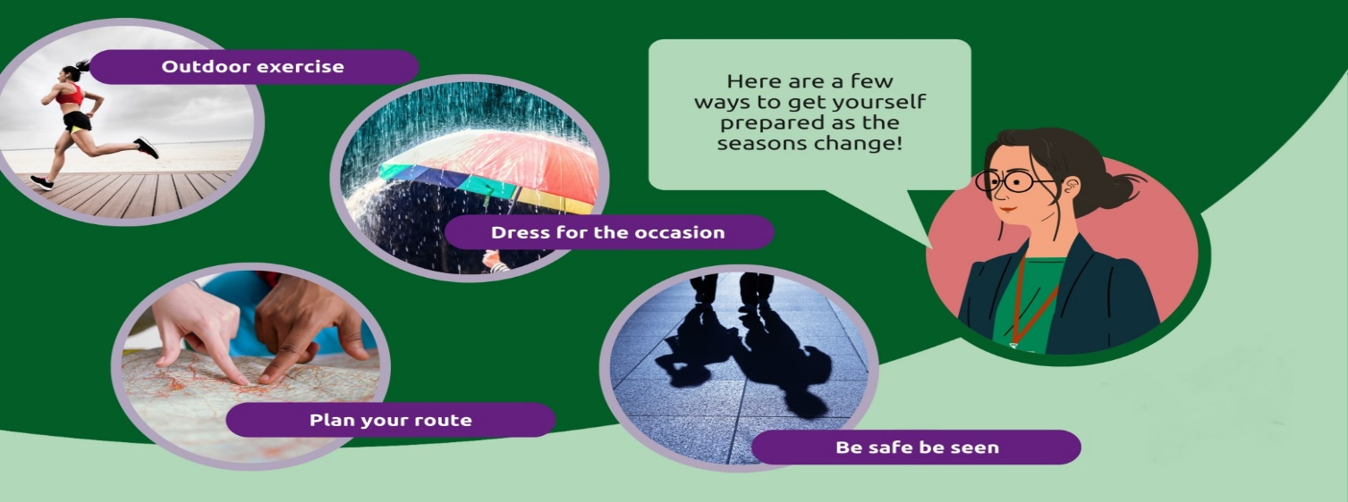

Christmas Message from Dr Cooney (Senior Partner)
As we embrace the spirit of the festive season, we would like to take a moment to extend our gratitude for your support and confidence in St Helens Medical Centre. Your trust in us has been invaluable, especially during what has been a challenging year for the NHS and GP services.
Despite the obstacles we faced, our team at St Helens has demonstrated incredible resilience and dedication. We are proud to have attracted high-level staff, including exceptional GPs, who have joined our committed clinical, nursing, and administrative teams. We have welcomed both Dr Westmore and Dr Yousab to our team and look forward to working with them as we go into 2025. Together, we have worked tirelessly to enhance the services we provide to you, our valued patients. Your health and well-being remain our top priority, and we are continually striving to improve your experience at our practice.
As we look ahead to 2025, we are excited about the positive changes on the horizon. We are confident that our strengthened team and our commitment to patient care will lead to even better services and outcomes for all. Your feedback and involvement have been crucial in shaping our direction, and we are eager to continue this partnership as we move forward.
We are proud of our dedicated practice team, and their continued commitment to provide the highest standard of care to our patients. Although 2024 has been a challenging year for healthcare services, our team have remained resilient, and their support is greatly appreciated.
From all of us at St Helens Medical Centre, we wish you a Merry Christmas and a Happy New Year!


St Helens Health Walks

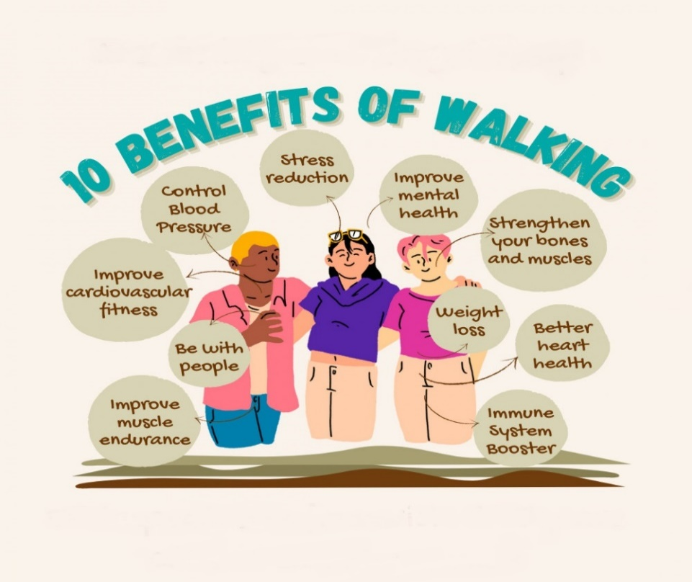

• St Helens Health Walks take place every Wednesday from 10am and usually ends around 1pm
• Walkers meet by the sports pavilion on St Helens Green
• The varied walks take place around the St Helens, Seaview, Bembridge and Brading areas and the distance is normally between 4 and 8 miles
• A shorter walk for those requiring one is offered
• The aim of the friendly walks is to help provide opportunities for physical exercise as well as positive social opportunities
• The walks have a leader and a back marker to provide support for walkers
• If you need further information, please contact Maurice Dix Tel: 07854 368 419 or by email at maurice.dix@btinternet.com

Below is a reminder of the purpose of the PPG at St Helens Medical Centre

The Patient Participation Group consists of a group of patients who try to make a positive contribution to the services offered to patients at the surgery. The PPG meet every other month and are joined by representatives of the practice staff. The PPG does not discuss any patient’s personal health details.
The objectives of the PPG are:
- To form a two-way communication bridge between patients and the practice
- To contact patients for their views and provide regular feed back to the practice
- To highlight any services that could be improved
- To promote health events and awareness days. This is done with posters, leaflets and information displayed on the notice boards and tables throughout the waiting areas of the surgery
- To influence the provision of local Health and Social care
Any patient wishing to contact members of the PPG will find details at the end of the Newsletter.

Group Members

Chairman - Keith Bradford - keithbradford18@yahoo.com
Vice Chair - Patricia Jepson - triciajepson@gmail.com
Susan Atwell
Maurice Dix – maurice.dix@btinernet.com
Gay Allen – gayallen@outlook.com
Diana Tuson – dianatuson52@hotmail.com
Derek Burt
George Weech
Pam Hogg – pamhogg57@gmail.com
Peter Dodds – peterdodds46@gmail.com
Business Manager – Megan Odell
Operations Manager – Summer Gomm
Secretary – Jolie Hurst

