    NEWSLETTER  Amersham Health Centre |  | September 2024  WHAT’S CHANGED  Each and every appointment request, whether received via AskFirst or a telephone call, is now triaged by our Duty Doctor. This way we ensure that every patient is seen by the most appropriate clinician and within the correct timescale.  To avoid telephone queues, please use AskFirst to request an appointment.
Dr Sara Convisser, MBBS, BSc (Hons), MRCGP  I am delighted to have joined the team at Amersham Health Centre as a salaried GP. Many thanks to those of you who have given me a warm welcome already! I very much looking forward to meeting many more of you over the coming months and years.  I am so pleased I chose to train as a GP after my junior doctor years – it is a very varied and interesting career. I enjoy most things but have particular clinical interests in perinatal health, paediatrics and palliative care.  Outside of work I am kept busy by my young family and enjoy a bit of Pilates and a good Netflix series. |  | What’s New
RSV VACCINE CLINICS
Saturday 7th and 14th September
Mid-week clinics - 11th, 12th, 18th and 24th September

FLU VACCINE CLINICS
Saturday 5th and 19th October. To check eligibility please click here.

To book any of these clinics please use Ask First - select "Routine appointment" then “Nurse appointment"

Online support for a healthy lifestyle  The NHS Digital Weight Management Programme is a free online 12-week programme, that could help patients living with obesity and have diabetes, high blood pressure, or both. The programme is easily available via a smartphone, tablet, or computer.  Musculoskeletal (physiotherapy) self-referral  Physiotherapists provide a wide range of services for any joint/muscle/ligament associated pain, sports injury rehabilitation, women’s health physiotherapy advice and treatment.  Patients over the age of 16 can now self-refer to a local NHS physiotherapy service directly without the need to get a GP appointment first. Click here to access this service.  COVID autumn boosters  Our surgery is not offering COVID boosters. However, all our housebound and care home patients will be vaccinated for both flu and COVID by the PCN team.  To check eligibility and for more details on the NHS COVID booster programme, please click here. |  |  | The new RSV vaccine  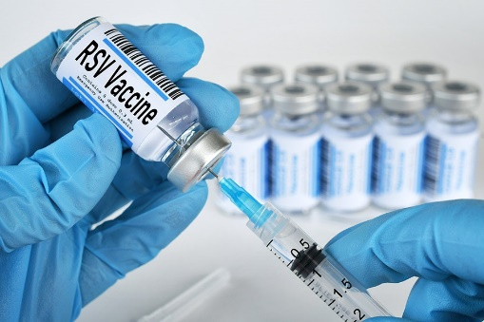  From 1 September 2024, those who turn 75 and those aged 75 to 79 will be eligible for a free single-dose vaccine to protect them from respiratory syncytial virus (RSV).  RSV is an infectious disease of the airways and lungs which often causes symptoms similar to a cold, including:  - cough  - sore throat  - sneezing  - a runny or blocked nose  RSV can be more severe in people with medical conditions such as heart or lung disease or a weakened immune system.  In clinical studies, the RSV vaccine provided good protection for at least 2 years and is expected to last longer.  Please click here to find out more about this vaccine and how it will protect you.  All eligible patients have been invited via email, but contact us if you think you are eligible and have not received the invitation.
Car-parking | We are fortunate to have a patient car park. However, we do share this facility with other healthcare providers based in the same building as us. We understand that it can be frustrating when there is no parking readily available when our patients need to visit us. We remain vigilant when it comes to non-patients using the car park - they are given a written warning, and their cars will be clamped if they reoffend.

