MSK Physiotherapy Services - Patient Self Referral Form

Please read this form carefully and answer ALL of the questions as clearly as you can.
Failure to complete the form adequately may result in it being returned to you.
Please be aware that this self referral option is NOT available for:
- minors (under 16)
- neurological or respiratory conditions requiring physiotherapy
- patients with complex or multiple conditions

Please note if your GP has referred you for Physiotherapy already, then you do not need to complete this form as well - we will contact you to book your appointment.

Name
Address
Date of birth
GP Name and Address
Contact Numbers | Home: | Mobile: | Work:
Can we leave message? | Yes No | Yes No | Yes No

Do you need an interpreter? | Yes No | Which language?

Where did you hear about service?

* Please answer the following questions:
Since your problem started do you have any numbness of the saddle area?  (Including genital area) | Yes* No
Since your problem started have you noticed a recent change in bladder function or control? | Yes* No
Since your problem started have you noticed a recent change in bowel function or control? | Yes* No
Did your problem start because of a major trauma – road accident or fall from height?  If yes: Did you attend A&E / GP? | Yes* No  A&E GP No
Since your problem started have you any weakness / pins and needles / loss of sensation / change in sensation in both of your arms or legs? | Yes* No  * If yes, please give details:

If you have answered ‘Yes*’ to any questions in the section above* and have not seen your GP then please contact your GP immediately

If you have answered ‘No’ to the questions in the section above* please turn over and complete page 2

Name |  | Date of birth

When did your problem start?

Please mark the symptoms (pain, pins and needles, numbness etc) on the chart below and then describe your problem for which you are seeking physiotherapy :
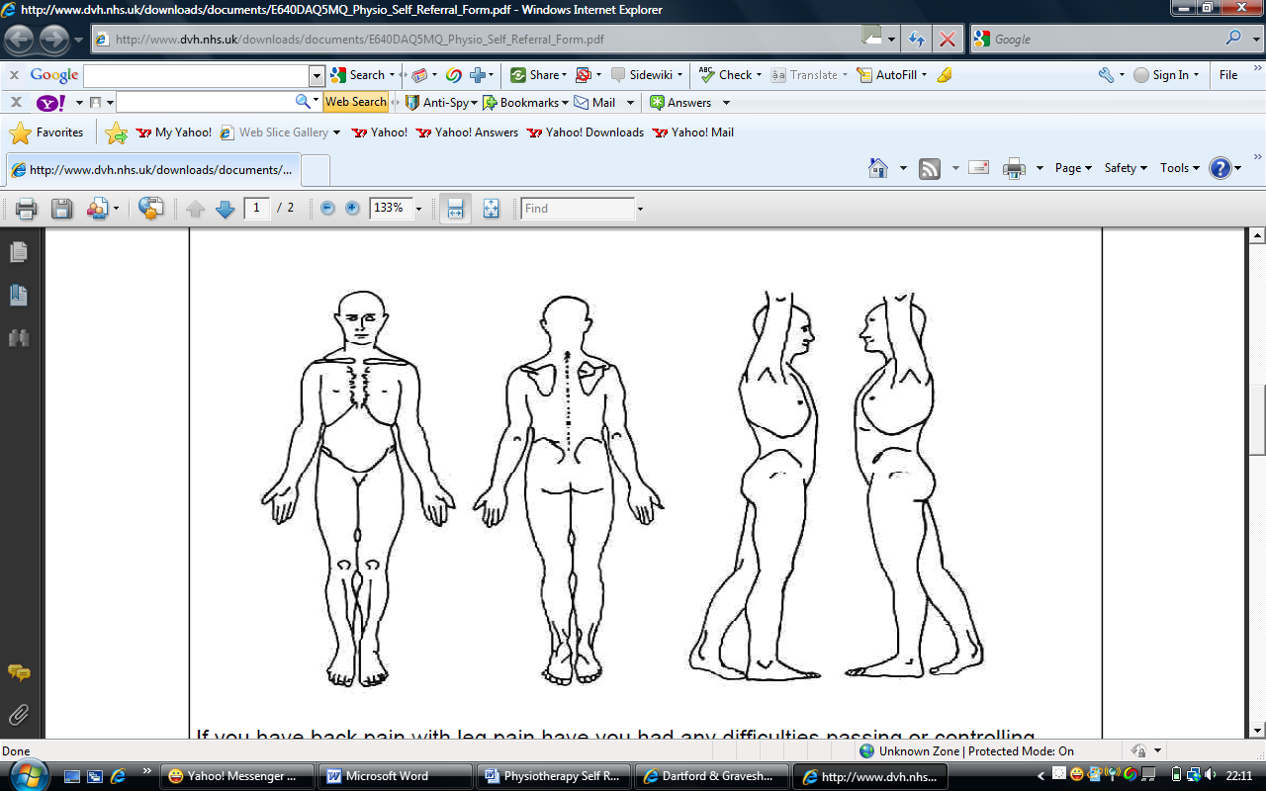
Description of problem / symptoms:

Is your condition making you struggle to care for yourself or any dependants? | Yes No | If yes, please give details:

Do you work? | Yes No Retired Self Employed
If yes, are you signed off or off work with this condition? Yes No

If yes, please give dates: From ………………..… to …………………….

General Health
Do you have any other medical conditions? (Heart condition, asthma, high blood pressure, diabetes etc):

Signed Date
Please return the completed form to - Patient Contact Centre, Room F20 / F21, First Floor,
Highfield Clinical Care Centre, Cliftonville Road, Northampton, NN1 5BU
Telephone number: 0330 555 6789

