Newsletter

Green Valleys Health
Abbotswood, Emersons Green and Leap Valley surgeries

Winter 2023

What is Happening over the next 3 months: -
You may get an opportunity to attend an “Asthma Group Clinic”, if a group session is suitable for you – no action needed, we will contact you with an invite.
Patients will gain a greater knowledge of their condition and support of how to self-manage it.
What is Happening over the next 3 months: -

Check in Machines will be back in operation in both our Leap Valley & Emerson’s Green surgeries. This will enable you to self-check in for a booked appointment rather than having to queue.

What is Happening over the next 3 months: -

Push Doctor is a facility that allows the patient to obtain a link from the surgery & book in a “video consultation” with a GP. This GP is currently not in-house. Moving forward this service will be offered in-house thus giving all our patients more continuity of care.
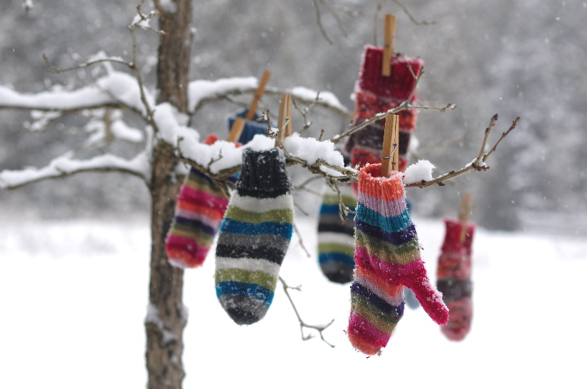

SAD (Seasonal Affective Disorder.
Seasonal Affective Disorder (SAD) is a type of depression that has a seasonal pattern, the episodes of depression tend to occur at the same time each year, usually during the winter months. As with other types of depression, two of the main symptoms of SAD are a low mood and lack of interest in life. You can also have low energy, have problems sleeping, crave carbohydrates, have difficulty concentrating and have thoughts of not wanting to live. To help control sadness you can write a journal, listen to music, or spend some time with friends/family. Symptoms can last between 4-5 months per year. You should not brush off that yearly feeling as simply a case of the “Winter Blues” that you must tough out on your own, take steps to keep your mood and motivation steady throughout the year. See your doctor if you can’t get motivated to do activities you normally enjoy.
Website: www.greenvalleyshealth.nhs.uk
Tel no: 0117 9576470
Facebook: Green Valleys Health
C
FLU UPDATE 2023.
Our Flu clinics, along with Flu & Covid for Abbotswood have been the best uptake we have ever had, with 400 patients eligible in our Abbotswood surgery and 300 taking up the offer to be vaccinated. We have also received such good feedback on how well the service was delivered. This year our housebound patients were under our control rather than the Primary Care Network, which allowed us to offer that extra care for these patients. To date 95% of housebound patients were all vaccinated before the end of October (amazing news). Great teamwork from the whole practice. If you have NOT had your Flu vaccination and you are over 65, please contact us to book in. Also eligible are patients aged 18-64 in clinical at risk groups, household contacts of Immunocompromised individuals, carers, pregnant women & children aged 2-3.

7 Cost Effective ways to stay warm this winter :-

Layer Up – Wear lots of layers.
Keep draughts out & heat in.
Be clever with heating.
Make warm food & drinks.
Get moving – move at least once per hour.
Check what support you can get.
Look out for others, elderly friends & neighbours.

Cold temperatures can increase the risk of Heart Attack & Strokes as well as respiratory diseases. Take some simple steps to help protect your health.

If you are worried about someone, contact your local council or ring AGE UK helpline on 0800 00 99 66.

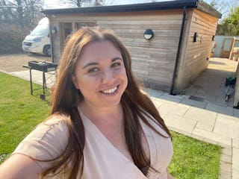
MEET THE TEAM
We are excited to announce that Aimee Hemmati (registered nurse) has been appointed as one of the leads for “Early Cancer Diagnosis”. Aimee has previously worked in oncology as a lung cancer specialist nurse and currently runs nurse led cancer clinics at Green Valleys Health, working closely with our Care Co-Ordinators team to support our patients. Aimee will be looking to improve patient uptake in screenings and opportunistic assessments, as well as sharing best practice across all Network practices.
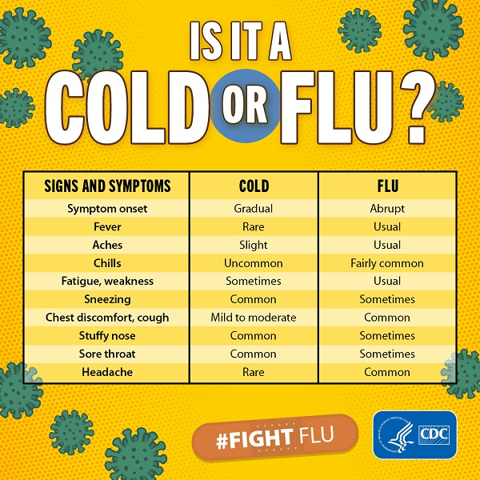

Website: www.greenvalleyshealth.nhs.uk
Tel no: 0117 9576470
Facebook: Green Valleys Health

