Newsletter

Green Valleys Health
Abbotswood, Emersons Green and Leap Valley surgeries

Winter 2024

New Appointment Booking System – Starts 6th Jan 2025
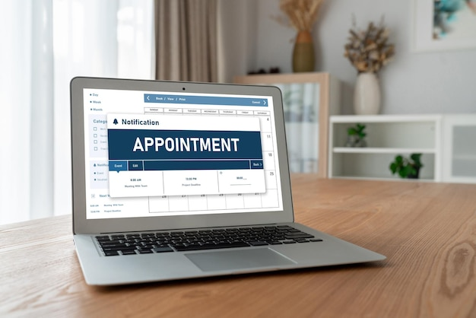
New Triage Appointment System
You said……
Following feedback from both our patients and our Patient Participation Group you wanted a more streamlined and clinical triage process.
We did…….
Whilst our Care Navigators follow a Protocol laid down by our Clinicians, we have listened to your concerns and from 6 January 2025 we will be introducing a new triage appointment system via an eConsultation form.
The new process:
Access to the surgery will not change, you can continue to contact us in person, telephone or online.
An eConsultation form will be completed in the best way that suits the patient, this can be at home through our website, or by attending the surgery or telephoning and speaking to our Care Navigators, who will complete the form on your behalf.

All nurse appointments will continue to be booked in the normal way either by telephone, or face-face this covers blood tests, wounds, injections, diabetes, child immunisations etc. If unsure, please speak with a member of our Care Navigators.

Our triage team will be led by Clinicians, with assistance from our Care Navigators. Your completed form will be passed to the clinical team for triage, the team will then contact you either via text message or telephone call advising you of the date and time of your appointment.

The benefits to you:
- You will get directed to the best source for your care, the first time.
- This will help with continuity of care.
- You feel more reassured if a clinician is listening to your initial request.
- You can ring to request an appointment anytime during our opening hours.
- Queues in the Reception area and on the telephone may reduce as patients get used to the new process.
- Our routine appointments will no longer be released on a Wednesday & Thursday, these will be allocated daily by our triage team.
Important Update:
- From the 7th – 20th December 2024 the surgery will be offering more routine appointments.
- From 20th December – 5th January 2025 all clinics will be urgent appointments only.
- 6th January 2025 our new appointment triage system will GO LIVE.

oijoi


Merry Christmas & a Happy New Year from Green Valleys Health.

Emersons Green Surgery Update
You will be aware that our Emersons Green surgery is temporarily closed. We would like to reiterate that this is NOT a permanent decision.
The temporary closure is due to the surgery having no heating or hot water.
Due to no hot water, we would be open against Infection Control Guidelines laid down by NHSE (National Health Service England) and against CQC (Care Quality Commission) regulations and therefore this decision has had to be made.
As we rent the property, the replacement needs to be of a commercial design, it is neither a quick job nor is it a cheap job. The work involves replacement hot water, two new boilers and ancillary works to accommodate a new system.
We are in negotiations with both the Landlord, NHS properties and our local commissioning body to see if we can secure the necessary funding and implement a suitable way forward.
We will send a further update as and when this becomes available and would like to emphasise that all services remain the same and will run from our Leap Valley site.
Please continue to contact us via telephone 0117 9576470, in person or via E-Consultation.
We apologise for any inconvenience caused.
Our staff are always happy to assist with any queries/questions that you may have.
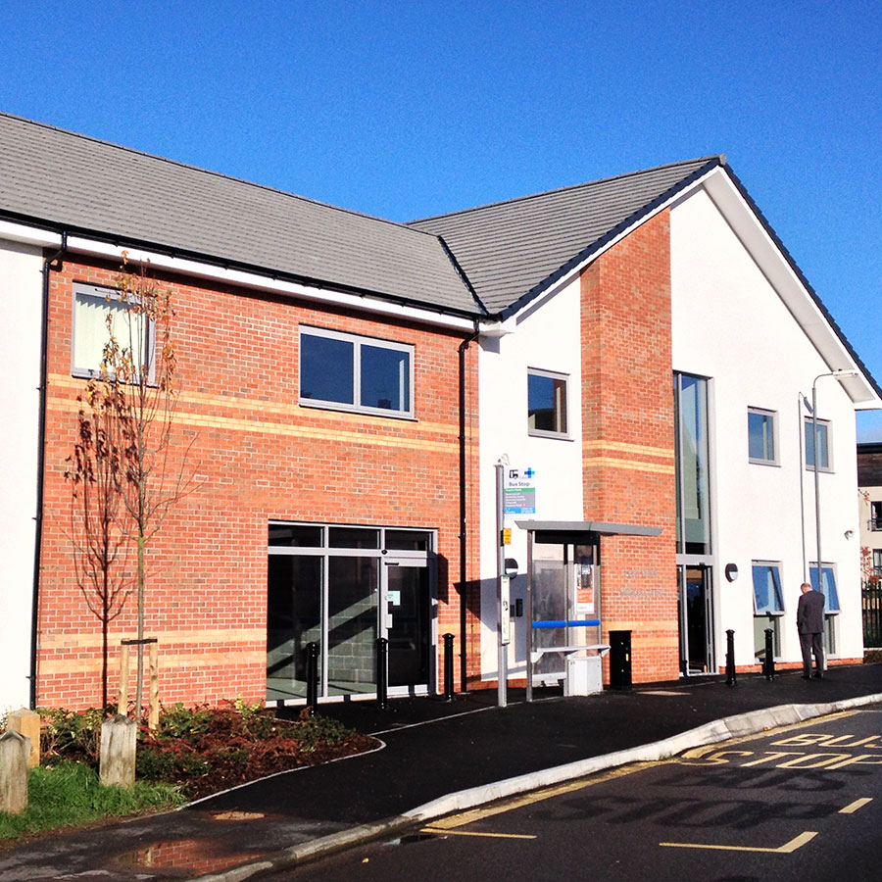
Diabetes Open Day
Saturday 28th September 2024
Back in May 2024 the surgery started thinking of putting together a plan to host an open day. We considered what the value would be of delivering group assessments as well as what support and resources we would need. The whole event took approximately 3 months to organise, the topic was agreed with clinical input, we then started to put a plan together on how to run the day. We started by searching our patient population to identify the number of patients that were either pre-diabetic, diabetic or had not been into the surgery for some time. Invites were sent. We arranged guest speakers these were “Age UK”, a “Nutritionist” and a “Foot Specialist”. Refreshments, tea, coffee and fruit were also made available.
We arranged numbers of staff to support on the day which ranged from GP’s, Nurse Practitioners, Health Care Assistants, Team Leads & staff from other departments. As well as four members of our Patient Participation Group, which were a great support on the day acting as marshals and directing patients where to go.
We endeavoured to get as many blood tests done before the 28th September 2024 as this gave us an opportunity on the day to review these with the patient.
On the day, patients were able to get their blood pressure done, height, weight, blood test, foot check and if it was deemed necessary have a face-face appointment with the GP. We also offered a “Fibroscan” which is to check a patient’s liver and also offered appointments if required for Asthma and Heart Failure.
The whole day was extremely successful, not without some learning points for when we do the next one in the new year.

Website: www.greenvalleyshealth.nhs.uk
Tel no: 0117 9576470
Facebook: Green Valleys Health

