
Marazion Surgery

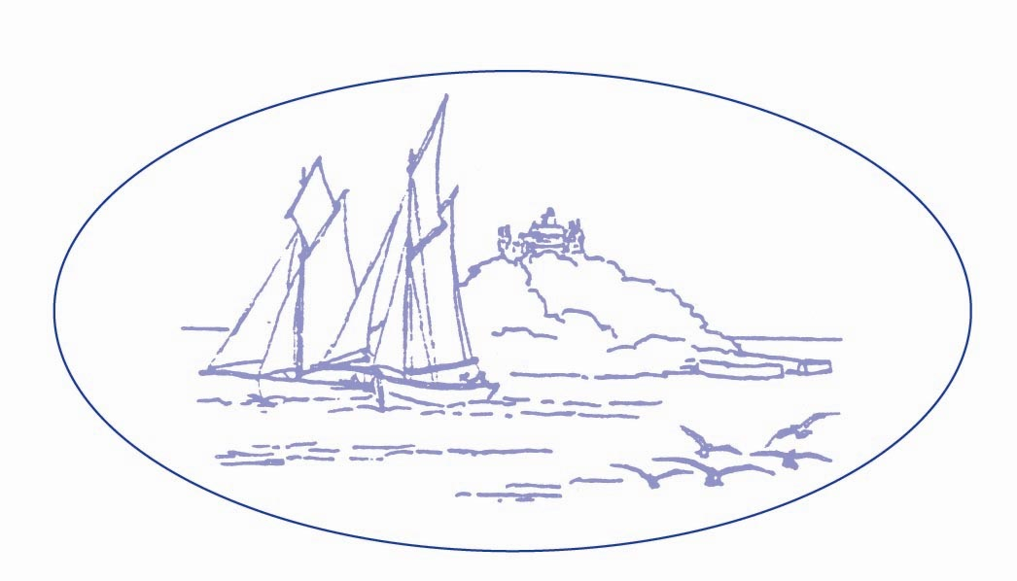
Gwallon Lane, Marazion, Cornwall, TR17 0HW
Telephone: 01736 710505
Website: www.marazionsurgery.com

MINOR OP LEAFLET

This is a lengthy appointment with both the doctor and the nurse, so it is important that you attend, or let us know that you are not able to attend so that we can offer this appointment to another patient.

Please contact the surgery as soon as possible on 01736 710505 and press option 1 to confirm that you will be attending this appointment. If you are unable to attend, please let us know so that we can offer this appointment to another patient and rearrange it for you.

Please read the information below.

You have been referred by your GP to undergo a minor surgical procedure. This may involve the removal of a skin or deeper lesion or cyst. Occasionally a nail procedure is undertaken or abscess drained. The GP Surgeon will discuss the nature of the procedure, options and associated risks and benefits beforehand. To remove a skin lesion requires a cut to the skin and subsequent wound, which then has to heal, leaving a faint scar.

You will also be informed of postoperative wound and if required stitch and dressing care. If stitches are used you will be asked to make an appointment with your Practice Nurse at the appropriate time to have them removed. Please be aware that sometimes we use dissolvable stitches that do not require removal, but we cannot use them all the time. Where deeper stitches are used, they are usually dissolvable but they lie under the wound and so are not visible.

Any bleeding is usually stopped with a cautery machine (diathermy). This can make a hissing sound and release a burning smell.
Most procedures involve an anaesthetic to make the skin numb, which is either injected or occasionally sprayed. The anaesthetic may sting initially but the skin will then go numb. You may be able to feel a pulling sensation at times but you should not feel pain. The anaesthetic will be tested before the procedure starts.
Occasionally a skin lesion cannot be treated here and you will then be referred onward to see either a Surgeon or skin specialist (Dermatologist) at the hospital. You will be fully counselled if this applies to you.
If you are having an operation on your hand, please could you remove any rings or other jewellery from that hand and wrist.

Please inform the GP Surgeon if you:

- Are taking any medication especially those to thin your blood e.g. Aspirin, Clopidogrel, Dipyridamole or Warfarin. If you are on Warfarin please arrange to have your INR checked two days prior to your minor operation appointment.
- Have any known allergies especially to anaesthetics
- Have a pacemaker or similar implanted device
- Have any metalwork or joint replacements
- Have problems with lying flat for up to thirty minutes
- Have problems with wound healing or suffer with any medical conditions that may affect the wound e.g. Diabetes or Rheumatoid Arthritis

After minor surgery you may have a dressing over the wound. Please keep the dressing clean and dry for 2 days after which time it can be changed. You can buy a waterproof dressing from any Pharmacy, which will then allow you to shower more easily e.g. Mepore Ultra. Please avoid soaking the dressing in the bath as this may delay healing. Occasionally an artificial skin spray is used to cover the wound.
You should not drive immediately afterwards. The vast majority of people have no problems after minor surgery.

The following may occur after any operation:
- Pain / discomfort
Take some paracetamol, ibuprofen or co-codamol unless you are allergic or have problems with this medication. Please avoid aspirin.
- Bleeding
It is normal for a small amount of bleeding to occur immediately after minor surgery. If there is excessive bleeding please apply firm pressure through a folded towel directly to the wound for 15 minutes. If the bleeding persists contact your GP, the Out of Hours Service (through your normal GP practice’s number) or the Casualty Department as appropriate.
- Infection
If you have any worsening swelling and redness after the operation or green / yellow discharge then you may have an infection. Please contact your GP, the Out of Hours Service (through your normal GP practice’s number) or the Casualty Department as appropriate. You do not always require antibiotics for a mild infection.
- Scar
Some people heal with built up or painful scars. These are called hypertrophic or keloid scars. If this occurs please contact your GP who will advise on further treatment. Try to be careful for 4 weeks after surgery as even a minor injury to the wound site may cause it to open up. If this occurs please contact your GP or Practice Nurse.

Most skin lesions that are removed are then sent to the hospital for analysis (histology). Your GP will be informed of the procedure, histology result and if any further treatment is necessary after 4 weeks.

Occasionally other techniques are used to remove a skin lesion:
- Curettage
The removal of a lesion by scraping with a sharp surgical instrument
- Shave excision
The removal of a lesion so that it lies flat to the surrounding skin
- Cryotherapy
The destruction of tissue by cold. The initial treatment can sting or burn a little. The area then becomes red and can swell. A water or blood blister can form after a few days. This can be released with a sterile needle by your Practice Nurse after which an antiseptic cream should be applied twice daily.

