

Marazion Surgery
Patient Participation Group

Minutes of the PPG Meeting on 22nd March 2023

1. Minutes of Previous Meeting:

The Minutes of the previous meeting on 22nd February 2023 were agreed to be a true record.

2. Presentation: Who works at Marazion Surgery? How can patients access services?

The group found the presentation by Mrs Benstead interesting and informative, and felt that sharing this with the wider community would be helpful. It would be attached to the Minutes.

3. Spring Raffle:

The necessary license had been obtained. Some prizes had been obtained but the group were encouraged to source more. A display had been put up by reception.

The raffle tickets were available to sell and being sold by reception and dispensary. They were offered to the group to sell to family and friends. The group were invited to come into the surgery at any time to sell tickets in the waiting room. There was a Covid vaccination clinic on Saturday 29th April and members were invited to come and sell tickets that day.

A small group were invited to help with the drawing of the raffle and contacting winners, late afternoon on Wednesday 31st May. An email would be sent nearer the time to remind volunteers.

4. Information Workshop:

The posters for the Dementia evening in November 2019 and the Carers evening in February 2020 were circulated, to show examples of what the group had put on previously. These were both well-attended.

The suggestion for a workshop on mental health had been put to the partners. They felt that mental health was a wide umbrella for many topics. Dr Herdman offered to do a workshop on sleep and how sleep could affect people of all ages, in terms of mental health, anxiety and general health. There was a new service called Sleep Station, that he could talk to patients about. It was agreed that this sounded very interesting. Dr Herdman would be asked to propose a date for this, perhaps in late June.

Juliette was aware of a project being done at another local surgery regarding diabetes. She offered to contact the person leading this to see if they may be able to offer an evening talk, as a topic for a future information workshop. The group felt that this would be interesting to many patients in the community and asked her to find out more about this.

5. Practical Support:

As mentioned previously, the surgery was offering spring boosters for Covid to patients over the age of 75 years, the immunosuppressed, and patients over 65 in nursing homes. Eligible patients would be contacted by text message, and this would be advertised shortly.

Mid-week clinics and a large clinic on Saturday 29th April were planned. The group were invited to help with car parking and selling raffle tickets on 29th April, and to sell raffle tickets at any time mid-week at their convenience (contact Juliette to let her know if you can do this).

If anyone were interested in doing some gardening this would also be welcomed.

6. Being Inclusive:

The group had been spreading the word about the PPG with a view to attracting new members, especially of younger age groups. An Instagram presence had not yet been set up.

7. Terms of Reference:

The terms of reference had been circulated with the agenda and would be attached to the Minutes. Although not discussed, no objections were raised. If any of the group had any concerns, please could they raise these at the next meeting.

8. Date of next meeting:

A couple of members had asked if meetings could be held on a different night of the week; recent meetings had been on Wednesdays.

It was agreed to hold the next meeting in May. Days/dates would be circulated nearer the time, and members were asked to let Juliette know which they could attend, so that the most convenient date for the majority could be confirmed. At this meeting, the arrangements for the information workshop, hoped to be held in June, would be finalised.

Action List:

Raffle prizes | Everyone
Sell raffle tickets (drop stubs and money into surgery once sold!) | Everyone
Sell raffle tickets at the surgery mid-week and/or on 29th April at the covid clinic | Everyone
Confirm date for Sleep Studies Information Workshop with Dr Herdman | JCB
Find out more about a potential speaker for a Diabetes Information Workshop in the future | JCB
Defibrillator and first aid – linked with Marazion Town Council | Derek Laity
Promote PPG membership in community | Everyone
Consider Instagram presence | JCB
Date of next meeting to be mid-May (day/date tbc) | JCB

Members of Staff

GP Partners:  Dr Suzanne Murphy  Dr Richard Robbins  Dr Jonathan Lock  Dr David Tinkler  Dr Paul Herdman  Retained GP:  Dr David Sugrue  Salaried GP:  Dr Rebecca Harling  Advanced Nurse Practitioner:  Mrs Tracey Brettell  Practice Manager:  Mrs Jackie Brown  Deputy Practice Manager:  Mrs Kathryn Burge  PA to the Management Team:  Mrs Juliette Benstead  Practice Nurses:  Mrs Chloe Gendall  Mrs Lucy Nicholls  Mrs Michelle Gerry  Assistant Practitioners:  Mrs Shirley Hatton  Health Care Assistant:  Mrs Hannah Nicholls  Miss Emily Fayer (on maternity leave)  Miss Ella Leiworthy  Miss Lisa George | Receptionists:  Miss Sophie Allum  Mrs Rachel Cripps  Ms Lindsay Gannon  Ms Sharon Knight  Miss Joanne Williams  Bella just about to start!  Advertising for another!  Dispensers:  Miss Tara Brownfield  – Dispensary Supervisor  Miss Faith Allen  Miss Lisa George  Mrs Catherine Mann  Miss Chloe Seviour  Mrs Jenny Symons  Mrs Donna Tomlinson  Delivery Driver:  Mr Colin Brodie  Administrators:  Miss Helen Greig – Bookkeeper  Mrs Ailsa Hammersley – Notes Summariser  Mrs Julie Holland – Notes Summariser  Mrs Nicola Noble – Data Clerk  Miss Katie Tebay – Medical Secretary  Attached Staff:  Dr Mark Battle – Consultant Geriatrician  Miss Tamasin Britten – Pharmacy Tech  Miss Angharad Jones – Clinical Pharmacist  Mrs Caroline Marchant –Social Prescriber  Mrs Gemma Rowland – First Contact Physio  Mrs Katie Spencer – Pharmacy Tech  Mrs Ruth Tod – Health & Wellbeing Coach

Marazion Surgery Vision Statement

To provide people registered with the practice and temporary residents with personal health care of high quality, efficient and safe standard. To seek continuous improvement on the health status of the practice population overall. To treat patients fairly, equally, and with dignity and respect. To listen, communicate and collaborate with patients effectively.

We aim to achieve this by developing and maintaining a happy sound practice which is responsive to peoples’ needs and expectations, and which reflects the latest advances in Primary Health Care.

Catchment Area
We cover a wide area in West Cornwall from Heamoor and Penzance in the West, to the outskirts of Hayle in the North, to Breage in the East and St Michael's Mount in the South, including the villages of Long Rock, Crowlas, Ludgvan, Canonstown, St Erth, Goldsithney, Marazion, Praa Sands, Townsend and Breage.
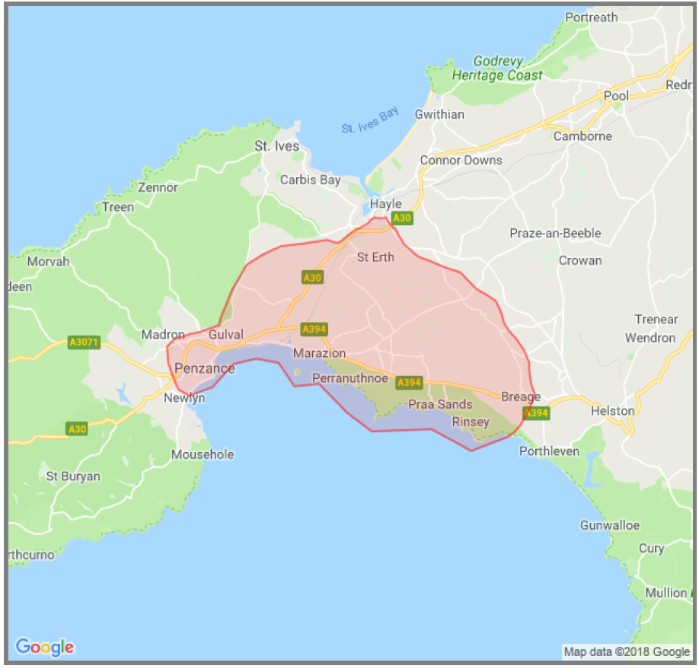

DOCTORS

The team consists of five GP Partners, one retained GP, one Salaried GP and an Advanced Nurse Practitioner. Dr Sugrue and Dr Harling do a similar workload to a partner; however they are not involved with the running of the practice. Dr Harling starts officially with us on 1st April but has been working here for the last couple of months as a locum. Tracey Brettell is an Advanced Nurse Practitioner, who does similar work to a GP and can prescribe treatment.

There are four working each day. When someone is absent from work, either due to leave, sickness or meetings, locum cover is arranged to ensure there is a minimum of four on a Monday or three on other days. We have a few locums that we use regularly and therefore know our staff, our patients, and our systems, which is helpful.

REGISTRAR & MEDICAL STUDENTS:
Our Registrar, Dr Ranjan Ranabhat, joins us for the next year. We currently have year two medical students and year four medical students for set weeks of the year; we are hoping to increase this to year two, year four and year five students with the next academic year. Being involved with training is enjoyed by the team and is very positive when looking to future employment and succession planning.
NURSES:
Chloe is our Lead Practice Nurse. She offers minor illness consultations for patients aged over 12 years, such as for skin infections, skin conditions, eczema, burns, earache, hayfever and allergies, minor cuts, insect bites and stings, and conjunctivitis.

The nursing team offer a wide variety of consultations, including dressings and blood tests, through to the management of chronic disease and checks associated with these. It is important for the correct procedure to be booked with the correct person and for the correct length of time. Ella is currently covering the maternity leave of Emily, who had a baby girl earlier this month.

ATTACHED STAFF:

We have various attached roles who work with us regularly. These roles are usually shared between different practices in the Penwith area. Our Physio is here on Mondays and Fridays and Dr Battle does a clinic every other week at the surgery. Ruth and Caroline are the ones that patients are most likely to have contact with and will accept referrals through any member of staff; more information on what they can offer is attached. The pharmacy team may contact patients to review medication and also help undertake prescribing audits.

MANAGEMENT:

Jackie Brown is due to stand down from being Practice Manager and Mrs Kathryn Burge who is currently Deputy Practice Manager will take on this role. Jackie will continue at the Practice to work on a project to streamline and make the dispensary more efficient, before retiring probably at the end of the year. I am their PA.

ADMIN:

You probably have little contact with the ‘upstairs’ team. The secretary Katie deals with all the patient-related referrals and correspondence. Nicola deals with the inputting of data, submissions of data within the NHS and manages the patients recalls for chronic disease to make sure everyone is called in and attends. The notes summarisers, Ailsa and Julie, check all incoming correspondence and ensure that details are Read coded into the records.

DISPENSARY:

Dispensary work closely with the doctors, nurses and pharmacists to ensure all enquiries regarding medications are dealt with efficiently. Dispensed medications are usually ready to collect three working days after being requested, though the recent disruption to the medicines delivery service has caused them some headaches.

Dispensary has a telephone line open at certain times of the day. Using this for appropriate enquiries would be helpful as this is a limited resource. Patients can be sent text messages when their prescriptions are ready; rather than them ringing to ask if they are ready which takes up valuable time.
Sainsbury’s pharmacy is due to close on 22nd April. Patients are being reminded to nominate a different pharmacy, but patients who can have their medication here are choosing to do so. There are government guidelines on who can be dispensed to at the surgery and these are beyond our control. These are quite complicated, but generally if you live within a mile as a crow flies of a chemist we are not allowed to dispense for you, or if you move doctors but not address, and you were previously non-dispensing, you will remain non-dispensing. (For example You live in Goldsithney, but are registered with a surgery in Penzance and get your prescriptions from a chemist. You decide to register with us and although Goldsithney is more than a mile from a chemist, we are not allowed to dispense for you as you previously went to a chemist.)

RECEPTION:

Reception have had some changes of staff recently, as one has left to go travelling and the other due to family commitments. We have a new member of staff starting shortly and interviews for another are ongoing at present. We had four staff off sick with covid last week, so some of you may have seen Kathryn and I in reception!

Our receptionists are trained Patient Advisors, they work to guidelines given to them by the partners. Calls are dealt with quickly and efficiently, especially first thing in the morning when lines are busy. Patients are asked to ring after 1100am for routine appointments. Giving out test results is done in the afternoons, as lines are quieter and staff have more time to look these up. If you want to pass a message to the doctor, sending a letter or email may be a much more efficient means of communication.

The Patient Advisors ask for information regarding the reason for your call to ensure that the details are passed to the most appropriate person in the team. They will also help you to assess if a telephone call or face-to-face appointment is most appropriate if you are booked with the doctor. The clinician can also review the information to assess the urgency and prioritise their workload. You can request a doctor of your choice, but sometimes that person may not be available. We also advise patients who have a list of problems, to prioritise those and ask about the most worrying as appointments are time limited.

DOCTORS:

There are four working each day, not including our GP Registrar. When someone is absent from work, either due to leave, sickness or meetings, locum cover is arranged to ensure there is a minimum of four on a Monday or three on other days. We have a few GP locums that we use regularly and they know our staff, our patients and our systems, which is helpful.
We offer appointments in the morning starting 7.30am, currently on Fridays. We offer evening appointments on Tuesday and Wednesday evenings alternate weeks. We also offer a Saturday clinic every four weeks.
Each day we have a ‘duty doctor’. This doctor is on-call for emergencies for the Practice. He/she will respond to requests for home visits and any enquiry that is felt to be medically urgent to be dealt with that day. This ideally prevents other clinicians from being interrupted in their booked clinics and avoid causing them to be delayed.

The other doctors have a combination of appointments that can be booked on the day, and some that can be booked up to two weeks in advance. The number of these is predetermined when calculating the amount required for that day/week. The appointments that are prebookable are released for booking at 8.00am, two weeks beforehand; every day there are prebookable appointments released for patients to book.

At the moment demand for appointments is high, so appointments in two weeks time are usually booked within a few hours of being released. We cannot increase the number of appointments that can be prebooked without reducing the number that leaves us to offer patients who ring on the day. This balancing act is difficult and has been for many years - doctors cannot see more than one patient at a time and there is a limit to what workload they can manage. There are huge pressures on the NHS as a whole, as I am sure you will be aware from recent news coverage.

ONLINE ACCESS:

We recommend that patients download the NHS App. Many patients are signed up to ‘Patient Access’ but this is not as efficient and is likely to be superseded by the NHS App in due course.

Currently patients can use these to book appointments with a doctor. The prebookable appointments that we have spoken about are released to book online two weeks in advance, the same as if you rang the surgery. You can also book appointments for blood tests, blood pressure and INR monitoring online.

If you have a medical enquiry, you can submit an online consultation
request through the link on the homepage of our website (scroll down
and look for a blue box, which I have copied here).

If you have an administrative enquiry that is not urgent, you can email the surgery at enquries.marazionsurgery@nhs.net This mailbox is not monitored daily, so is not appropriate for medical enquiries.

Patients who are due a particular check-up, such as a cervical smear, are being sent a text message that contains a link that allows them to book appointments in predetermined clinics. This is convenient for patients and means less incoming phone calls to reception. Patients have to have given consent for text messaging for this to be used. We have also been using this for booking covid vaccine appointments, but some of the elderly do struggle with this!

We are planning to increase the online booking facility, hopefully in early May.
We are considering making some of the ‘on the day’ doctor appointments visible to book online that day, so that patients can book online or contact the surgery on the day they want to be seen. This will help reduce the number of calls trying to get through at 8.00am.
We are also hoping to increase the facility to book nurse appointment online, however this is likely to be for specific things, such as shingles vaccines, as we need to ensure they are with the correctly trained person and for the correct length of time. There is the potential for a patient to book for a procedure that takes 30minutes with the nurse, into a blood test appointment with the phlebotomist, if it is not clearly set out!

I hope this brief outline has been helpful – and not too long.

22.03.23
Marazion Surgery
Patient Participation Group

Terms of Reference of the Patient Participation Group

Title of the Group:

- The Group shall be called Marazion Surgery Patient Participation Group (hereinafter referred to as ‘the Group’).

Purpose of the Group:

- The purpose of the Group is to give a voice to patients of Marazion Surgery and to promote co-operation between the Practice and patients to the mutual benefit of both.

- The Group will enable, where appropriate, patients to influence local health care services.

Membership of the Group:

- Membership of the Group shall be open and free to all registered patients and staff of the Practice.

- Members must agree to the Terms of Reference.

- If a member is unable to attend a meeting, they should offer their apologies ahead of the meeting so that a quorum of at least five persons in attendance can be ensured.

- If a member is disruptive or uncooperative within the Group, their membership may be terminated by the Chairperson after consultation with the Group.

- Administrative support for the Group will be provided by the Practice.

- Mrs Benstead, PA to the Management Team at the Practice, will provide a link between the Group and the Practice.

Objectives of the Group:

- Provide feedback about Practice services and make suggestions on how patients’ experiences can be improved.

- Promote health and wellbeing information to patients.

- Review patient feedback annually following patient survey.

- Contribute to Practice decision-making and act as a forum for consultation on service development and provision.

- Represent patients at the Practice in seeking to influence local provision of health and social care.

- Support the Practice in its dealings with other bodies.

- Fundraise for Practice, such as for new or replacement equipment.

- Offer practical support (For example, helping direct parking during vaccination clinics).

Meetings of the Group:

- At least four weeks notice of the date of meetings will be provided. At each meeting the date for the next meeting will usually be agreed.

- The Agenda and related documents will be circulated by Email at least one week prior to the meeting.

- Meetings will be held at intervals determined by the group. Working party groups may meet separately and report back.

- Notices of meetings, Minutes of meetings and information about the Group will be displayed on the noticeboard in the Practice and on the Practice website.

- Members will agree to treat items discussed as confidential as appropriate.

- A quorum of three would be required to conduct the business of the group. Contentious issues or proposals could be circulated to all members of the group by email so that all would have opportunity to voice their opinion.

- Ground rules of the Group will be adhered to:

- The group is not a forum for individual complaints and single-issue concerns.
- We advocate open and honest communication and respectable challenge between individuals.
- We will be flexible, listen, ask for help and support each other.
- We will demonstrate a commitment to delivering results, as a group.
- Silence indicates agreement – speak up, but always go through the Chair.
- All respectable views are valid and will be listened to.
- Offensive and discriminatory language will not be tolerated.
- No phones or other disruptions.
- We aim to start and finish on time and stick to the Agenda.

February 2023

