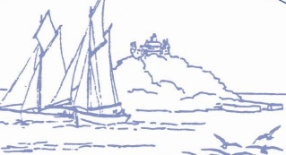
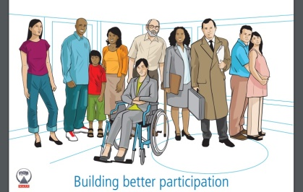
Marazion Surgery
Patient Participation Group

Minutes of the PPG Meeting on 24th May 2024

1. Minutes of Previous Meeting:

The Minutes of the previous meeting were agreed to be a true record.

2. Matters Arising:

2.1 Safe Places Scheme:

The Practice had still not heard back from the local office.

2.2 Grand Spring Raffle:

The raffle was being drawn that day!

Addendum: The raffle raised an amazing £548.00 (640 tickets were sold, the lottery licence cost £20 and the ticket printing £72).

2.3 Papyrus – Suicide Prevention Presentation:

There had been a disappointing attendance, though it was noted that those who attended found it very interesting.

2.4 Fundraising – New Chairs:

The new chairs and reupholstered chair looked great and enhanced waiting facilities.

2.5 Covid Spring Boosters:

There were a small number of catch-up sessions each week. Anyone who still wanted a vaccine should contact the surgery. The car park volunteers were thanked for their time and support.

2.6 What Next?

It was suggested that the PPG could do an event on menopause.

3. General Practice Improvement Plan:

The Practice had just begun this project, working with an external facilitator to review processes, systems, and workload. This was a national scheme looking at ensuring that primary care was sustainable for the future, given the increasing workload and demand on the already stretched NHS.

The first meetings had been earlier that week and had already prompted some lively debate and challenged whether things were done that way because they always had been historically, or whether there was a more efficient way of working perhaps using new technology.

One of the initial outcomes was to identify the pressures on reception and the fact that they often came into work much earlier than they were supposed to, due to the amount of incoming emails, paperwork and telephone calls. A proposal to help manage this was discussed and supported by the PPG. A draft notice to patients that could be sent out by email, text, website, and social media was discussed. The Practice was not yet ready to share this with the public, but it was extremely helpful to obtain the support of the PPG.

Please watch the website for more information.

The Practice was keen to seek PPG feedback throughout this process and the PPG were very keen to be involved, seeing the benefit to both the practice and the patients.

4. Date of Next Meeting:

Juliette would email the PPG throughout the GPIP process, for feedback from the patients’ perspective. Everyone was asked to respond, by email, with their thoughts in order to feed into this process.

September - TBC – date of next formal meeting

Action List:

Safe Places scheme signage to be reinstated on front door | Juliette/Suzanne
GPIP – General Practice Improvement Plan – Being a critical friend and responding to emails throughout the project. | Everyone!
PPG – WHAT NEXT ?? | Everyone!
Date of next meeting to be confirmed | Juliette

