****************************

February Newsletter

****************************

for the patients of The Roseland Surgeries
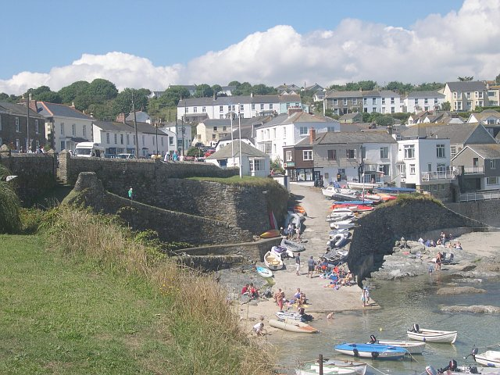

A huge thank you!
We were overwhelmed with gifts from patients and their relatives just before Christmas. We would like to express our gratitude to you all and say a very big thank you. It really is very kind of our patients to think of us at this time.

Roseland Surgeries Patient Group
The next meeting of the group will be held on
Wed 15th February 3.30 pm in the meeting room of the Memorial Halll, Portscatho. All welcome!

Do you need blood taking for a hospital appointment?
Occasionally, prior to a hospital appointment, or as part of regular monitoring, patients are asked by their consultant to have bloods undertaken. We can do this at the surgery as this is much more convenient than having to travel over to Treliske. However, we can only do this IF the hospital team has put the information on the pathology platform (commonly known as ICE) prior to your appointment.

Once the request has been entered into ICE, and the blood is taken, a bar-coded label is generated. This not only has your personal identifying data on it (name, date of birth and NHS Number) but it also has the detail of the person requesting the sample. This means that once the sample has been taken, the result goes straight back to your consultant.

We can check the ICE platform when you book, so please do mention to the receptionist that the blood is being requested by the hospital – this will trigger a ‘back office’ process to double check the pathology platform. We don’t want you to have a wasted journey, but the nurse cannot take the blood without the request having been actioned first.

Defibrillator Awareness Sessions
The Roseland Surgeries Patient Group raised funds several years ago to provide defibrillators across the whole of the Roseland. They also continue to fund consumables for each defibrillator and ensure they remain in good working order. They have been used a number of times and have saved lives…… but, would you feel confident about using one in an emergency?

To that end, free defib awareness sessions were organised with the aim to increase confidence when faced with an emergency , use the recovery position, a defibrillator and effective CPR, or help a choking person. These were very successful and Kate and Gary Blake are happy to do more, if you can assemble at least 6 people and arrange a venue. Could you spare a couple of hours of your life to maybe save the whole of someone else’s? If you have any questions in the meantime, please contact kateeblake1958@gmail.com or 07989902292

Most of the defibrillators are at least 10 years old and will need replacing over the next few months or so. To that end, we are asking for donations to help with the cost of replacing these vital bits of kit (an article is in the Feb edition of the Roseland Magazine with more detail) If you can spare anything, please make your donation to the RSPG – their bank details:-
Sort code 20-87-94, Account 63179419
Very many thanks for your support.

Warmth Hubs
Warmth hubs are open to everyone across the Roseland this winter (until the end of March 2023), offering a warm, friendly space with free refreshments. You might be feeling cold at home and would like to warm up and have a hot drink or you might just like some company. Please come along!

The warmth hubs are running on various days and times during the week at Tregony Bible Christian Church (opposite Londis) and at the RSPG cafes and activities. More details are available in the surgeries and on Roseland Online.

The Community Gateway
There is a new Community Gateway for anyone to access voluntary sector support. The phone line is open for help and information 7 days a week - 01872 266383.
More information can be found here:
Community Gateway - Cornwall Link (cornwall-link.co.uk)

Get help from our Digital Champions!
Do you need help to learn how use a new device you got for Christmas, do you want to video call your friends, to join online activities or support groups or just be able to send an email and save a photo? Do you want to be more digital but don't have a laptop or tablet to use?
Get in touch with our digital champions and get online now!
Contact Sophie Maziere through any of the surgeries to find out more.

Working towards a greener practice.
Do you know that the NHS is responsible for 4 - 5 % of the UK's carbon footprint? Roseland Surgeries is now a member of the Cornwall Greener Practice Network and we are working towards improving our sustainability and environmental impact. We are reviewing our practice with the aim of reducing our harmful impact on planetary health, the risks of climate change and the surgery expenses.

We will be providing updates through the newsletter of actions we are taking and how you, our patients, could also be involved with helping to make the practice ‘greener’.

Medication Delivery Service
We offer a free medication delivery service to our housebound patients. We’re trying to improve efficiencies and reduce our carbon footprint so we’re asking patients who use this service to help us…….

Firstly, if you know you’re due a delivery on a certain day, please be at home to accept receipt of your medication – the driver has to return it to the surgery if you’re not at home (and this means more charges to the surgery for fuel/driver time).
If you have to come to the surgery for an appointment and you know you’re due a delivery, please phone in advance and we can keep the medication at the surgery for you to save the driver a trip.

Secondly, please order all of your medication in one go, each time – this way all of your medication will come to you in one delivery.

We’re all trying to do our bit to save the environment and with fuel costs as they are, multiple trips to the same house can be costly. We know that sometimes we’ve got issues with our wholesaler supplies and so occasionally, we’ll have to do more than one visit in a month, but hopefully, this should be infrequent.

Please remember that although this delivery service is free to our patients, it is not free to the surgery – we have to pay the driver for his time and his fuel.

Do you have to pay for your prescriptions?
If you’re between the ages of 16 and 59, you will normally have to pay for your prescriptions. The current fee is £9.35 per item and this usually gets increased by the Dept of Health every April.
There are certain reasons why you may be exempt from paying:-

- 16-18 yr old and in full time education
- Maternity exemption
- Medical exemption (because you have a particular medical condition)
- An exemption issued by the MoD
- You hold an up to date HC2 certificate
- You’re claiming income support or income-based job seeker’s allowance
- You’re claiming tax/universal credits
- You have a pension credit guarantee certificate
- You have an up to date pre-payment certificate*

We may require you to provide evidence of your exemption from paying – so please carry your certificate with you at all times. If you cannot prove exemption, you will be asked to pay for each item dispensed. We can, however, provide you with a refund claim form and a receipt so that you can claim any fee paid back from the Prescription Pricing Authority (a division of the NHS Business Services authority).

The fine for falsely claiming that you have an exemption from paying for your medication can be up to £100.

*If you have two or more regular medications each month, and you have to pay for your medication, it is definitely worth paying for a pre-payment certificate. This can drastically reduce the total amount you pay out each year. In order to apply for a pre-payment certificate, please go to:
Prescription Prepayment Certificates (PPCs) | NHSBSA

Currently, a prepayment certificate for 3 months costs £30.25, (on 2 medicines a month, this is a saving of more than £115 a year) and for 12 months, the certificate costs £108.10. Applying online is the quickest way and you get an instant email certificate once you’ve paid.

Nicola Davies
Practice Manager

Dr. Will Hynds MA MB BChir MRCGP DRCOG DCH
Dr. Terese Tubman BMed MRCGP DipFFP
Dr Mark Stephen MB BCh BSc MRCGP DRCOG

