About to go Strimming? Beware

Each year we see cases of a condition called Phytophotodermatitis secondary to using garden strimmers.

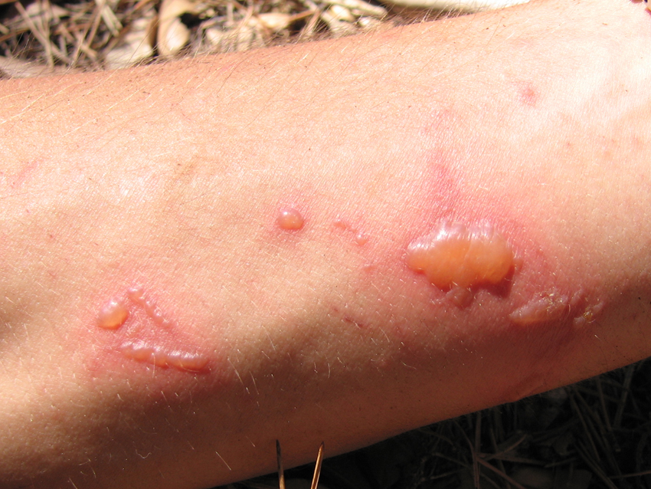

***Some plants contain agents in their sap which sensitizes the skin to UV light. As a result burning occurs after small amounts of exposure to sunlight…even through a cloudy sky!***

The commonest cause of exposure to the sap is getting splashes of it on to your skin whilst using a strimmer.

The best form of protection is to cover ***all*** your skin before starting. If you feel you have been splashed, stop and wash the area and then cover it to stop UV light getting to the area.