**Kingstone Newsletter July 2024**

**Flowers:** July is the month of flowers. Thank you so much to those who have brought us flowers for the front desk- it has brightened everyone’s lives. And our garden ‘wildflower meadow’ has been marvellous this year with goldfinches on the seed heads.

**Feedback**: Another thing to brighten our lives has been the National GP Patient surgery. Herefordshire ICS has does well compared to national baseline, and we have done very well within Herefordshire. You can all read is here: <https://www.gp-patient.co.uk>, and I have attached our best and worst bits with the comparison baselines.

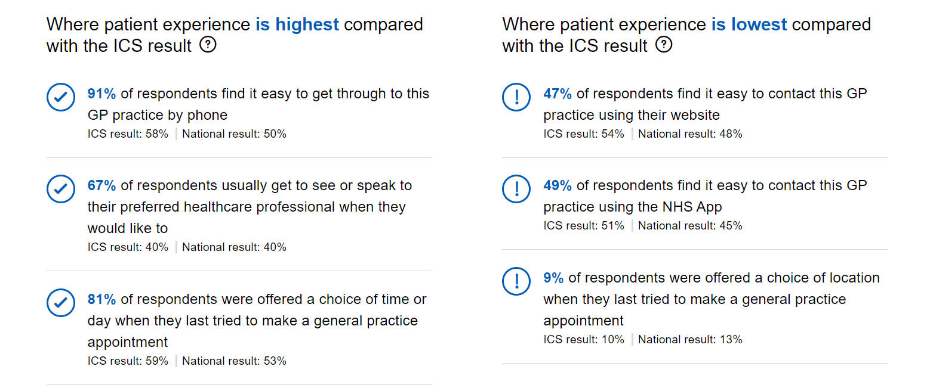

97% also said they found the reception and administrative team helpful.

The left hand column speaks for itself. On the right hand column, we are currently re-designing the website so you should find it easier to contact us via this. We would also LOVE you to use the NHS app more. Everyone has the facility to book a selection of appointments via the app, and order their prescriptions. If you wish to see all your medical record, then a GP partner needs to do a records review for safety reasons so there may be a wait after the request is submitted. As to choice of location- we have worked hard to get the majority of the extended access appointments to happen from Kingstone surgery, so we do not often have the opportunity to offer appointments in Hereford. I am not sure if this is a bad thing.

Remember, one of the reasons we can do well is because we have the dispensary which cross-funds our clinical service. We do ask all our patients to be aware of this, and choose the dispensary for the provision of your medications.

**Dispensary update:** Many people have told us they like getting the text messages to let us know their medication is ready. However we have had a spate of phone calls to the dispensary to check this- *even though a text message has been sent*. Every phone call takes a dispenser away from the bench, so please check your phones first for a text message to make sure your medication is ready to collect rather than calling. If you do not get a message please provide your mobile phone number and permission to contact next time you are in the surgery.

Dispensary lines close at 4pm. After this only urgent calls to the dispensary will be put through.

**Recall for chronic conditions:** Many conditions involve routine annual reviews (e asthma, COPD, Learning disabilities). We are moving slowly to a system whereby this is done in the MONTH OF YOUR BIRTH to try and make it clearer and more memorable for everyone.

**And Finally…**Dr Amar Rehal will sadly be coming to the end of her training stint with us. She will return for a year in August 2026. Please welcome our next GP trainee in August when you see him. He is new to Herefordshire and we are looking forward to showing off our glorious county.