**Kingtsone Surgery Newsletter September 2024**

I have gone for headings again this month as there is so much information to impart. Leading with the most important, ending with the most exciting…..

**Flu clinic**: It has come around already! All people >65 years and with ‘at risk’ conditions (eg diabetes/ COPD/ asthma/ heart conditions) are eligible and we DO recommend it. Usually we run this in September, but NHSE have asked for flu vaccines to be delivered in October this year. We are planning a weekend clinic on Sat 12/ Sun13th of October (weekend, so as not to disrupt usual service). We will be having small mop up clinics after this date, too. When clinics are finalised, we will be inviting people by text message in the first instance so please **inform us of your mobile phone number if you think we do not have it.**

Flu clinic funding cross-funds our other services so please book with us if possible. It is also a fun sociable day. We hope to be able to offer simultaneous COVID vaccines that weekend, too- although this does depend on their occasionally erratic delivery.

**More vaccines, this time RSV:** The government have started a new Respiratory Syncytial Virus vaccine program. This protects against another winter respiratory virus that affects the very young and the older population. Everyone will be eligible in their 75th year, but we are also offering it this year to 76-79 year olds and pregnant women. Ideally it is not co-delivered with the flu and COVID vaccines, so we will not be offering it at flu clinic. Again, we will be sending out text message invites in the first instance and do recommend that you book.

**Research engagement**? The Rapid Eczema Trials research project is enabling people with eczema to answer questions they have about living with eczema.  If you have eczema then do think about getting involved in future studies. Information here: [https://rapideczematrials.org/](https://gbr01.safelinks.protection.outlook.com/?url=https%3A%2F%2Frapideczematrials.org%2F&data=05%7C02%7Crosie.wellesley%40nhs.net%7C411cb6f321e94cef939c08dccdbaeeb7%7C37c354b285b047f5b22207b48d774ee3%7C0%7C0%7C638611449946637928%7CUnknown%7CTWFpbGZsb3d8eyJWIjoiMC4wLjAwMDAiLCJQIjoiV2luMzIiLCJBTiI6Ik1haWwiLCJXVCI6Mn0%3D%7C0%7C%7C%7C&sdata=sKhQzHdQaK62EKX0uJWGlIOaalO74KL3fK%2BKcConCgg%3D&reserved=0)

**Local services for dementia**: There is an excellent new website detailing our local services (and a much needed resource). Look up : Dementiaroadmap.co.uk

**Art Updates**- The Clehonger Art group have been re-hanging our wall monthly. We hope you enjoy it as much as we do. Kingstone surgery have also been working with Meadow Arts who -in partnership with other local arts organisations- have secured some funding from Arts council England to run an art project based around the Kingstone area. Hopefully we will hear more soon.

**Medicines wastage**: Request from our dispensary team- please be thoughtful about what you order. 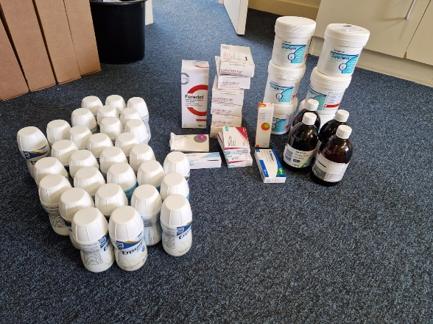This photo is what just one person had stored in the cupboard when it came to a clear out. Sadly, once the medicines have left the surgery, we cannot re-use them.

**New website coming soon:** Please feedback to us about how you find it! It has taken a huge amount of work. It has a unified format with the rest of the county’s GP websites, but we have tried hard to retain our personal stamp. It will be an excellent place for surgery updates.

**Quizz night is approaching**: The Kingstone Surgery Charitable trust Quizz night date is fixed for Friday October 4th. This is in aid of fulfilling our dispensary collection machine dreams. Please do come and support and try not to tease us when the surgery team does very badly….

And finally, most excitingly, I am delighted to let you know Dr Edwards is A WORLD CHAMPION! We of course knew this already, but now it is official: she has won gold in the Powerlifting World Championships in Ireland in August. We are sinfully proud.