Pershore Medical Practice

Patient Newsletter – July 2024

[www.pershoremedicalpractice.co.uk](http://www.pershoremedicalpractice.co.uk) Tel: 01386 553346

Partners:

Dr Paul Ferenc

Dr Kate Moore

Dr Catherine Mann

Dr Jade Elliott

Natasha Beynon-Brown (ANP)

Doctors:

Dr Emma Axon

Dr Ella Bosmith

Dr Bruno Onyeagoro

Dr Anita Patel

Dr Disha Sinha

Dr Salman Ali (GP Registrar)

If you find yourself unable to attend an appointment, please notify the surgery as soon as possible. This will enable us to use this time for other patients. Thank you.

**What were staff doing in May at the Practice?**

Reception answered 3701 calls

Dispensary issued 10523 medications

We received, read, actioned & filed 2234 tests

We offered 8636 appointments

We received, read, actioned and filed 3191 letters for patients

Sadly, we had **198** appointments wasted due to DNA’s

Surgery Opening Hours:

Monday to Friday 8am – 6.30pm

Dispensary opening Hours:

Monday to Friday 8am – 1pm and 2.30 pm – 5.30pm.

**1-7 July is Alcohol Awareness Week.** This is a chance for people across the country and in workplaces have a better understanding about alcohol harm, can make more informed choices about their drinking, feel able to seek support if they need it (for their own or someone else’s drinking), and are better able to support those who may be struggling.

More information can be found on the NHS website: [Alcohol misuse - NHS (www.nhs.uk)](https://www.nhs.uk/conditions/alcohol-misuse/)

**Order your prescriptions early!** Summer will soon be upon us, and many people are starting to think about their holidays. Whether it is pre-booked, or a spur of the moment get away, please remember that we require 7 working days to prepare prescriptions, so do put your request in early! We know from our statistics that the next few weeks are particularly busy so your help in let us help you is much appreciated.

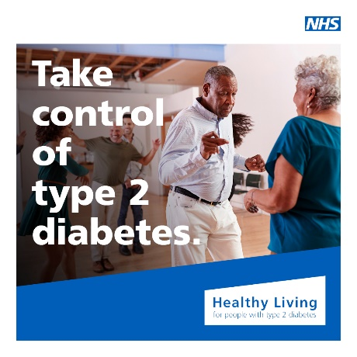Join thousands of others who are already using the free NHS Healthy Living programme to help them live well with type 2 diabetes.  
Get advice at home or on the move by signing up today.  
Healthy Living is a free, online NHS programme that supports people to live well with type 2 diabetes.

It includes information and advice about:

type 2 diabetes, eating well, becoming more active, how to look after your body and mind and other NHS services and support.

You can use the Healthy Living programme whenever suits you, and for as long as you need - there is no limit to access so you can learn at your own pace. It can also be used alongside any other diabetes programmes or education you may be taking part in.

For more information, visit [www.healthyliving.nhs.uk](http://www.healthyliving.nhs.uk)

**Our next NHS App hub session will take place on Friday 12 July, 9 til 12 and 2 til 5**.

We can help you set up the App, show you how to view your health record, see recent test results and order repeat prescriptions all from the comfort of your own home.   
Please bring your selected smart phone or tablet and a form of identification to confirm your identity for setting up the App.

**Do we have your email address?**

**Do you have a new mobile phone or moved house recently?**

Please visit Reception to update or give us your email address.

**Have your say**… Do you as a patient have ideas on how we can improve the surgery?

Join our Patient Participation Group (PPG) to get involved.

Please sign up to our Newsletter via the PMP website for electronic delivery straight to your mailbox.