**TRAVEL RISK ASSESSMENT PROCESS**

When travelling abroad please complete the following travel risk assessment and return it to the surgery *at* ***least* 6 weeks** prior to travel

The form needs to be reviewed by the Practice Nurse prior to an appointment. **Please call the** **Surgery 14 working days after you’ve submitted the form** to make your initial appointment with the Nurse. **Please note we will not contact you.**

It may be necessary for you to attend more than one appointment to receive your vaccinations. Some vaccines are not available on the NHS- a price list for these is attached (subject to change). Any vaccinations not available on the NHS will need to be paid for **prior** to the start of the course.

Please note : ***Some vaccinations require more than one dose and the full course may take over one month to be completed fully***.

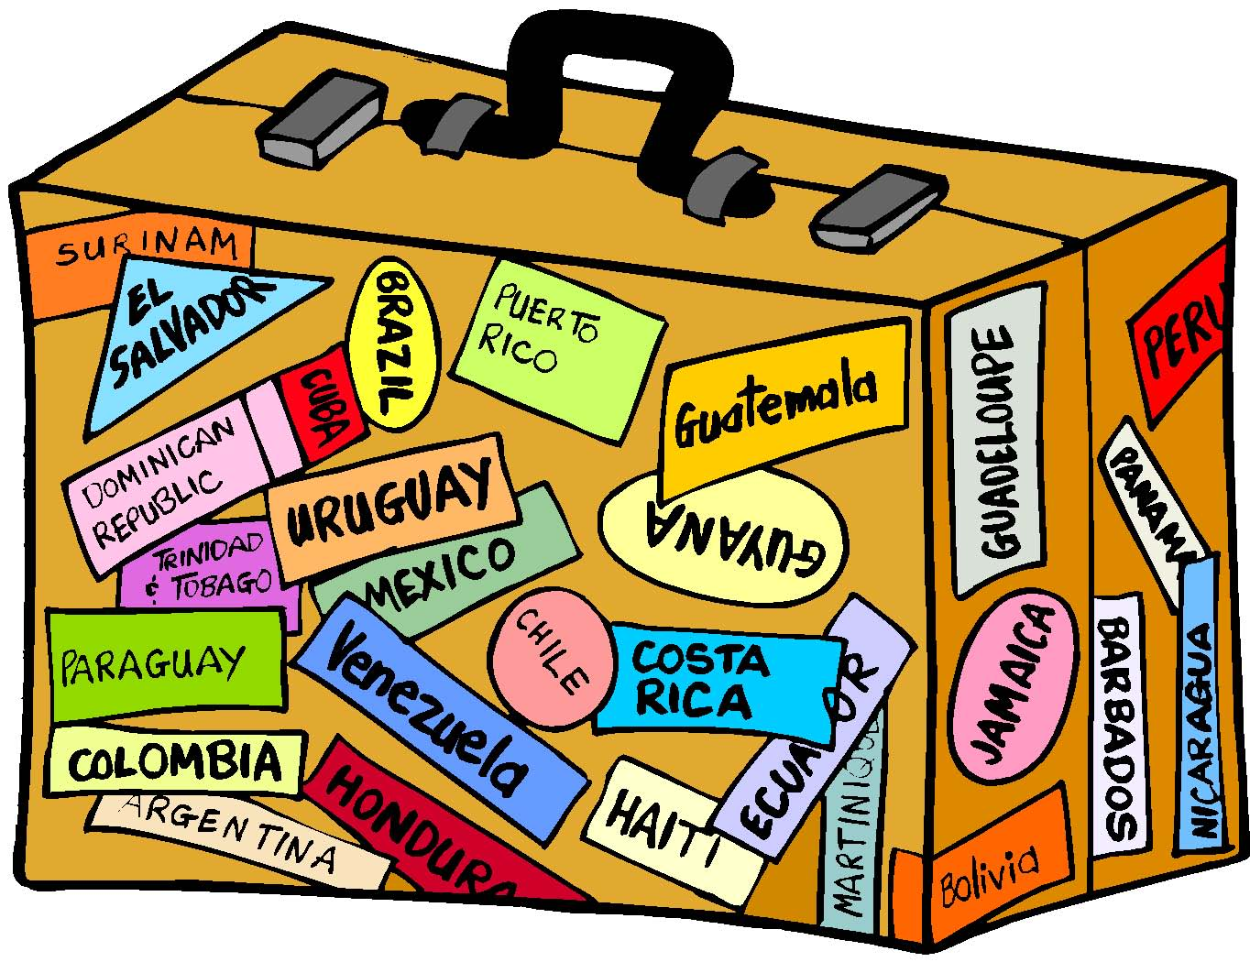

*For Office Use*

*Date received:*

*__________________*

|  |  |  |  |  |  |
| --- | --- | --- | --- | --- | --- |
| ***Personal Details***  **PLEASE COMPLETE ALL PAGES FULLY. EACH TRAVELLER MUST COMPLETE AN INDIVIDUAL FORM**  Name: | | | | | |
| Date of birth: Male  Female | | | | | |
| Telephone number: | | | | | |
| ***Dates of Trip***  Date of departure: | | | | | |
| Return date or overall length of trip: | | | | | |
| ***Itinerary and purpose of visit***  Country to be visited Length of stay Away from medical help at destination?  If so, how remote? | | | | | |
| 1 | | | | | |
| 2 | | | | | |
| 3 | | | | | |
| ***Please circle the descriptions that best describe your trip*** | | | | | |
| 1. *Type of trip* | | Business | Pleasure | | Other |
| 1. *Holiday type* | | Package  Camping | Self-organised  Cruise ship | | Backpacking  Trekking |
| 1. *Accommodation* | | Hotel | Relatives/family home | | Other |
| 1. *Travelling* | | Alone | With family/friend | | In a group |
| 1. *Staying in area which is* | | Urban | Rural | | Altitude |
| 1. *Planned Activities* | | Safari | Adventure | | Other |
| ***Personal Medical History***  Do you have any recent or past medical history of note? This includes diabetes, heart or lung conditions, thymus disorder. | | | | | |
| List any current or repeat medications | | | | | |
| Do you have any allergies, for example to eggs, antibiotics, nuts?  Yes No | | | | | |
| Have you ever had a serious reaction to a vaccine given to you before?  Yes No | | | | | |
| Does having an injection make you feel faint?  Yes No | | | | | |
| Do you or any close family members have epilepsy?  Yes No | | | | | |
| Do you have any history of mental illness including depression or anxiety?  Yes No | | | | | |
| Have you had your spleen removed? If Yes please give details.  Yes No | | | | | |
| Have you recently undergone radiotherapy, chemotherapy or steroid treatment?  Yes No | | | | | |
| **Women only**: Are you pregnant or planning pregnancy or breast feeding?  Yes No | | | | | |
| Have you taken out travel insurance?  Yes No  If you have a medical condition, have you informed the insurance company about this? Yes No | | | | | |
| Are all children who are travelling up to date with their childhood vaccinations? If yes, please give details.  Yes No | | | | | |
| Please give any further information that may be relevant, including any future travel plans | | | | | |
| ***Vaccination History***  Have you ever had any of the following vaccinations/malaria tablets and, if so, when?  Date Date Date | | | | | |
| Tetanus | Polio | | | Hepatitis B | |
| Typhoid | Hepatitis A | | | Influenza | |
| Meningitis | Jap B Enceph. | | | Tick Bone | |
| Rabies | Diphtheria | | | Other | |
| Anti Malarial Tablets | | | | | |
|  | | | | | |
| ***I understand that it is my responsibility to contact the surgery 7 days after returning this form.***  Name: ……………………………………. Signature:……………………………………. Date:………………………  **The following will be discussed at the initial appointment with the Nurse**  **I have no reason to think that I might be pregnant. I have received information on the risks and benefits of the vaccines recommended and have had the opportunity to ask questions. I consent to the vaccines being given.**  ***I have been made aware of the items I am required to pay for and I agree to pay prior to receiving the vaccines. I am aware that some vaccines require more than one injection to complete the course. I have received the list of charges and understand I will receive an invoice if relevant***  Name: ……………………………………. Signature:……………………………………. Date:………………………  Travel Risk Assessed by: Nurse……………………………………………. Date: ………………… | | | | | |

***If you require this form in any other format such as large print or easy read or have difficulty communicating because you use British Sign language for example please contact the Reception team to let us know either by calling 01886 880207 or emailing*** [***cradleysurgery@nhs.net***](mailto:cradleysurgery@nhs.net)

We can provide you with Hepatitus A, Typhoid and Tetanus for travel, free of charge.

Any other vaccines will need to be sourced independently at a private clinic

Examples :

Antimalarials

Hepatitis B

Rabies

Tick Borne

Japanese encephalitis