Minor Illness Clinic

Dr McCarthy & Partners
Monday- Friday
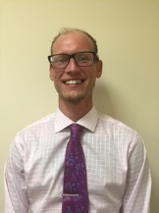
Clinicians

Alan Bradley – Senior Clinical Pharmacist Practitioner
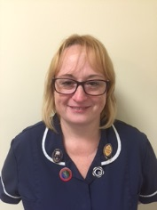

Amanda Bickle – Advanced Nurse Practitioner

Conditions
- Sore Throat
- Fever
- Flu-like illness
- Cough
- Rash/ Skin condition
- Asthma/COPD exacerbation
- Earache/ hearing loss
- Eye pain/ irritation
- Urinary tract problems
- Men’s health (Alan)
- Women’s health (Amanda)
- Headaches
- Generalised/ Back Pain
- Minor injuries
- Wounds (Amanda)
- Dizziness/ Vomiting/ Nausea
- Abdominal pain/ discomfort
- Rectal problems
- Anxiety/ depression (Alan)

You can also make general appointments about your long term conditions or medication issues with Alan or Amanda, please speak with reception.

