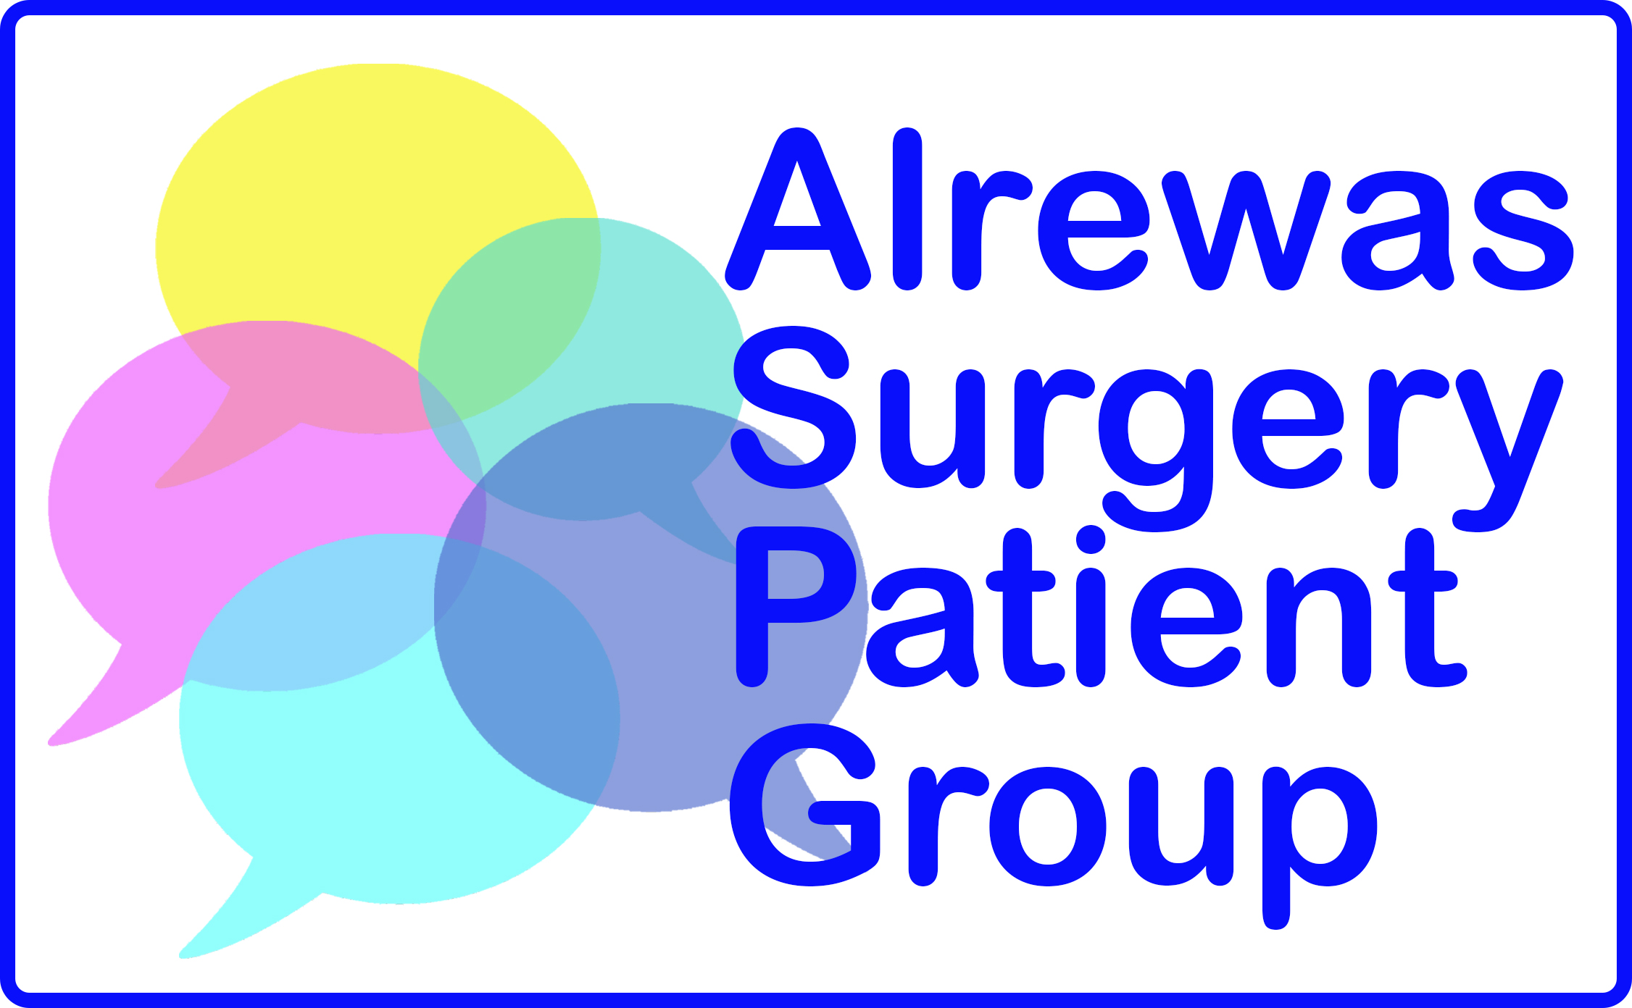

**Alrewas Surgery Patient Group Joining Form**

**I would like to join Alrewas Surgery’s:**

Patient Group Committee 

Virtual Patient Group 

**Please tick one box (details overleaf)**

Name _____________________________________________________________

Address ___________________________________________________________

__________________________________________________________________

Post code ________________ Phone number ____________________________

Email ____________________

The information below will help us ensure that members of the group are representative of the patients that are registered at the practice.

Your Gender: Male □ Female □ Other □ Prefer not to say □

Your Age: Under 16 □ 17 – 24 □ 25 – 34 □ 35 – 44 □ 45 – 54 □ 55 – 64 □

65 – 74 □ 75 – 84 □ Over 84 □

I confirm that I am a registered patient of Alrewas Surgery and would like to join the PG/Virtual PG.

Name _____________________________________________

Date ______________________________________________

Signature ___________________________________________

Please return to the surgery or email to alrewas.ppg@nhs.net

**Confidentiality**

General Data Protection Regulations (GDPR): Leaving your contact details above indicates your consent for us to contact you for PPG purposes only. In order to maintain confidentiality, any email correspondence will be addressed to the specific recipient only, or via ‘blind copy if sent as a group email.

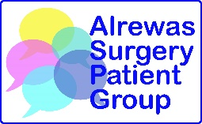

**Alrewas Surgery Patient Group**

**Who are we?**

We are a small, friendly group of patients working together with the practice staff to improve the services of Alrewas Surgery for everyone.

We warmly welcome more people to join us and share their ideas, skills and enthusiasm! Our committee meets four times a year to discuss issues that concern our practice patients.

**What do we do?**

We work in a partnership with the surgery to:

* contribute to the continuous improvement of services and quality of care
* foster improved communication between the surgery and its patients
* provide support for the surgery and help to implement change
* help patients to take more responsibility for their health

Examples of our past activities: Helping residents throughout the Covid-19 pandemic by mobilising volunteers and supporting the vaccine rollout; organising under 18s health information sessions at a local secondary school; helping at flu clinics; conducting our own patient surveys**;** introducing defibrillators into Alrewas and providing training on how to use them; organising a community café for those who fancy company and a chat; producing Surgery/PG newsletters.

**What we don’t do**

Please note that the group is used to represent the patient voice and is not for individual issues or complaints. These should be addressed by contacting the surgery on 01283 790316.

**Virtual Patient Group**

This is an online group of ‘virtual’ members who participate in surveys and are available to be contacted for feedback and comments on the surgery’s services.

**How to join the Alrewas Surgery Patient Group**

If you are interested in joining our Patient Group Committee **or** the Virtual Patient Group, please fill in the joining form and return it to the reception desk. Alternatively, you can download it from the surgery website, [www.alrewassurgery.co.uk](http://www.alrewassurgery.co.uk), and email it to alrewas.ppg@nhs.net.

**We’d love to hear from you!**