

FibriCheck App
Patient Information Leaflet



Date | 19.7.22
Version | 2.0
Approved by

Table of Contents

What is AF?

Who is taking part?

What happens if I am invited to take part?

What you need to know about using the APP?

How do you download and use the APP?

What if I decide not to use the APP?

How will my information be stored?

How to get help with the APP



1. What Is AF

Atrial Fibrillation is the most common cause of irregular heartbeat, known as cardiac arrythmia. There are 500,000 people with undiagnosed AF in the UK.

Atrial Fibrillation (AF) significantly increases the risk of developing a blood clot in your heart, which can travel to your brain and cause a stroke.

The chances of developing AF increase as you get older. It is much more common from age 65+. Having other conditions also makes AF more likely. They include:
- high blood pressure
- an overactive thyroid
- lung disease
- chest infections like pneumonia
- alcohol or drug misuse
- vascular disease
- diabetes
- any previous stroke or transient ischaemic attack (TIA)
- a diagnosis of dementia

For more information about AF please visit the NHS site: Atrial fibrillation - NHS (www.nhs.uk)

The good news is that these risks can be significantly reduced with the correct course of treatment.

Staffordshire and Stoke on Trent Integrated Care Board are leading on the implementation of a digital heart rhythm check to test for Atrial Fibrillation. Find out more below.

2. Who is taking part?

Digital Heart rhythm checks are being offered to people who currently present to the GP surgery with symptoms that suggest that they may have an abnormal cardiac rhythm. You will only be offered this check if you DO NOT have immediate and life-threatening symptoms.
In addition, a practice may also invite people that may be considered to be at higher risk of developing AF.
Please do not call your GP with enquires regarding this heart rhythm check. Your GP will either discuss using the App with you if you have symptoms or contact you if they think you will benefit for the use of this App.

“Wow hasn’t technology moved on”
“I felt reassured being able to take my reading any time I felt symptoms and seeing it was normal”

3. What happens if I am invited to take part?
We are using new digital technology to help identify AF in people. This means you will need access to your own smartphone or be able to ask a family member/carer who has a smartphone to help. This App is called FibriCheck. To find out more about the App follow the link below.

FibriCheck - Monitor your heart rhythm, prevent strokes

Your GP will discuss using the FibriCheck App with you in your consultation, to see if this might be appropriate for you. They will ask if you consent to using the App. This consent will be recorded on your patient record.

If you are able, and agree to use the App, your GP will send a unique code for you to be able to download the App free of charge for 7 days.

DO NOT SHARE THIS CODE WITH ANYONE ELSE
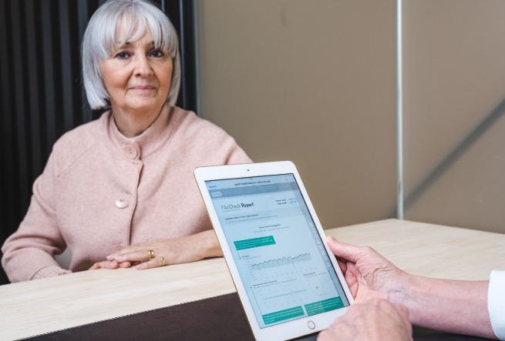

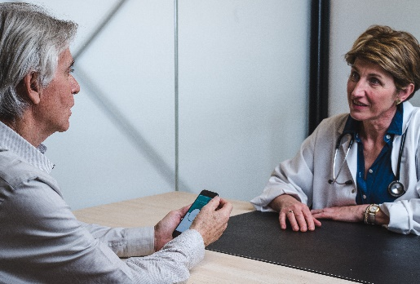

4. What you need to know about using the App?

- You have 7 days free access after which time you will need to pay if you want to continue using the App
- You will download the App on to your smart phone and start to take measurements
- Measure your heart rate twice a day for 7 days
- You can take extra measurements any time of the day or night or when you are experiencing symptoms – (there is no limit to the number of times you can take)
- You will receive a report in the FibriCheck App at the end of each measurement that will let you know that your reading is either normal or if there needs to be any further investigation
- Any abnormal readings are checked by a FibriCheck technicians/cardiologist to verify the reading before submission to your GP
- Your GP will receive a report within 48 hours of the first instance of an abnormal reading
- Your GP will receive a report of the full week’s readings at the end of the 7-day period whether the readings are normal or abnormal
Please note this is a self-monitoring tool and any change in symptoms should be reported to your GP

Call 999 if:
You have sudden chest pain that:
- spreads to your arms, back, neck or jaw
- makes your chest feel tight or heavy
- also started with shortness of breath, sweating, and feeling or being sick
- lasts more than 15 minutes

You could be having a heart attack. Call 999 immediately as you need immediate treatment in hospital.

5 How do you download and use the APP?
If you have given consent to using the App, you will receive an automated text message, email, or paper invitation from your Practice. This will contain a link to further information and a unique Practice Code to allow you to download the FibriCheck APP and use it free of charge for 7 days.
This link is unique to you and must not be shared.

The Code and instructions will look like this:

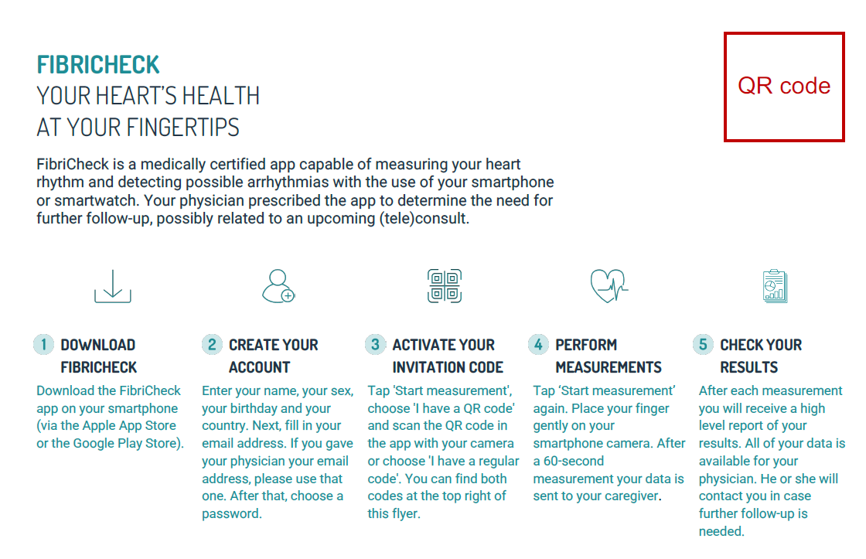

- The text you receive will come from the following number, XXXXXX insert practice detailXXXXX
- You will need to create and activate your account. Instructions on how to do this can be found here Insert link to document.
- If you require further information or help downloading or using the App, you can call the UK FibriCheck support number on 01273 092051 or email support@fibricheck.com.
- When you register to use the App, you will be asked a series of questions about your health. You must try to answer all the questions as accurately as possible as the App uses your responses to help calculate your reading result.
- Use FibriCheck to monitor your heart rhythm twice a day for seven days.
- You may measure your heart rhythm if you are experiencing symptoms at any time of the day or night in addition to the normal twice daily readings
- You can set and personalised your notifications within the App. The default is set to one or two reminders a week.
- To use the App, simply press the heart button in the App and place your finger on your smartphone camera, located at the back of the phone, for 60 seconds and your heart rhythm will be recorded. You will receive a summary of the reading on your phone after you have answered some simple questions
- After seven days your results will be sent to your Practice and reviewed by your GP
- If your readings are all normal (Green), you will not be contacted. If you continue to experience further symptoms, please contact your GP again.
- If any of your readings are abnormal and further investigation is required, you will be contacted directly by your GP who will explain the next steps.
Please note that if you wish to continue using the FibriCheck App after the seven-day period, this would be at your own cost and results will not be automatically shared with your clinician.

Call 999 if:
You have sudden chest pain that:
- spreads to your arms, back, neck or jaw
- makes your chest feel tight or heavy
- also started with shortness of breath, sweating, and feeling or being sick
- lasts more than 15 minutes

You could be having a heart attack. Call 999 immediately as you need immediate treatment in hospital.

The goal of the FibriCheck heart health check is to help you and your doctors to understand your heart health. FibriCheck is a screening tool, not a diagnosis. A diagnosis is always made by the treating doctor who can consider your complete medical history and advise on the best course of action for you.
It's important to note that some people experience an irregular heart rhythm every now and then, rather than regularly or constantly. Some people may have a normal heart rhythm and then suddenly get an abnormal one, this is known as paroxysmal atrial fibrillation.
Both frequent and infrequent irregular heart rhythms carry the same risks and therefore both require frequent and regular checks.

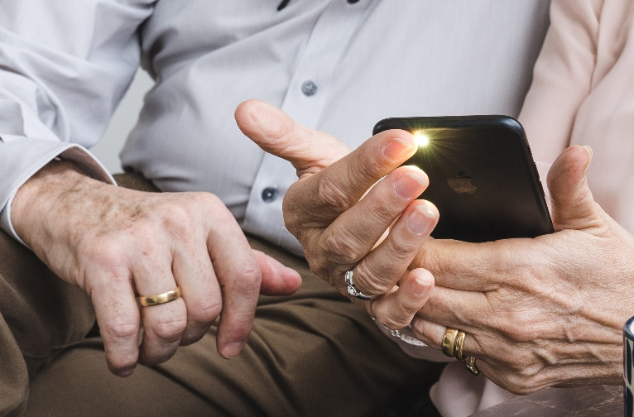

6. What if I decide not to use the APP?
You must let your GP know that you have decided not to use the App as this could delay any investigations and they will not be informed if you do not submit any readings.

7. How will my information be stored?
FibriCheck is a Medically Certified App that measures your heart rate and heart rhythm using the camera and flash of your smartphone. The results of these measurements will automatically be shared with your doctor.
FibriCheck processes and stores your personal and medical data with utmost care using a secure cloud which meets the highest industry standards. FibriCheck’s data security is compliant with GDPR and adheres to NHS cyber security standards. You can find out more by checking FibriCheck’s privacy policy. https://pages.fibricheck.com/privacy-policy/1.5.0/en/
To learn more about how we may use your data and to see our privacy notice cleck Here – XXXXXXpractice to insert a link to privacy noticeXXXXXX

Frequently asked questions and additional information

Insert link to FAQ Page

8. How to get help with the APP
For more help and advice using the App please contact FibriCheck directly. You can call the UK FibriCheck support number on 01273 092051 or email support@fibricheck.com

