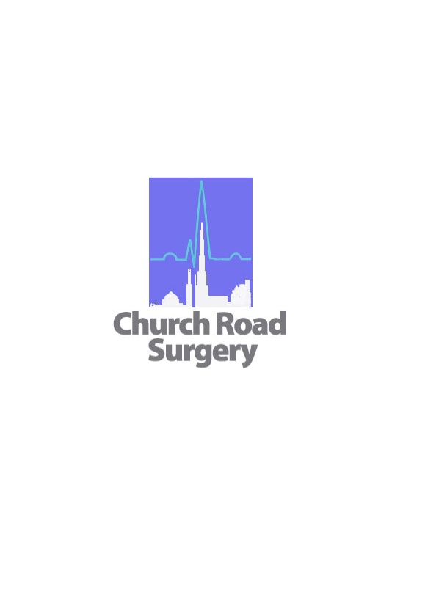

Church Road Surgery

**Queen’s Platinum Jubilee**

**Come and join us at Church Road Surgery to celebrate with us,**

For Afternoon Tea and Scones

**On Wednesday 1st June 2022**

**From 12noon till 2pm**

We will be Unveiling the Platinum Jubilee Rose to Commemorate Her Majesty’s 70 Years of Service

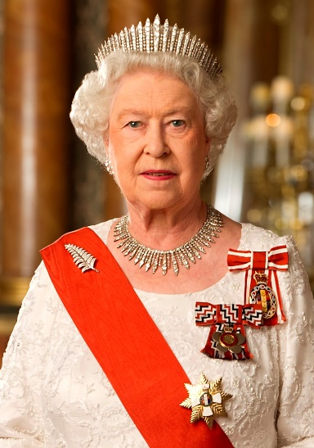

**Her Majesty Queen Elizabeth II**



**Surgery Bank Holiday Opening Times**

**Thursday 2nd June-Sunday 4th June**

**9am to 1pm (Improved Access Service) CALL 0121 411 0344**

**Outside of these hours please CALL BADGER 0121 766 2100.**