

Whitmore Reans Health Centre
Lowe Street, Whitmore Reans,
Wolverhampton, WV6 0QL

01902 421679

Ednam Road Surgery
14 Ednam Road, Goldthorn Park,
Wolverhampton, WV4 5BL

01902 340200

Pendeford Health Centre
Whitburn Close, Pendeford,
Wolverhampton, WV9 5NJ

01902 789080

Whitmore Reans Health is within close proximity to the Avion Shopping Centre, easy reach by public transport, and it is close to the main city centre. Pendeford is lo-cated by Morrison’s Supermarket off Whitburn Close.

Both surgeries are in the Health Centres and are equipped to serve patients in a primary care environment.

The Practices are within the

Royal Wolverhampton Trust Area
Welcome to Dr. Vij & Partners


We are a dedicated team of healthcare pro-fessionals that strive to bring you the best healthcare possible to meet your needs.

Our team includes Doctors, Advanced Nurse Practitioners, a Practice Nurse, a Health Care Assistant and a Pharmacist complimented with dedicated Administration team in three locations.

OPENING HOURS

Whitmore Reans Ednam Road Pendeford Health

Monday 8:30am—7:30pm 8:30am—6:30pm 8:30am—6:00pm

Tuesday 8:30am—7:00pm 8:30am—7:30pm 8:30am—6:00pm

Wednesday 8:30am—6:30pm 8:30am—6:30pm 8:30am—6:00pm

Thursday 8:30am—1:00pm 8:30am—6:30pm 8:30am—1:00pm

Friday 8:30am—6:00pm 8:30am—6:30pm 8:30am—6:00pm

Pendeford Health is closed between 1:00pm and 2:00pm each day emergency calls will be taken - 01902 445406

WAYS TO REGISTER

Registration forms are accessible online on our website to print or obtained at all reception desks at each surgery.

The Practice operates a policy of non-discrimination on the grounds of race, gender, social class, age, religion, sexual orientation, appearance, disability or medical condition from patients wishing to join the practice.
APPOINTMENTS

Appointments can be made over the phone or in person at our reception desk.

Many of our patients will book to see a doctor or nurse on a regular basis. However, we do not see enough of some of our registered patients. If you are between the ages of:

18-74—we recommend that if you have not seen a doctor or nurse within the last 3 years—book a routine appointment.

Over 75—if you have not seen a doctor or nurse in the last year— book a routine appointment for a health review.

Medication reviews—if you have not had a review of your repeat medications in the last year—book a routine appointment for a review with our Pharmacist.

Health Reviews—If you suffer from Chronic ailments such as Diabetes, COPD, Asthma, Hypertension, Mental Health Issues or CHF you will be invited in for an annual Health Care Check.

Routine Appointments

We appreciate that many of our patients work or are in education full time. Therefore we offer appointments before or after work hours as well as booking of routine appointments up to 8 weeks in advance.

Patients will receive confirmation of the booking as well as a reminder close to the day of the appointment.

Urgent on the Day Appointments

For more urgent medical needs that can not wait for a routine appointment we ask that you ring us between 8 and 9am or come into the surgery on the day to book the appointment. While we can not guarantee a specific doctor or time we will do our best to accommodate you on the day.

We have priority on the day appointments for children who are unwell and a full range of nursing services as well.

Online Access

You have access to Routine appointments and repeat prescriptions though our online Patient Access Portal. Please see reception for set up with an Online login and password as well as instructions to help you.

Telephone Appointments

If you need to speak to a doctor or nurse with a query please ask to be booked for a telephone consultation. These requests are allocated as an appointment within the surgery and therefore are for 10 minutes and for one patient with one query. Please be aware that many medical concerns can not be diagnosed over the phone and therefore you may still be required to come in to attend an appointment.

If you wish to speak with a doctor or nurse regarding another family member or a patient who is not yourself, we cannot discuss any medical issues without prior written consent from the patient.

Home Visits

We encourage where possible, all our patients to attend the surgery to see a doctor. Home visits are only for patients who are housebound, terminally ill or frail and there is a medical need. Transportation issues are not a reason for a home visit.

Please ring the surgery before 11:00am to book same day home visits. Requests made after this time will be made on the following working day.

Please ring before 10am to arrange a visit and let us know if your condition is urgent.

Please provide as much information as you can to our reception team and ensure that your contact details are up to date.

Please note there is no guarantee that a specific doctor will visit you at home and the time is determined by clinical workload and urgency of request.

Clinical Staff

Dr S K VIJ (P) Amardeep Singh (Pharmacist)
Dr A VIJ (P) Najeeb Alkozei (Physician Associate)
Dr K. Vij (P) Happiness Amune (Pharmacist)
Dr Ahmed (M) Farzana Beg (Pharmacist)
Dr I Ponna (F) Tasneem Ahmed (Practice Nurse)
Dr N Ghani (F) Sabrina Buchanan (Practice Nurse)
Kamlesh Maman (Practice Nurse)
Mandeep Mandeep (HCA)

When we are closed

If you require medical attention when the practice is closed, please phone 111 to access NHS Direct. This service is run by a team of Doctors, nurses and other health care professionals and will assess and inform you as to the best course of action of medical attention. (Also see Additional Services available )

NHS 111

You should call the NHS 111 service if you need medical help fast, but it’s not a 999 emergency. You will be assessed, given advice and directed straightaway to the local service that can help you best. Calls to NHS 111 are free from landlines and mobile phones.

NHS England has produced a short film to help people with a learning disability, au-tism or both, understand how and when to access the service, and what to expect.

https://www.youtube.com/watch?v=CMePMsS9KT

Health Advice/Information

Ask Your Pharmacist

Pharmacists are medicines experts and are able to give free health advice and treat-ment about common illnesses like colds and flu or sickness and diarrhoea. You do not need an appointment and you can speak to them in confidence.

NHS Choices

You can access health advice and information on the NHS Choices Website at www.nhs.uk

NHS Walk In Centres

Walk In Centre for minor health problems, minor injuries and emergency contra-ception - led by experienced, specially trained nurses available at:

The Phoenix Health Centre, Tel: 01902 444015
Parkfields Road, Parkfields,
Wolverhampton WV4 6ED

Open Monday to Friday: 10.00am - 7.00pm, Saturday, Sunday and Bank Holidays:
10.00am - 4.00pm.
Urgent Care Centre - Call NHS 111 to access this service

The urgent care centre is situated above the A&E department at New Cross Hospital and is open 24/7, 365 days a year. You can self-present at the UCC reception or you may be directed to it via NHS 111 when appointments will be booked electronically for you. You may also be redirected to this service from A&E if it more appropriate to manage your needs.

Emergencies – A&E/Call 999

The local Accident and Emergency Department is New Cross Hospital.

Whatever the day or time, if you suspect you may be having a heart attack, stroke, severe acute illness or serious Accident then please dial 999 and you will be advised accordingly. If you are well enough to attend A&E yourself then please do so.

Patients with Particular Needs

Each of our surgeries is accessible to patients using a wheelchair. We also have parking spaces outside each of our practices which are reserved for patients displaying a disabled sticker.

We can arrange interpretation and translation services in person or by phone for patients who do not speak English. Please let us know if you need this service when booking an appointment behaviour. If they persist, we may exercise our rights to take action to have them removed, immediately if necessary, from our list of patients.
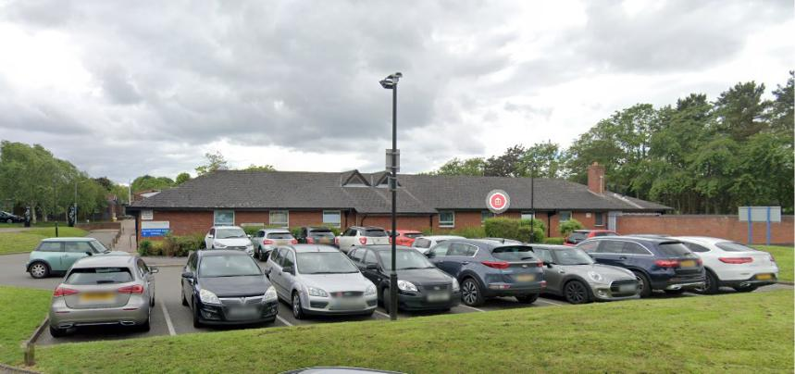

SERVICES WE OFFER

We run a range of clinics. Please call for an appointment or further details.

Flu Vaccination

This vaccination is recommended for all patients aged 65 years and over and for adults and children with:

Lung Disease (including Asthma), Heart Disease, Kidney Disease, Diabetes

We will be advertising the service each year and will contact those registered patients who fall into the categories mentioned. If you feel you should be offered a flu vaccine, please speak to a member of the reception team.

Travel Vaccinations

We offer a full range of travel vaccines and our Practice Nurse is fully trained in not only administering travel vaccines, but also in offering essential travel health advice. A charge may be made for certain vaccines. If you would like travel vaccines, please call the surgery and book a travel consultation 6-8 weeks before departure to ensure you get the right vaccines before travelling.

Vaccines would also be suited for people going for Pilgrimage to Holy Shrines in India, Pakistan and Middle East.

Child Health Checks & Baby Clinics

Routine child health assessments are carried out here. You will be notified when your child is due for an assessment, however, if you have any questions, please don’t hesitate to ask a member of the team. Health Visitors, Practice Nurses and Doctors are available for advice on Tuesday mornings and Wednesday afternoons.

Family Planning
A full range of family planning services are available.

Cervical Smears

Cervical screening can prevent cancer of the cervix by finding and identifying any abnormal cell changes. Regular smear tests can save your life.

If you require a smear, please let the reception team know that this is what you need in order that they can make a longer appointment for you.

Most women between 25 & 50 should have a test every 3 years and if over 50 it should take place every 5 years until they are 65. We will send out automatic reminders to our registered patients.
Health Promotion and Information

We have a wide selection of booklets available for your information. If you can’t find what you’re looking for, please just ask at reception or our nurse team and they will try and help you.

We also provide health advice & medical check-up’s for HGV drivers, taxi drivers and driving instructors.

Child Immunisations

It is very important to make sure that children continue to be protected from infections such as measles, mumps and rubella. Immunisations are carried out by the practice nurse and reception can provide information regarding the cor-rect age to administer different childhood immunisations. (2, 3, 4 and 13 months and preschool boosters at 4 years) Make sure your child remains pro-tected.

Repeat Medication

If you are in need of repeat prescriptions there are several ways for you to request them. Please note that all repeat prescription requests take 48 hours. Please plan accordingly.

- In person—Either mark the items you wish to order on your previous script or fill out one of our convenient script request forms and hand it to our reception staff or place in the script request box.

- Online—if you have registered for online access you may order your prescriptions through our online option.

- By Phone—Calling the repeat voicemail telephone no: 01902-575407

Please be sure to nominate your regular Pharmacy if you wish your prescriptions to go through Electronic Prescribing directly to the chemist.

Requests for new medications or medications prescribed by an external provider may require a Medication Review and therefore may take longer to collect.

All controlled drug scripts must be collected in person at the surgery during normal business hours.

Test Results

Patient may ring between 1:00pm and 2:00pm each day. Please allow 4 working days for test results to come back unless your doctor or nurse has advised you otherwise. Items such as X-Rays and Smear Test results will take longer and this will be explained. In interests of GDPR results can only be given to the patient unless there has been prior written consent.
OTHER SPECIALISED CARE

Referral Appointment Time Requests

If a GP or another member of our health care team believes you need hos-pital treatment or specialist care elsewhere, they will ask you where and when you would like to go. They can then book your appointment electroni-cally while you wait.

If you would prefer to have some time to think before deciding where and when to have treatment, you will be offered the option of calling the prac-tice later and we will be able to book your appointment then.
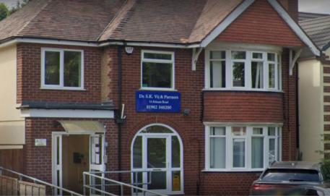

Patients Confidentiality & Data Protection

We respect your right to privacy and keep all your health information confidential and secure.

It is important that the NHS keeps accurate and up-to-date records about your health and treatment so that those treating you can give you the best possible advice and care. This information is only available to those involved in your care and you should never be asked for personal medical information by anyone not involved in your care.

You have a right to know what information we hold about you. If you would like to see your records, please call our Practice Manager at the Surgery.

All data used for analysing trends and information shared with your PCN & other health related organisations is where possible anonymous, i.e. names and other indenting features removed.

Information requested by third party organisations outside the NHS will NOT be shared without your explicit consent.

Summary Care Records

Your Summary Care Record is a short summary of your GP medical records. It tells other health and care staff who care for you about the medicines you take and your allergies.

This will enable health and care professionals to have better medical infor-mation about you when they are treating you at the point of care. This change will apply for the duration of the coronavirus pandemic only. Unless alternative arrangements have been put in place before the end of the emergency period, this change will be reversed.

All patients registered with a GP have a Summary Care Record, unless they have chosen not to have one. The information held in your Summary Care Record gives health and care professionals, away from your usual GP prac-tice, access to information to provide you with safer care, reduce the risk of prescribing errors and improve your patient experience.

Complaints

Dr. Vij & Partners aims to give a friendly and professional service to all our patients. However, if you have any concerns about any aspect of our service, please let us know.

Speak to whomever you feel most comfortable - your GP, our practice man-ager or our reception staff will be happy to help.

In the majority of cases, concerns can be resolved quite easily. However, If for any reason you do not want to speak to a member of our Staff, then you can request that NHS England investigates your Complaint. They will contact us on your behalf:
NHS England

PO BOX 16738
Redditch
B97 9PT

03003 112233

england.contactus@nhs.net Complaint can be made verbally or in

writing. A Complaints form and instructional leaflet are avail-able from reception.

We treat our patients courteously with dignity and respect. The practice operates a ZERO-tolerance policy and will not tolerate any rude, abusive or threatening behaviour against any of our staff.

