Medicines Waste campaign

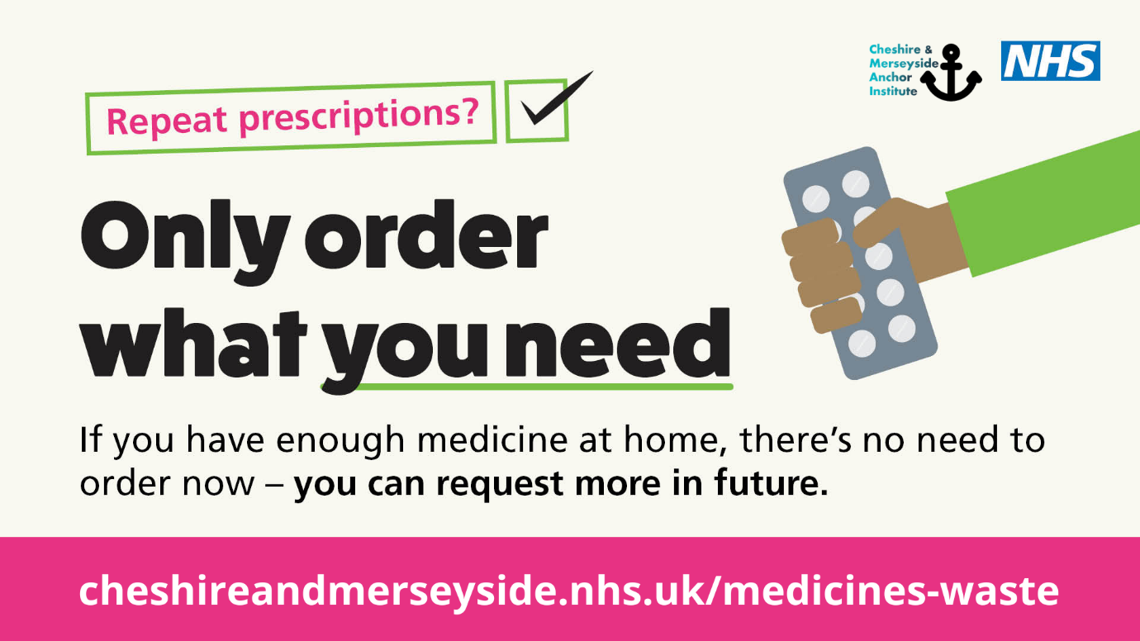

Help reduce medication waste and support the NHS across Cheshire and Merseyside

Pharmacists and GPs across Cheshire and Merseyside are urging people to only order the medication they need from their repeat prescriptions.
A report by the Department of Health estimates that unused medicines cost the NHS around £300 million every year and a large amount of medicine items are wasted unnecessarily in Cheshire and Merseyside each year. We need your help to reduce this.
NHS Cheshire and Merseyside along with NHS England - North West, NHS Greater Manchester and NHS Lancashire and South Cumbria have launched a new campaign asking people to check their order to help reduce waste and save on cost.
Susanne Lynch MBE, Chief Pharmacist at NHS Cheshire and Merseyside said:
“We want to remind you how important it is to check what medicines you have at home before placing your repeat prescription order.
“We know that a significant amount of repeat prescription medicines are not used and returned to pharmacies for destruction. With your support, we hope that we can make a difference and improve on the number of unused medicines.
“We have learned that ordering unnecessary medication can increase the risk of medicines shortages in pharmacies and we want to make sure essential medications are available to those who need them the most. We want people to have the right medicine and the right care, while reducing the amount of medicine waste. Thank you to the many people who already do this.”
Helen Murphy, Chief Officer of Halton St Helens and Knowsley Local Pharmaceutical Committee, said:
“We are asking our community to be conscientious about only ordering medication they need”.
Helen shares some tips on how everyone can to do this:
- Only order the medication if you need it - repeat items still remain on your prescription if you don’t order it every month.
- Try keeping all medication in one safe place at home, so you can see what you have left and what you need to reorder.
- For each prescription, take medication from one pill packet at a time, so that you can keep a track of what you’ve taken and what you have left
- Make a note on your calendar 7 to 10 days before your prescription due date, to go through your medication and see what is left. Being organised in this way means that if bank holidays or weekends are coming up, you will have planned enough for these dates too.
Helen adds: “It can be challenging organising medication, particularly if you need to take a lot of medication or you support someone to take their medication, but it is safer to organise and manage medication in this way.”
If you have questions about your prescription or need some support, speak to your pharmacy team. Unused or out of date medicines and inhalers should always be returned to your pharmacy for safe disposal.

Karen O’Brien MBE, Regional Chief Pharmacist, NHS England - North West said:
“I am delighted to be working with each Integrated Care Board in the North West on this really important work to raise awareness of the amount of medication that is wasted every year. I also want to reassure people that your GP will continue to prescribe medication for as long as you clinically need it, but if you aren’t due to run out, you don’t need to over-order, that medicine will be there for you when you need it.”
In addition to asking the public to only order the medication that they need, the NHS is also encouraging the people to take medication into hospital should they be admitted, whether it’s planned or unplanned. This helps staff in hospitals to have a complete record of medicines and means the hospital won’t need to dispense more of the same medication and can speed up care.
To see the campaign and for more information visit: www.cheshireandmerseyside.nhs.uk/medicines-waste

Newsletter copy – Medicines Waste campaign

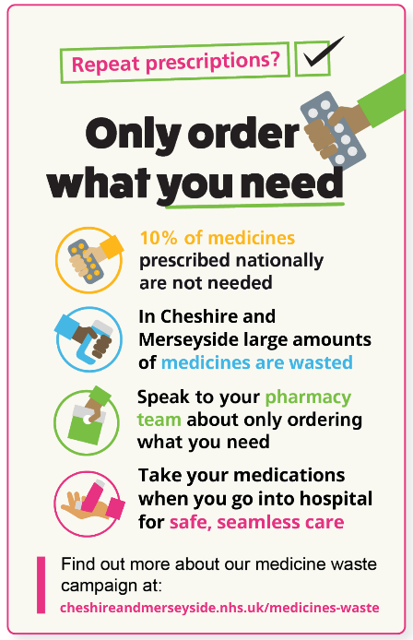
Only order what you need

Did you know large amounts of medicines are wasted in Cheshire and Merseyside each year? We need your help to reduce this.

Check what medicines you have at home before you order your repeat prescriptions. If you have enough, only request the medicines you need this time. You will still be able to order others again in future.

Here are some tips to help you only order what you need:

- Try keeping all medication in one place at home so you can see what you have left and what you need to reorder.
- For each prescription, take medication from one pill packet at a time so that you can keep a track of what you’ve taken and what you have left
- Make a note on your calendar 7-10 days before your prescription due date to go through your medication and see what is left. Being organised in this way means that if bank holidays or weekends are coming up, you will have planned enough for these dates too.

Speak to your pharmacy team if you have any questions about how to change your prescription request.

Thank you for helping to reduce medicine waste.

Visit the Medicines Waste page on the NHS Cheshire and Merseyside website to find out more: www.cheshireandmerseyside.nhs.uk/medicines-waste

