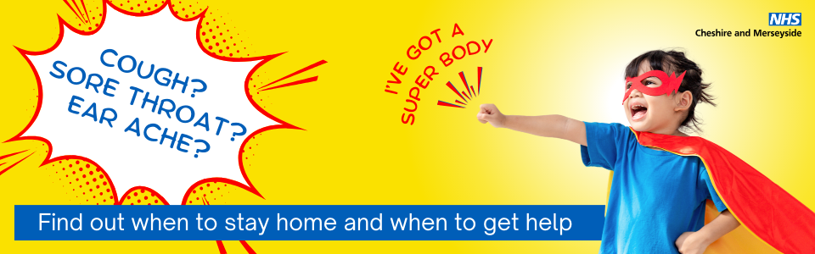

Super Bodies – what to do when your child has a common illness

Illnesses like coughs, sore throats and ear ache are extremely common in young children, but did you know… our children’s ‘super bodies’ are designed to fight off many common illnesses, without the need for antibiotics?

NHS Cheshire and Merseyside is sharing guidance for parents and carers on common winter illnesses like coughs, sore throats and ear ache. These common ailments and can be unpleasant for children and their caregivers, but are most often caused by viral infections and do not need to be treated with antibiotics.

Antibiotics rarely speed up recovery for these conditions and have no effect on viruses. Instead, our children’s ‘super bodies’ get to work, and most children with a normal immune system and up to date immunisations will recover in the same amount of time with or without antibiotics.

The ‘Super Bodies’ campaign shares a guide for parents and carers on the simple things they can do to treat these common ailments at home, as well as helping them to spot the signs of a more serious illness, and knowing when and where to go for medical help.

Visit the Super Bodies page on the NHS Cheshire and Merseyside website to find out more: www.cheshireandmerseyside.nhs.uk/super-bodies

