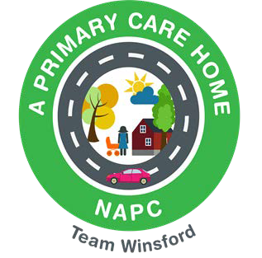
Th
WINSFORD PRIMARY CARE NETWORK
PATIENT PARTICIPATION GROUP (PPG)

MEETING TUESDAY 11th June 2024 AT 4pm
DENE DRIVE PPC ROOM 2

NOTES

1. | Welcome / Apologies  All members to identify the practice they represent (sign-in sheet includes this):  Attendees: Tina Birkby, Tony Williams, Carol Barton, Chris Brenan, Jackie-Ann Hardman, Maggie Davenport, Sue Sanderson, Jane Cope, William Greenwood, Hannah Marshall.  Apologies received prior to meeting: Carole Heiriss, Colin McGuffie, Anne Buchanan, Jackie Brown, Carole Walker, Ged Hind, Janet Hind, Lesley Graffham, Sue Stott, Tracy Hoather,  Note Taker: Tina Birkby | TB  ALL
2. | Declaration of conflicts of interest | ALL
3. | William Greenwood – Chief Exec LMC  - Understanding key issues for practices  William spoke to the group about current live issues in general practice including workforce issues, finances, attracting new staff. William is a retired PPG Chair and went on to discuss how we keep engagement going within our PPG. His suggestions were:  - Promote on noticeboards within practice waiting areas.  - Facebook – how to engage younger people to join the PPG.  - Website – on individual practices websites.  - E-newsletter – ask permission from patients first.  - Hold an annual AGM – when?  - He recommended a GP be present at meetings.  - Volunteers to help run flu/covid clinics.  - Leaflet drops.  We also discussion having a mixture of virtual members to include their input – send AccuRx messages out to patients to encourage to join the group either virtually or f2f. It was proposed (and passed) to hold the meetings in the evening from 6pm to 7pm – This will be implemented for the next meeting to try to engage with patients who work. Try to revisit students in college to try and engage.
3. | Actions from last meeting?  None noted.
4. | Chair for PPG – Any volunteers?  Tony Williams has very kindly volunteered to take over as chair – he will be supported by Carole Heiriss.
5. | PPG Members – How to engage new members/what platform?  See notes above. | ALL
5. | Care Community Steering Group - update  Jackie-Ann gave an update of the great work being carried out in the community. | JAH
6. | Cloud Based Telephony – How are patients finding it/Any feedback from PPG members? Practices will plan to do a survey with patients.  All participants gave very positive feedback to the new cloud-based telephony system which is now in place in all practices – Everyone really likes the call-back feature! | TB
7. | Any Other Business?  - Frequency of Meetings  Agreed to hold meetings quarterly.  - Parking Eye  Patients have been very confused with the signage on the carpark. Tina has emailed Parking Eye to see if the notices can be altered so they read more clearly. Dene Drive have also put notices all around the building to try and inform patients of the new system – 1.5 hrs FREE parking, no vehicle registration required unless staying longer, then patients can have a further hour. Anything longer than this requires the vehicle registration to be entered onto the portal – practice staff can do. | ALL
8. | Next meeting: Tuesday 10th September – 6pm till 7pm – Conference Room 2 at Dene Drive.

