‘Safe Adventures’ supporting children as they move to secondary school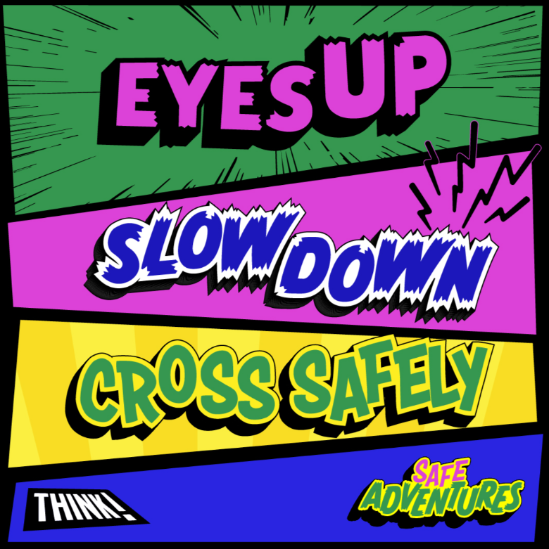
The THINK! ‘Safe Adventures’, aims to help parents across the country prepare their children for independent travel when they move to secondary school.
Road casualty data shows that the number of child pedestrian casualties’ doubles between the ages of 9 and 11, with incidents more likely to happen during drop-off and pick up times.
THINK! ‘Safe Adventures’ speaks to parents with children about to make the leap to secondary school, focusing in on the top 3 risky behaviours (based on the top contributory factors assigned to child pedestrian casualties):
- Pedestrian failure to look / distraction (friends and mobiles).
- Pedestrian careless, reckless or in a hurry.
- Safe place to cross (including parked cars and behind buses).
Parents are encouraged to undertake practice journeys, always model best practice and to have a road safety conversation as part of their children’s preparation for changing schools.
During practice walks, children can use the three key road safety rules: ‘EYES UP, SLOW DOWN, CROSS SAFELY’.

‘EYES UP’ prompts children to put their phone away and look out for their friends and not distract them. Children should stay focused near traffic, look right, left and right again before crossing the road and continue looking and listening while they cross.

‘SLOW DOWN’ advises children to take care and don’t run across the road when traffic is coming even if you think there is time. It can be difficult to judge the speed of traffic. If traffic is coming let it pass.

‘CROSS SAFELY’ reminds children to always find a safe place to cross, use a pedestrian crossing if there is one and choose a place where you can see clearly in all directions. Crossing between parked vehicles is hazardous and should be avoided where possible. But when they need to, use the outside edge of the vehicles (as if they were the kerb), stop there and check for traffic looking right, left and right again before entering the road. Check the vehicles are not about to move off, look for drivers in the cars, lights and listen for engines running. When getting off the bus, wait for the bus to leave so you have a clear view and can be seen by other road users.
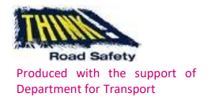 https://www.think.gov.uk/campaign/safe-adventures/



Pedestrian safety | Parents and carers play a vital part in teaching children how to cross the road safely. When you cross the road, don’t take risks – children will copy you.
Stop, look, listen and think | Remember to find a safe place to cross, then stop, look, listen and think.
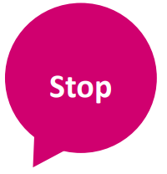 | - Stop just before you get to the kerb.  - Do not get too close to the traffic.  - Give yourself lots of time to have a good look all around.  - Remember to choose a place to stop where you can see clearly in all directions, and where drivers can see you ‐ try to avoid crossing between parked cars.
 | Look all around for traffic – look right, look left, then look right again.
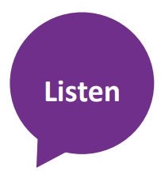 | Listen carefully, because you can sometimes hear traffic before you can see it.
 | - Do not cross until there is a safe gap in the traffic, so that you have lots of time to cross the road.  - Always choose a place to cross the road where you can see the traffic coming in both directions – a straight part of the road is good for this.  - When it is safe, go straight across the road – do not run.  - Keep looking and listening for traffic while you cross.  - Look out for cyclists and motorcyclists travelling between lanes of traffic.

Cheshire Fire & Rescue Service Pedestrian Safety

