Winter Water Safety 2024
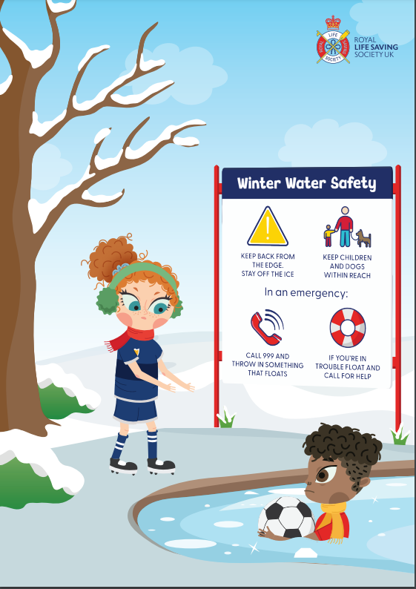
  Stop & Think | Keep back from slippery banks and wear footwear with good grip.  Stick to well-lit areas – the reduction in daylight in the winter adds to risks around water. Plan your walks in daylight or along well-lit paths.  Ice can be extremely dangerous even during prolonged periods of prolonged cold. NEVER go onto the ice.
  Stay Together | Keep children within reach and teach children not to go onto ice.  Keep dogs on a lead near ice and slippery banks.  If out enjoying a winter walk, walk with friends.
In an emergency
  Call 999 | Call 999- do not enter cold water or ice to rescue.  Try to reach them from the bank using a rope, pole, tree branch, clothing tied together or anything else which can extend your reach
  Float | Fall in or become tired – stay calm, float on your back and call for help. Throw something that floats to somebody that has fallen in.  If you cannot climb out, wait for help and keep as still as possible. Preserve heat by pressing your arms by your side and keep your legs together. Keep your head clear of the water.  Make sure the whole family knows basic water safety and what to do if they find themselves in the water unexpectedly. You can access free RLSS UK resources to help.
Ice Rescue and self – survival
Areas with frozen lakes, ponds, canals and reservoirs cam be beautiful places to visit during the winter months but all too often many people risk their lives by venturing onto frozen water. Don’t be fooled by popular movie scenes, ice can be extremely dangerous and across the UK and Ireland is unlikely to freeze to a suitable depth to safely walk on:
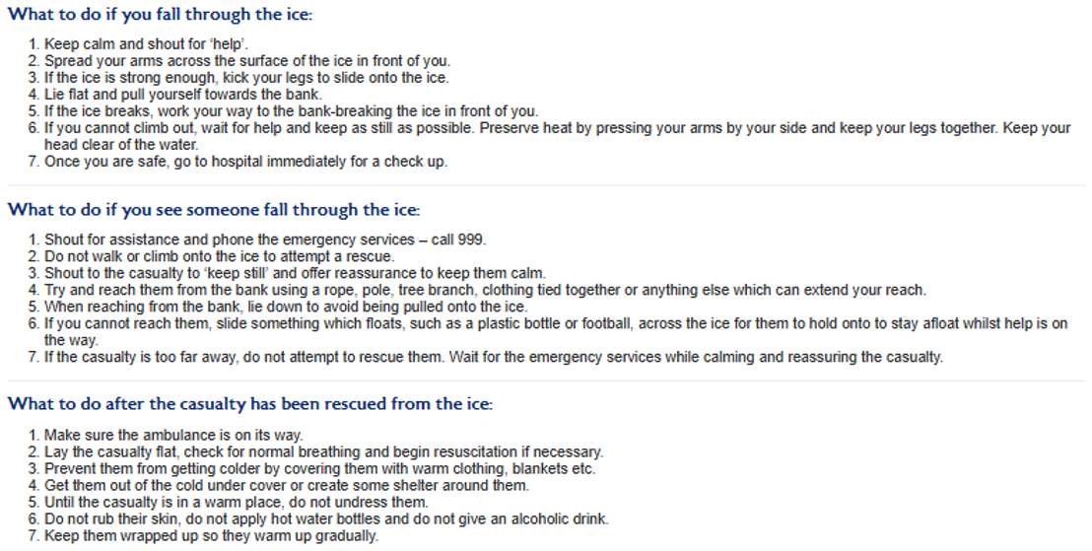
https://www.rlss.org.uk/pages/category/winter-water-safety

