

Cumberland House Surgery
Patient Privacy Notice
Children and Young People

What is a privacy notice?
A privacy notice is a document which helps your doctor’s surgery tell you how it uses information (also known as personal data) it has about you, such as your name, address, date of birth and all the notes the doctor or nurse make about you when you come to see us. It also tells you how we make sure your information is kept safe. |     It tells you what information of yours we have and how we keep it safe.

Why do we need one?
We want to make sure your personal data is safe and looked after, and that everybody at the Practice is following the laws which keep your information secure. These laws are called the UK General Data Protection Regulation (UK GDPR) and the Data Protection Act 2018 (DPA 2018). | 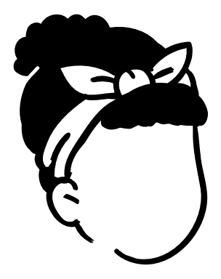  The law says we must tell you what we do with your data.

Why do we collect information about you?
Your data helps us to be our best data.
We help to look after your health. To do this, we collect and keep information about you such as your name, address and telephone number so that we know how we can contact you, the name of the person who will generally bring you to your appointments. Each time you visit, we will write down what you tell us, what your family shares about you, things we tell you and any medicines or treatments we give you; that way we can look back at what we have done to make sure we are treating you in the best way. | 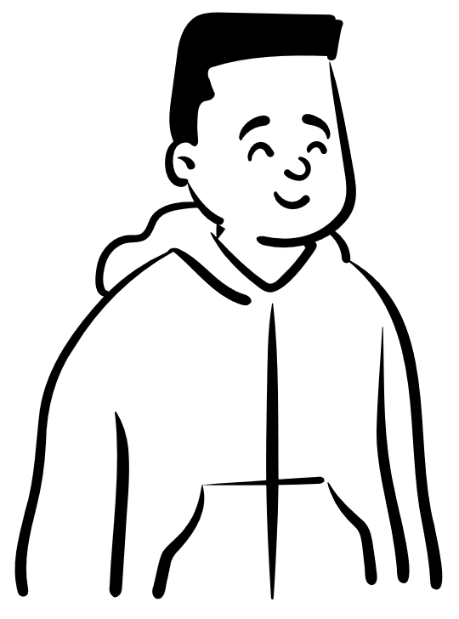

What do we do with it and how we keep it safe?
We keep the information we collect about you. This information is called your Health Record. Anyone involved in your care at the Practice can see what has been collected. This helps us make the right decisions about your care when you are poorly. We might need to share this information with others, such as a hospital so the doctors and nurses there also have access to your information to treat you and help us keep you healthy.
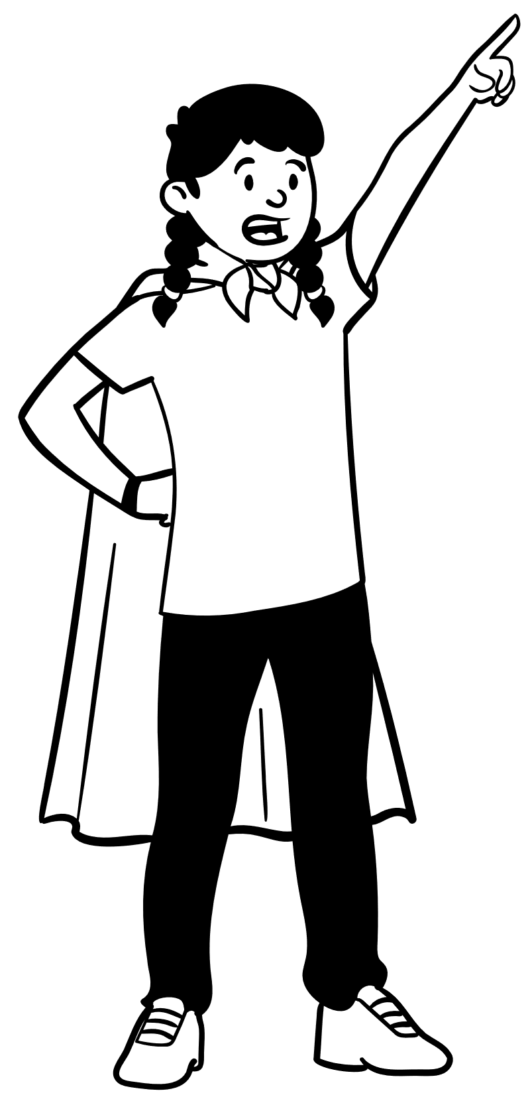
We undergo training every year to make sure we know
how to look after your data. Staff are only allowed to look
at your information if they are involved in your care and
must keep all your information safe. We are only allowed to
give your information to authorised people.

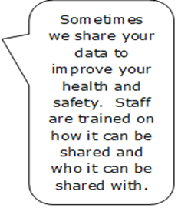
Who do we share your data with?
We can share your data with other doctors and nurses, including the ones at school.
We may share the information we record about you with others involved in your care. We routinely share information with school nurses, but not directly with school unless it is important for them to know. We might need to share this information with other medical teams, such as hospitals, if you need to be seen by a special doctor or sent for an X-ray. |   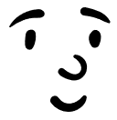
Your parents/guardians should get a copy of any letters sent by your doctor about your care. Some of you may decide that you do not want information being shared with your parents/guardians, we advise you to speak with a member of our team if you have any questions about this. |   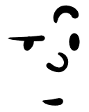  If you don’t want us to share your data with someone, please tell a member of staff…
If you have a social worker, we will share it with them too. That way they are kept up to date on what we are doing for you.

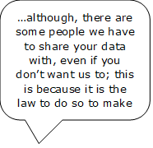
We may have to share information with the police, the courts and other organisations and people who may have a legal right to see your information.
If you tell us something that makes us worried about your safety or the safety of someone else you know, we might have to share this with other people outside of the practice – even if you don’t want us to. This is part of our job to keep you and others safe. | 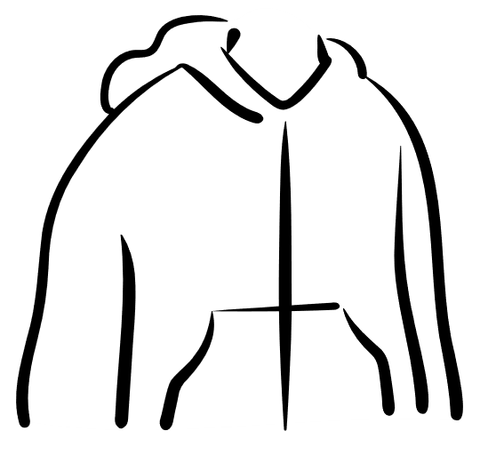
Sometimes our surgery might be asked to take part in medical research that might help you or other people in the future. We will always ask you or your parent(s) or adult with parental responsibility if we can share your data.

What if you don’t want to share?
You may only want to share data with people involved in your care. If so, tell a member of staff.
You can tell us that you don’t want to share your information. It is called ‘opting out’ and every patient has a right to do so. You can choose to opt out of sharing your confidential information for research and planning, it is called National Data Opt Out. There may still be times when your information is used, for example when there is risk to your health or the health of other people. | 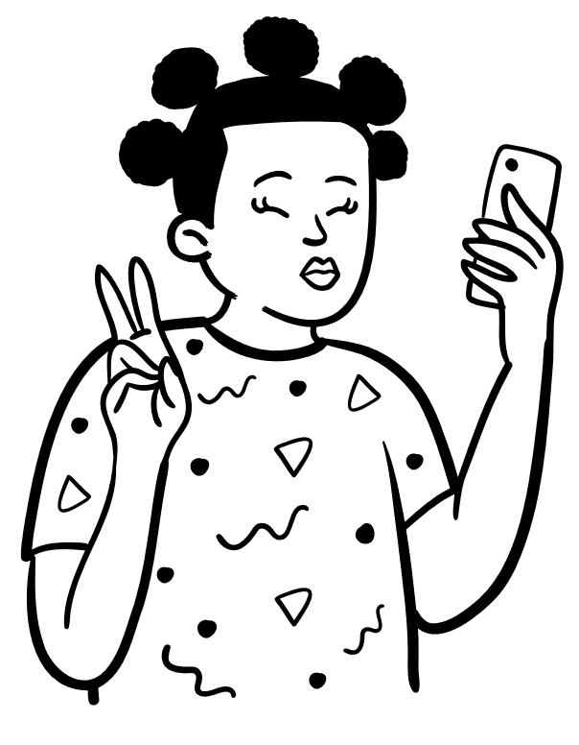

How long do we keep your information for?
We will keep a copy of your information in our Practice for as long as you are registered as a patient. If you leave the Practice, we will make sure that a copy of any information we hold about you is passed to your new GP so they can continue with your care. The practice must follow the NHS Records Management Code of Practice 2021. This is a document that tells us how long we can keep records for. Once the records have been kept for the time needed, they will be safely deleted / destroyed. | 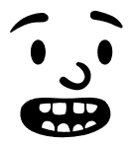  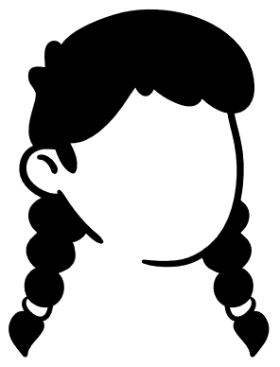  We follow a special code which tells us how long we can keep your data for and what to do with it once we can no longer keep it.

Can I have a copy of my medical records?
You or your parent/guardian can ask for your data. If you are old enough, we will ask your permission to release anything.
Yes. You or your parent/guardian need to contact us to specify what information you would like to access. This could include a particular part of your medical record, an X-ray, or a report. If your parent/guardian is making the request on your behalf, we will verify their identity to ensure that we share your information appropriately, and obtain your consent, if necessary. | 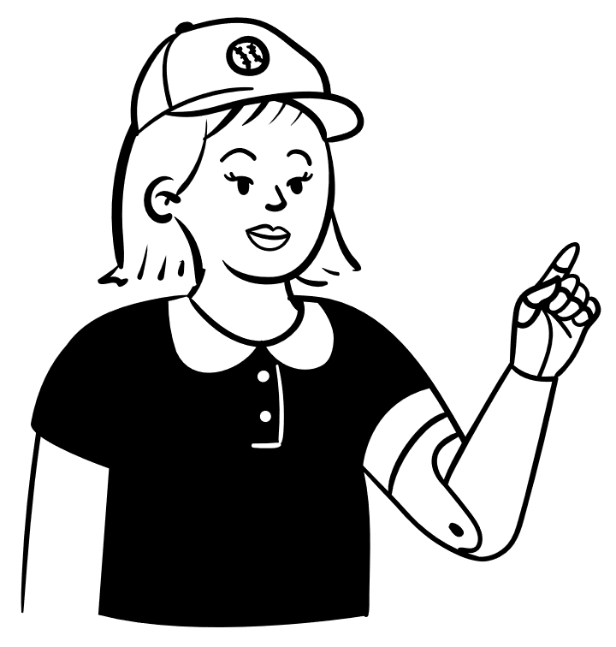

What are your rights over your personal data?
You have the following rights over your data we hold:

- You can see what information we have on you. Other people can ask on your behalf, however we will check they are who they say they are to make sure we are not sharing your information with anyone who should not see it.  - If there is anything incorrect in your record, you or someone on your behalf can ask us to correct it, including finding any missing information. However, the law says we cannot remove it, even if you ask us to.  - If we have asked for permission to share your information with someone, you or someone on your behalf can tell us that you have changed your mind. As soon as we are told, we will not share the information.  - If you would like to talk to us about not sharing your information, even if this means you do not want us to share your information with your parent(s) or adult with parental responsibility, please let us know. We will be happy to help. |   You can ask us to see your data, correct anything that’s wrong, take back your permission and stop sharing your data

What if you have a question or if you are not happy with how we process your data?
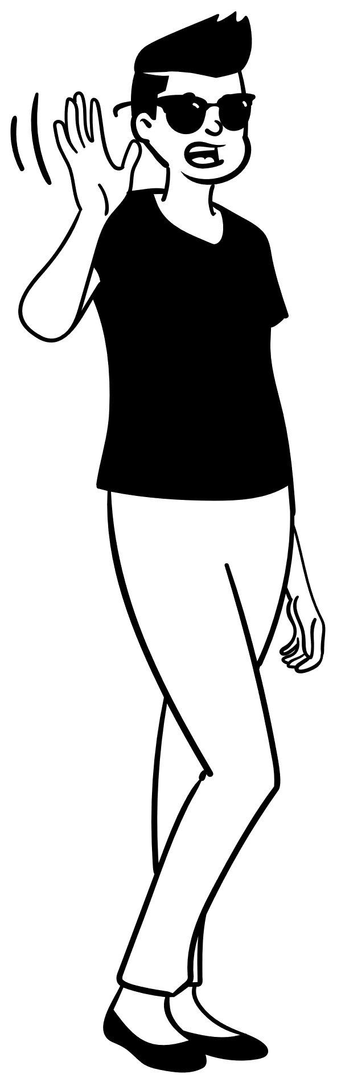
If you have a question or if you are not happy about the way your information is managed, you can either email us on Cheshireccg.cumberlandhouse@nhs.net, visit the Practice or call us on 01625 428081 and speak to a member of our staff who will be happy to talk to you and answer any questions or worries you might have . We will do our best to help you. You can also ask your parent or adults with parental responsibility to speak to us on your behalf. If you are still not happy after speaking with us, you can contact the Data Protection Officer (DPO) by email at dpo.healthcare@nhs.net or you can telephone the DPO team on 07946 593082. | If you have any questions or are unhappy with how we treat your data, contact the practice first. They will do their best to help.
If you are still not happy with the advice you have received you can contact an organisation called Information Commissioner’s Office (IC0) by visiting www.ico.org.uk and select ‘Raising Concern’ or call them on 03031231133.

