
GREENMOSS MEDICAL CENTRE

Welcome to our Practice
We are a three doctor non-limited partnership. We have a dispensary for eligible patients. Staff members are as follows:

Doctors
Dr Sarah L Bennett MBChB (Aberdeen 1991)
Dr Neil A Bailey MBChB (Edinburgh 1986) MRCGP
Dr Christiane D Bunte State Exam Med 1995 Universitat Dusseldorf

Advanced Nurse Practitioner ANP
Dequilla Jenkinson

Practice Nurse
Suzanne Talbot RCN (Clinical trainer re Healthcare Assistants)
Vicki Malkin RCN

Health Care Assistant/GP Assistant
Rachael Humphreys

Practice Manager
Janet Weaver MSc, BA (hons)

We are not a GP training practice. However, we are committed to the training of practice-based staff to their full potential. Some months the practice closes between1pm-5pm for Practice Learning Time – details will be displayed in reception and on the practice website

Reception is open: Monday to Friday 8.00-18.30

How to register as a patient
Please ask for a form at Reception. You will be required to give your address so that the receptionist can check that you live within our practice area. We will also ask for proof of identity.
If you live outside the practice boundary, you will be advised to register at another surgery nearer your home.
If you are accepted as a patient, you will be asked to make an appointment so we can obtain details of your past medical history and current health status. All children under 5 years of age will have their details passed on to our Health Visitor who will contact the family for the same reason.

Practice Area
If you require clarification of the area that the practice covers, please speak to the Practice Manager.

Disabled Access
There is full disabled access and patient services are based on the ground floor.

Confidentiality
ALL members of the practice and attached staff are bound by the rules of confidentiality and records are held in accordance with the Data Protection Act and NHS code on confidentiality. Your personal and medical details will not be discussed with anybody else unless we have your permission to do so.

Change of address/personal details
If you move or change your telephone number or personal details please inform the surgery so that records are kept up to date. This will enable us to contact you without delay if necessary. We will use your mobile phone number as our initial contact method so please make sure that we have your current one.

Mobile phone policy
Please ensure mobile phones are switched to silent while you are in the surgery.

Additional services
We offer a range of services in addition to doctor appointments to support your needs.

Practice nurse
The practice nurse offers the following services.
- Cervical smears
- Dressings
- Asthma checks
- Diabetic checks
- Removal of stitches
- Family planning advice
- Injections
- Travel vaccinations (please pick up a questionnaire before your appointment, complete it and return so that the nurse can research what is needed prior to your appointment. Please make the appointment at least 8-10 weeks before you travel
- Treatment of minor injuries
- Chronic heart disease checks
- Chronic lung disease checks

Health Care Assistant
Appointments can be made with the health care assistant for blood pressure checks, NHS Health Checks and new patient checks. They will also perform ECGs and 24hour blood pressure monitoring at the request of a doctor.

Phlebotomy Clinics
Twice weekly phlebotomy clinics are held for blood tests only. If you are unable to attend the clinic alternative arrangements can be made. All blood tests must be taken in the morning.

Dietician
The dietician provides dietary advice for patients with medical problems eg diabetes, cholesterol abnormalities, bowel disorders, metabolic disorders.
A monthly clinic is held at Greenmoss Medical Centre. Appointments are arranged via the doctor or practice nurse.

Social Prescriber
The Social Prescriber can help to signpost patients to other services (medical and non-medical) and supports a range of issues including mental health, social isolation, money worries etc. Please book an appointment via the Reception

Physio
We have an on-site physiotherapist who will help patients with musculoskeletal problems. Please book an appointment via the Reception.

Pharmacist
We have a Pharmacist working remotely providing telephone support to patients with medications concerns. They will also carry out medication reviews with patients on behalf of the GPs.

Community links
We work closely with other health care professionals.

Community Nurses
They are based at Alsager Clinic 01270 275140 (answerphone)
The team provides nursing at home for those unable to visit the surgery or hospital. Care is given for acute and chronic illnesses eg post operative care, dressings, injections, terminal care, general advice and health education. They teach and support carers and offer advice on statutory and voluntary services that may be available.
The District Nurse visits your home to do an individual assessment of need, plan the required package of care or refer to the appropriate service to meet that need.

Health Visitor
The health visitor supports families and the elderly in the community. They provide advice on child care and accident and illness prevention including child health care surveillance checks at 7.5 months and 2.5 years. The GP and health care staff will provide a 6 week check on babies.
Baby clinics are held at Alsager clinic (for weighing and advice). The health visitor can be contacted at Alsager Clinic on 0300 123 4767

Community midwife
The community midwife provides antenatal care in the surgery and at home. Antenatal clinics are held at Greenmoss Medical Centre. Parentcraft classes are held at the Alsager clinic.
Details of how to contact the midwife are available at reception.

Pharmacy First - Minor Ailments Scheme
The minor ailment scheme is designed to give patients improved access to treatment for minor ailments. Community Pharmacies in Alsager, Sandbach and Congleton are able to offer advice and, if necessary, prescribe medication (with exceptions) to treat a range of health conditions.

Other resources for self-care and minor ailments can be found on www.nhs.uk

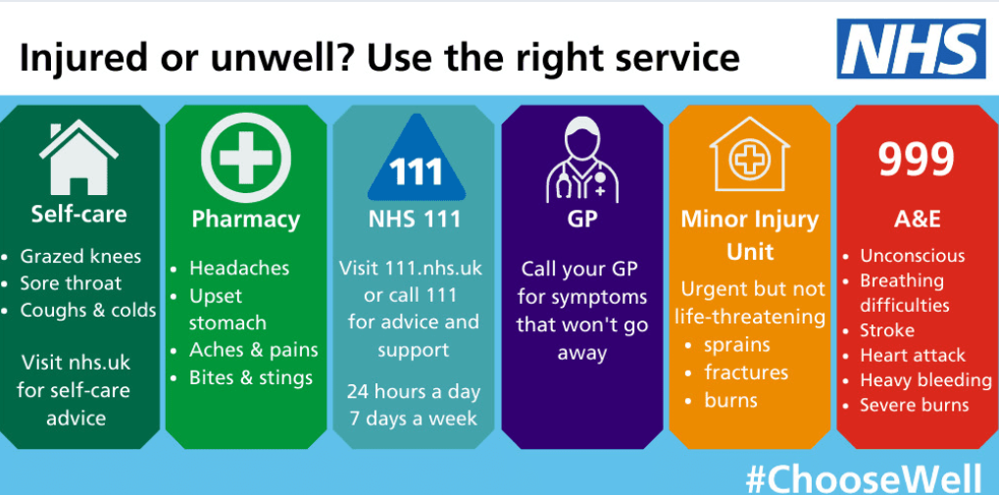

Appointments
All consultations are by appointment. Please contact reception to make an appointment. Alternatively, you can book appointments online –please ask reception for details. We offer a text reminder service for appointments – please inform reception if you do NOT want this.

Please be prepared to give the receptionist the reason for the request so that we can ensure you have the most appropriate appointment. If you do not provide this, we will not be able to make you an appointment.

If you feel you have a complicated problem or several things to discuss, please ask the receptionist for a longer appointment to help avoid delays for other patients.

If you are unable to attend an appointment, or no longer need it, please inform the receptionist as soon as possible so that it may be offered to another patient whose need may be urgent.
You may request a suitably trained chaperone for any procedure, test or examination. Friends and family are not permitted to act as chaperones, however, they may be present during the procedure/examination if the patient is content with this decision. Please note – both male and female clinical team members work within the practice, if you have a preference, please ensure you discuss this when you book your appointment

Urgent appointments
If you feel you have an urgent appointment which cannot wait until the next available routine appointment, please phone as soon after 8.30am as possible and tell the receptionist.

Home visits
These are available only for patients who are housebound or too ill at present to leave the house.
If you feel that a home visit is necessary, please telephone the surgery before 10am if possible. Please give the receptionist some details of your problem and also a contact number so that we may make an assessment of the urgency of your problem. A doctor or nurse may wish to call you to discuss your problem with you.

Services

Fit Notes
If you're off work sick for 7 days or less, your employer should not ask for medical evidence that you've been ill. Instead they can ask you to confirm that you've been ill. You can do this by filling in a form yourself when you return to work. This is called self-certification.

If you're off work sick for more than 7 days, your employer will usually ask for a fit note (or Statement of Fitness for Work) from a healthcare professional. The health professional treating you (doctor, nurse, occupational therapist, pharmacist or physiotherapist) will provide a Fit Note on request, if appropriate. If you are under hospital care for your illness, please ask them to provide you with your Fit Note.

If your employer will not accept self-certificates (e.g. for repeated short absences), you may be given a private certificate for which a fee is payable. Some employers will reimburse this so please ask for a receipt if you need one.

Should you recover from your illness or injury more quickly than expected, you can return to work and resume your normal duties before the end date on the fit note so long as your employer is in agreement with the decision to return to work. If you are not yet fully fit but could resume some level of work, you could return so long as your employer is able to support you in your alternative/reduced role; a Fit Note stating that you “may be fit for work” can be issued. This will state possible changes required. If your employer is unable to accommodate these changes, then the Fit Note is treated as though it said “unfit for work.
There is no longer an option to say that you are fit for work. If your employer requires medical evidence that you are fit for work they should help you arrange this privately with a healthcare professional or occupational health specialist.

Private Fees & Examinations
Certain services are not paid for by the NHS so a private fee is charged. Details of current fees are available from reception. In most cases we ask for the fee to be paid before collection.
Private medicals for life insurance, certain sports, HGV and PSV drivers etc can be arranged via reception. The medical examination usually takes 20-30 minutes. The fee will be charged to yourself or your insurance company.
Other private services include private sick notes, private prescriptions, private medical insurance claim forms, solicitors letters, holiday cancellation forms etc.

Repeat prescriptions
Please see separate leaflet explaining how to order and collect repeat prescriptions. 3 working days are required for repeat prescriptions.
If you should require an emergency supply of medication when we are closed, a community pharmacy may be able to assist with this and there may be a charge for this. You will require proof of items prescribed. NHS.UK gives details:
https://www.nhs.uk/common-health-questions/medicines/where-can-i-get-an-emergency-supply-of-medicine/

Family Planning
All the doctors provide a full range of contraceptive advice. Information can also be obtained from the practice nurse. Requests for emergency contraception will usually be dealt with within 24 hours. Family planning procedures (IUD and implants) are available following consultation with a GP or Practice Nurse.

Cervical Smears
All women aged 25 to 64 years are advised to have regular smear tests, every 3 years for women aged 25-49 and every 5 years for those aged 50-64. The practice nurses take all routine smears. Please inform the receptionist why you are booking the appointment so that sufficient time is allotted and relevant paperwork completed. Your result will be sent to you by letter directly from the screening service.

Samples
If you are asked to bring a sample to surgery, please hand it in at reception, before 11am to allow transportation to the laboratory. All samples must be clearly labelled with name, date of birth and time sample was obtained. The lab will not process samples without this information.

Test Results
When a test is undertaken you should be informed how long it will take until the result will be available. This can vary from a day to several weeks, depending on the test.
You may call in person or by telephone for your results. Please call after 11am when the staff will have more time to help you and the doctors have had time to review the results.

Minor operations by appointment (not walk-in)
We are able to perform minor operations for our patients. Appointments are made following consultation with any of the doctors. The clinic is held at Greenmoss Medical Centre

Out of Hours
If you require medical attention when the surgery is closed, please telephone your usual surgery number and a message will inform you how to contact the on-call service. Please be prepared to note down details.
It is normally one of our own doctors on call during Monday to Friday daytime.
The out of hours service for medical attention in the evening, overnight weekends and bank holidays is provided by NHS111. The contact telephone number is 111. This phone call will be free of charge.
This telephone number will be given on the surgery telephone number. If necessary you may be asked to attend the Out of Hours centre at Leighton Hospital, Crewe.

Other services including emergency dental care/self-care etc can be found on the following website:
https://111.nhs.uk/

Dispensary
We are a dispensing practice. This means we can dispense prescription medicines to our more rural patients. We regret that we are not permitted to dispense to patients who live within 1.6 kilometres (1 mile) of a chemist.
We do stock a wide range of medicines, but inevitably cannot keep in less commonly used ones. Where possible we will try to obtain most for you within 3 working days. If the item requested is not on your regular repeat medication list, whilst we will endeavour to have this ready within 3 working days, on occasion extra time may be required eg around Bank Holidays, medicines in short supply etc.
We are only allowed to dispense medicine during the following hours:
Monday to Friday: 8.30-13.00 and 16.00-18.15

Patient responsibilities
The practice is entitled to:
- receive co-operation, civility and courtesy from its patients at all times
- patience if the clinicians are running late - on another occasion it might be you who needs the extra time
- not to be asked for another member of the family to be seen at your appointment without making prior arrangements
We are an NHS practice and follow the NHS guidelines for violent or abusive patients. The NHS will not tolerate violent or abusive behaviour towards any member of staff, other patients or repeated abuse of its facilities including emergency or out of hours service. If this happens you will be removed from the practice list.

Patients’ rights
Patients at this practice are entitled to:
- be provided with services in a courteous, civil and co-operative manner
- a clear explanation of and advice on the patient’s medical condition and any proposed treatment
- a referral for specialist medical opinion or other second opinion where appropriate
- receive information via the practice about any relevant health promotion exercise and preventative medicine initiatives
- absolute confidentiality of medical records maintained by the practice subject to any provisions for disclosure imposed or allowed by law
- access their own personal health records, in accordance with the Data Protection Act
- have any formal complaint against the practice investigated and dealt with fairly and according to the practice complaints procedure
- request (either in writing or verbally) to be seen by a particular doctor. We shall endeavour to comply with this request but it is not always possible
- a health check on request for patients aged 16-74 who have not been seen at the practice for 3 years
- annual health checks on request for patients who are over 75

Patient Participation Group
We have a group of patients who work with us to ensure that patients’ needs are met in the most appropriate way. The Patient Group can be contacted by leaving a message at reception. If you wish to join the group, please contact the Practice Manager.

Staff training
The Practice is closed one afternoon each month from 1pm – 6.30pm for staff training. The Dispensary is closed 1pm – 5pm. Dates are advertised in the Waiting Room, on the plasma screens and direct to patients via text message.

Suggestions and complaints
We continually strive to improve our services and welcome any helpful suggestions you may have.

Please post your ideas and comments into the Patient Feedback box by the side of the Reception desk or complete the online questionnaire after your appointment.

Sometimes things go wrong and there is a practice complaints procedure in place, which complies with National Guidelines. We value the opportunity to work with our patients, so please speak to our Practice Manager initially if you’re unhappy with our service. A copy of our complaints leaflet is available from reception if you feel you need to make a formal complaint.

Alternatively, you may wish to contact NHS Cheshire and Merseyside integrated care board, Telephone: 0800 132 996

E-mail: enquiries@cheshireandmerseyside.nhs.uk

Writing to: Patient Experience Team, No 1 Lakeside, 920 Centre Park Square, Warrington, WA11QY.

