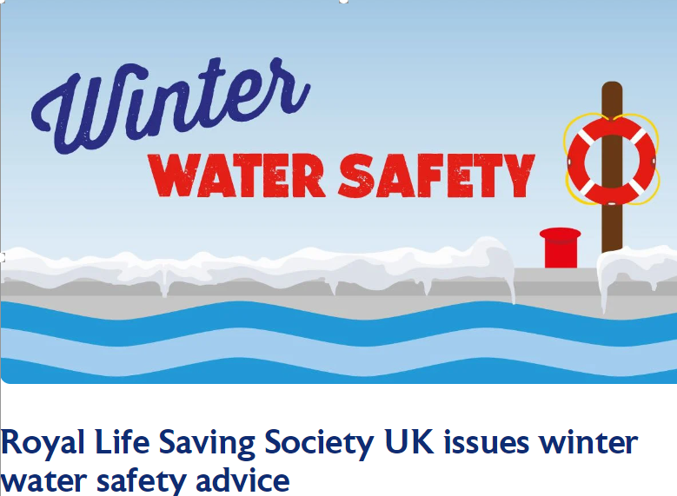

Urgent Winter Water Safety Message

RLSS UK offer safety advice for winter water safety, with simple steps to keep safe during the winter:
- Never go onto the ice to play, to retrieve an object, or a pet
- Never enter the ice to rescue somebody, call 999 and ask for the Fire and Rescue Service
What to do if you fall through the ice:
- Keep calm and shout for ‘help’
- Spread your arms across the surface of the ice in front of you
- If the ice is strong enough, kick your legs to slide onto the ice
- Lie flat and pull yourself towards the bank
- If the ice breaks, work your way to the bank-breaking the ice in front of you anyway
- If you cannot climb out, wait for help and keep as still as possible. Press your arms by your side and keep your legs together. Keep your head clear of the water
- Once you are safe, go to hospital immediately for a check up

What to do if you see someone fall through the ice:
- Shout for assistance and phone the emergency services – call 999 or 112
- Do not walk or climb onto the ice to attempt a rescue
- Shout to the casualty to ‘keep still’ and offer reassurance to keep them calm
- Try and reach them from the bank using a rope, pole, tree branch, clothing tied together or anything else which can extend your reach
- When reaching from the bank, lie down to avoid being pulled onto the ice
- If you cannot reach them, slide something which floats, such as a plastic bottle or football, across the ice for them to hold onto to stay afloat whilst help is on the way
- If the casualty is too far away, do not attempt to rescue them. Wait for the emergency services while calming and reassuring the casualty
https://www.rlss.org.uk/winter-water-safety

Winter water safety | Staying safe on our canals | Canal & River Trust (canalrivertrust.org.uk)

