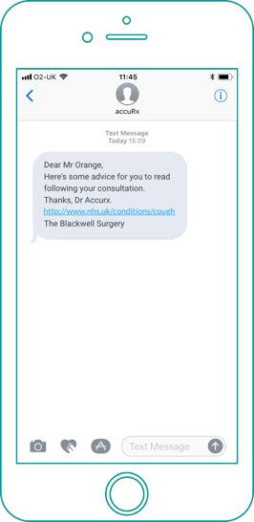
The practice name will always be at the bottom of the message.
You won't be able to reply to them.
Please help us to help you by keeping your number up to date.
If you don't want us to contact you in this way please let us know.
The practice name will always be at the bottom of the message.
You won't be able to reply to them.
Please help us to help you by keeping your number up to date.
If you don't want us to contact you in this way please let us know.
- Reminders or notifications (e.g. prescription ready)
- Responding to simple queries (e.g. if you had a quick question about your medication)
- Letting you know we tried to call
- Sending you advice at the end of a consultation
Some examples of how we might use it...
A system which allows us to easily send text messages to patients.​ It means we can be much more proactive about some communications, messaging you quickly and securely, so you are not waiting around to hear from us!
Chain SMS is...
We are now using Chain SMS to message patients!
- Reminders or notifications (e.g. prescription ready)
- Responding to simple queries (e.g. if you had a quick question about your medication)
- Letting you know we tried to call
- Sending you advice at the end of a consultation
Some examples of how we might use it...
A system which allows us to easily send text messages to patients.​ It means we can be much more proactive about some communications, messaging you quickly and securely, so you are not waiting around to hear from us!
Chain SMS is...
We are now using Chain SMS to message patients!

