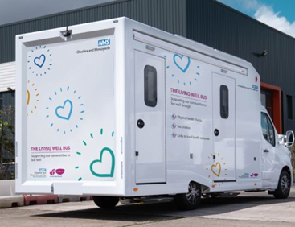

**THE LIVING WELL SERVICE**

**Offering Covid and Flu vaccines across Cheshire West**

|  |  |  |
| --- | --- | --- |
| **Date** | **Location** | **Time** |
| **Friday 4 October** | **Princeway car park**  **Frodsham WA6 6RX** | **10.30-16.00** |
| **Tuesday 8 October** | **Princeway car park**  **Frodsham WA6 6RX** | **10.30-16.00** |
| **Wednesday 16 October** | **Asda Saltney**  **River Lane**  **Saltney CH4 8RH** | **10.30-16.00** |
| **Friday 25 October** | **High Street car park**  **Malpas SY14 8NW** | **10.30-16.00** |
| **Friday 1 November** | **Princeway car park**  **Frodsham WA6 6RX** | **10.30-16.00** |
| **Saturday 2 November** | **Asda car park**  **Wellington Road**  **Ellesmere Port CH65 0BZ** | **10.30-16.00** |
| **Monday 4 November** | **Wagon and Horses car park**  **Western Avenue**  **Blacon CH1 5PR** | **10.30-16.00** |
| **Thursday 14 November** | **Princeway car park**  **Frodsham WA6 6RX** | **10.30-16.00** |
| **Wednesday 20 November** | **Winsford Lifestyle Centre**  **The Drumber Winsford CW7 1AD** | **10.30-16.00** |
| **Saturday 30 November** | **Wagon and Horses car park**  **Western Avenue**  **Blacon CH1 5PR** | **10.30-16.00** |