**Southdene Primary Care Resource Centre   
Bewley Drive, Kirkby, Liverpool, L32 9PF  
Tel: 0151 546 2480  
Website: www.millbrookmedicalcentre.nhs.uk**

***Partners*  
Dr. M.G. Merriman  
Dr. M.J.I. Segarajasinghe  
Dr. G. West  
Dr. A. Fisher**



**Facebook Page**  
The practice has a live Facebook page! Be sure to give us a like and follow for the latest news and updates: **@MillbrookMedicalCentre**

|  |  |  |
| --- | --- | --- |
|  | *Appointments* Help us to help you by ringing from 8am only for an acute, on the day appointment. If you require a routine GP appointment, have an Admin query, or a sick note request; we advise you complete an AccuRx Triage form on our practice website. You can also visit our Appointments section on the practice website for further information/links. | Welcome to our July 2024 Newsletter! |
|  | *Prescriptions*  Patients should allow 48 hours for a prescription request to be completed. Any medication that has not been issued in over 2-3 months may require a review appointment with a GP beforehand, so please enquire at Reception if you are unsure.  If you haven’t already, why not register for the NHS App? It is easy to order your repeat prescriptions via the app. Any patient can register for the NHS App from their mobile/tablet device. Scan the QR code with your camera to register.  Between April & May we had a total of **38 appointments** that were booked from 8am and not attended the very same day. This totals  9 hours and 30 minutes worth of wasted clinician time. Not being able to attend an appointment the same day it is booked should be a rare occurrence, but if for any reason you are no longer able to attend your appointment, please ensure this is cancelled either through the **NHS App** or by contacting Reception. Failing to cancel an appointment that is no longer needed deprives other patients the opportunity of receiving medical attention. Please remember if you do not attend 3 appointments and fail to notify us at least one hour before, you will be deducted from our list.  Remember to Cancel Your Appointment! | Monthly calendar with solid fill    Medicine with solid fill |
| Opening Times  **Monday**  08:00am – 6:30pm  **Tuesday**  08:00am – 6:30pm  **Wednesday**  08:00am – 6:30pm  **Thursday**  08:00am – 6:30pm  **Friday**  08:00am – 6:30pm  Southdene PCRC  Bewley Drive  Liverpool  L32 9PF  Towerhill PCRC  Ebony Way  Liverpool  L33 1XT |  |  |
|  |  |  |

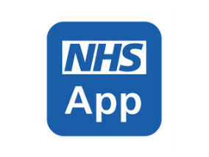

Millbrook Healthy Liver Clinic  
Millbrook Medical Centre is running a research project called the ‘Knowsley Healthy Liver Clinic’. Patients registered at the practice with Type 2 Diabetes or Obesity will be invited to attend this  
clinic. The clinic will involve a painless bedside scan  
(Fibroscan) to screen for liver fat and liver scarring. We will  
also look at your weight, diabetes control, cholesterol,  
blood pressure and risk of heart disease and discuss  
ways to improve your ‘metabolic’ health.

Patients can opt out of the liver clinic or attend the liver  
clinic without taking part in the research study if they wish.

Local Pharmacy  
Contact Numbers

**Leeside:**0151 546 2988 **Westvale:**0151 546 9708 **Kirkby Town:**0151 548 5480 **Towerhill:**0151 549 1308 **Broad Lane:**0151 546 6016 **St Chads Walk In Centre:** 0151 546 6454 **Harvals (St Chads Parade):** 0151 549 1818 **Tops Pharmacy:**0151 547 1734  
**Copplehouse Lane:**0151 525 1160



**Southdene Primary Care Resource Centre   
Bewley Drive, Kirkby, Liverpool, L32 9PF  
Tel: 0151 546 2480  
Website: www.millbrookmedicalcentre.nhs.uk**

|  |  |  |
| --- | --- | --- |
|  |  | Doctor using tablet |

Pharmacy First  
“Pharmacy First” is the new service launched nationally on 31st January 2024. Almost all pharmacies now offer the Pharmacy First service, giving advice and, if needed, NHS medicines to treat seven common health conditions – and all without the need for a GP appointment.

Speak to Reception who can refer you for:  
  
*- Sinusitis (adults & children aged 12 and over)  
- Sore throat (adults & children aged 5 and over)  
- Earache (children & young adults aged 1 – 17 years)  
- Infected insect bite (adults & children aged 1 and over)  
- Impetigo (adults & children aged 1 and over)  
- Shingles (adults aged 18 and over)  
- Urinary tract infection (women, aged 16 to 64)*



Abdominal Aortic Aneurysm Screening

The Abdominal Aortic Aneurysm Screening Programme is available to men over the age of 65 and is aimed at early detection and prevention of a burst AAA. About 8 in every 10 people who have a burst AAA die before they get to hospital or do not survive emergency surgery to repair it. The service is ran by Liverpool University Hospital.

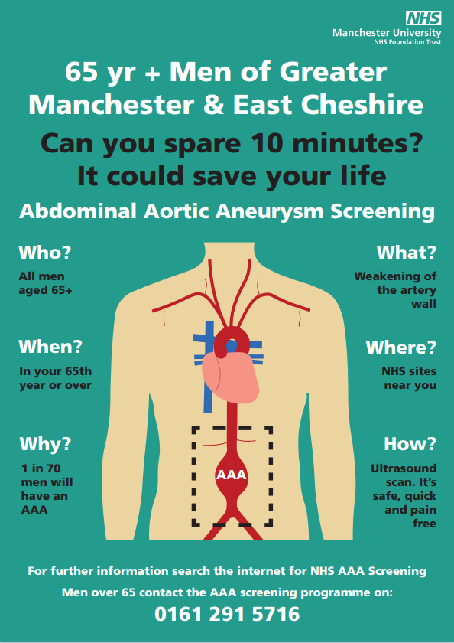

**Scan this QR code with your smart phone for more   
information, or visit** [***www.nhs.uk/aaa***](http://www.nhs.uk/aaa)

**Men over 65 or if you have missed your appointment contact your local screening programme on *0151 706 4767***



**Southdene Primary Care Resource Centre   
Bewley Drive, Kirkby, Liverpool, L32 9PF  
Tel: 0151 546 2480  
Website: www.millbrookmedicalcentre.nhs.uk**

|  |  |  |
| --- | --- | --- |
|  |  |  |
|  |  |  |
|  |  |  |
|  |  |  |
|  |  |  |
|  |  |  |
|  | **DID YOU KNOW? …**  We offer direct Physiotherapist appointments at both Bewley Drive & Towerhill sites. If you have any pain in your joints, muscles, or back; the Physiotherapist can give you an exercise plan, send you to the hospital for scans, and even talk to one of our GPs about giving you medicine for the pain. Simply speak to Reception if you would like to book in today. |  |

Kirkby ENT (Ear, Nose, Throat) Service  
SK Health offer an ENT service for ear micro suctioning, nasal cauterising and throat cameras.  The waiting time for the service is around 2 weeks and it is delivered by a GP with a Specialist Interest. If you think you would benefit from a referral into this service, submit an AccuRx link on our practice website today!

|  |  |  |
| --- | --- | --- |
|  | SmokeFree Knowsley SmokeFree Knowsley offer appointments with people who would like to quit smoking at Towerhill Resource Centre every Tuesday morning. Signing up is quick and easy, just call the office on 0151 426 7462.  The service is offered over the phone if you prefer, or they have Face-to Face appointments at Towerhill on Tuesday morning or Kirkby Library on Monday afternoons.  They offer a choice of NRT patches, mouth spray, gum, lozenges, inhalator, Zyban tablets and a vape through their partnership with Totally Wicked, or just support from an advisor if that is what is preferred.  Clients can have products for up to 12 weeks, and they will call or see patients every week to monitor their progress to hopefully being smoke free for good.  Find more information at [www.smokefreeknowsley.org.uk.](https://l.facebook.com/l.php?u=http%3A%2F%2Fwww.smokefreeknowsley.org.uk%2F%3Ffbclid%3DIwZXh0bgNhZW0CMTAAAR3WU43PtCQ3iAHxg6Mkh7nzLO8eRJFhfjyrxk-b6-uchlt_97T8Z3WyXlM_aem_ZmFrZWR1bW15MTZieXRlcw&h=AT3f25Qs9SIPNzyCofDIpB_Uu3W6y5HuRtC2SouOIRLoMWMI0DZGmjSW72TSQORmwQCRCtZ21SNqgQhORnfEPFDfRPSkxcoj99qlECe8-dfy5Cvi6J0qob7D_uWRuZINC6Md&__tn__=-UK-R&c%5b0%5d=AT2qfyKUNSONda57gG7j5LTGa3imPaKwjUnNlVFWwlLguCmZYvdGJULrNkezGDI2ZZZzXmVYfkGL7jb-QwLK_ZvFD3ksIhO12ot-yE2QIfFukVDfXszJYnhhDZKnccL6_e089BMyFfiNGt9p0bbppbePmA2Gk3wdWa8ichUbUeBl9zzhkcWTNHJ6tNQo054T6-I3L1ZxJr9bhSkWHlgZ1hEWlaq6Vw) No smoking with solid fill |  |
| **Southdene Primary Care Resource Centre  Bewley Drive, Kirkby, Liverpool L32 9PF Tel: 0151 546 2480 Website: www.millbrookmedicalcentre.nhs.uk** |  |  |
|  |  |
| **Mental Health Matters**  Qwell is a free, safe and anonymous online mental health and wellbeing service for adults.  Signing up is quick and easy, no GP referral is required and you can talk to them about anything.  Visit their website at [https://www.qwell.io/](https://l.facebook.com/l.php?u=https%3A%2F%2Fwww.qwell.io%2F%3Ffbclid%3DIwZXh0bgNhZW0CMTAAAR2wzWh-80I4Hd32yq3e1nt46KXsKQs83q1kGtv_-gCfDUK-rwP7L9RqbRk_aem_AdJYWkwayzr1vKfERztjxV01DZ-9U3j8RjMW4TpowY7oOjnKWqCszYLxGeQw60Jp23xr2BAS5Lk7JtvnE6ukeqep&h=AT3hkr6ELvy4mO4Qejbe-Yk19C8DxpxAhJ6mGS-1K8TARKu4sS2KgfH2n7GlP8Q-TD-VA-C9xgLjUFYZCSqDLL3RmGJuIx0EBH7PzUB9SY0i-pexT8eBDiErzGjSupeNnSW3&__tn__=-UK-R&c%5b0%5d=AT2JvgzZkkZzsQ95MCYbod2Qzl4W-NJ2-KrjVfmYy7HWV4Iy2EX8GmKNTbtVzTBXz544shLlcNiCHZUui4kL4yDeamg-xK-H7FwqB2dR_PksdQ-wx6_9s1r1NRTPBBy8SAFR1p6h4g1jpxJz2zQHt2mAU5z794nX4XcfIstT8vBm84l7TuzZhODnijHQSYOfmjv8RfrIfv_HSGHXG8AZ6EGKMBm609M_OpDo) for more informationA logo with a black background  Description automatically generated |  |



**Southdene Primary Care Resource Centre   
Bewley Drive, Kirkby, Liverpool, L32 9PF  
Tel: 0151 546 2480  
Website: www.millbrookmedicalcentre.nhs.uk**