**World Suicide Prevention Day**

**September 10th, 2024**

**Promoting worldwide commitment and action to prevent suicides**

**Stoptober this October**

**Encouraging the nation’s smokers to make a quit attempt for the month of October and beyond**

**World Breastfeeding Awareness week****1st-7th August 2024**

**The global campaign that aims to inform, anchor, engage and galvanise action on breastfeeding and related issues**

**Know your numbers week; Encouraging adults to know their blood pressure numbers and take the necessary action to reach and maintain a healthy blood pressure**

**9th – 15th September 2024**

**CONTACT US AT REGENT HOUSE SURGERY**

**01257 442628**

**Email:** [**Lscicb-csr.regenthousesurgery@nhs.net**](mailto:Lscicb-csr.regenthousesurgery@nhs.net)

**Website:** [**www.regenthousesurgery@nhs.net**](http://www.regenthousesurgery@nhs.net)

**Regent House Surgery – Facebook/Instagram**

**Please can we politely ask, if you are unable to attend an appointment, please call us to cancel it so the slot can be given to another patient.**

**To cancel appointments please call the surgery, send us an email, or cancel via the NHS app.**

**Please ensure you keep us updated of any changes in your contact details.**

**Well done to our receptionist Julie who completed her skydive for the Suzy Orrsome Foundation!**

**We have recently placed new practice signage outside; the staff have a brand-new uniform, and the refurbishment of the surgery continues. We thank you for your continued support and patience on creating an improved space for you all.**

**Our new website is now live!** <https://www.regenthousesurgery.co.uk/>

***Practice News***

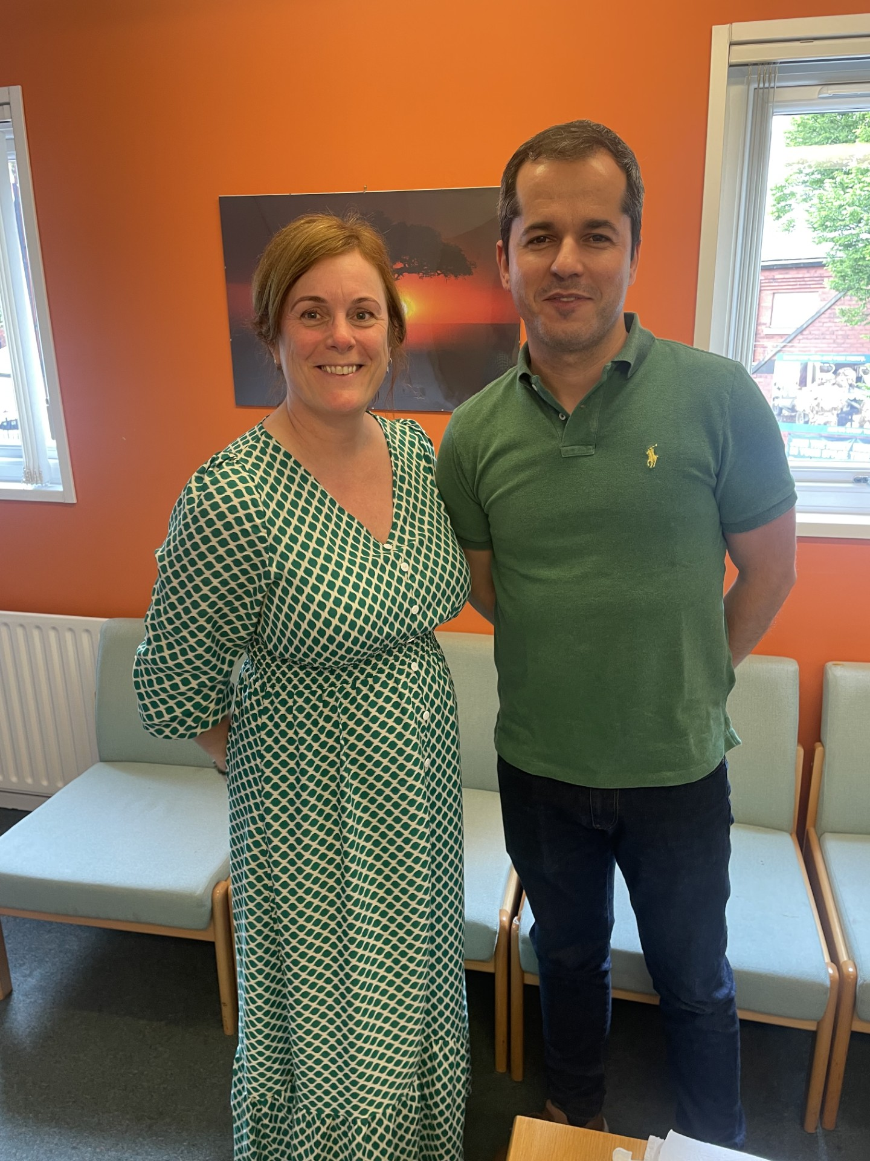

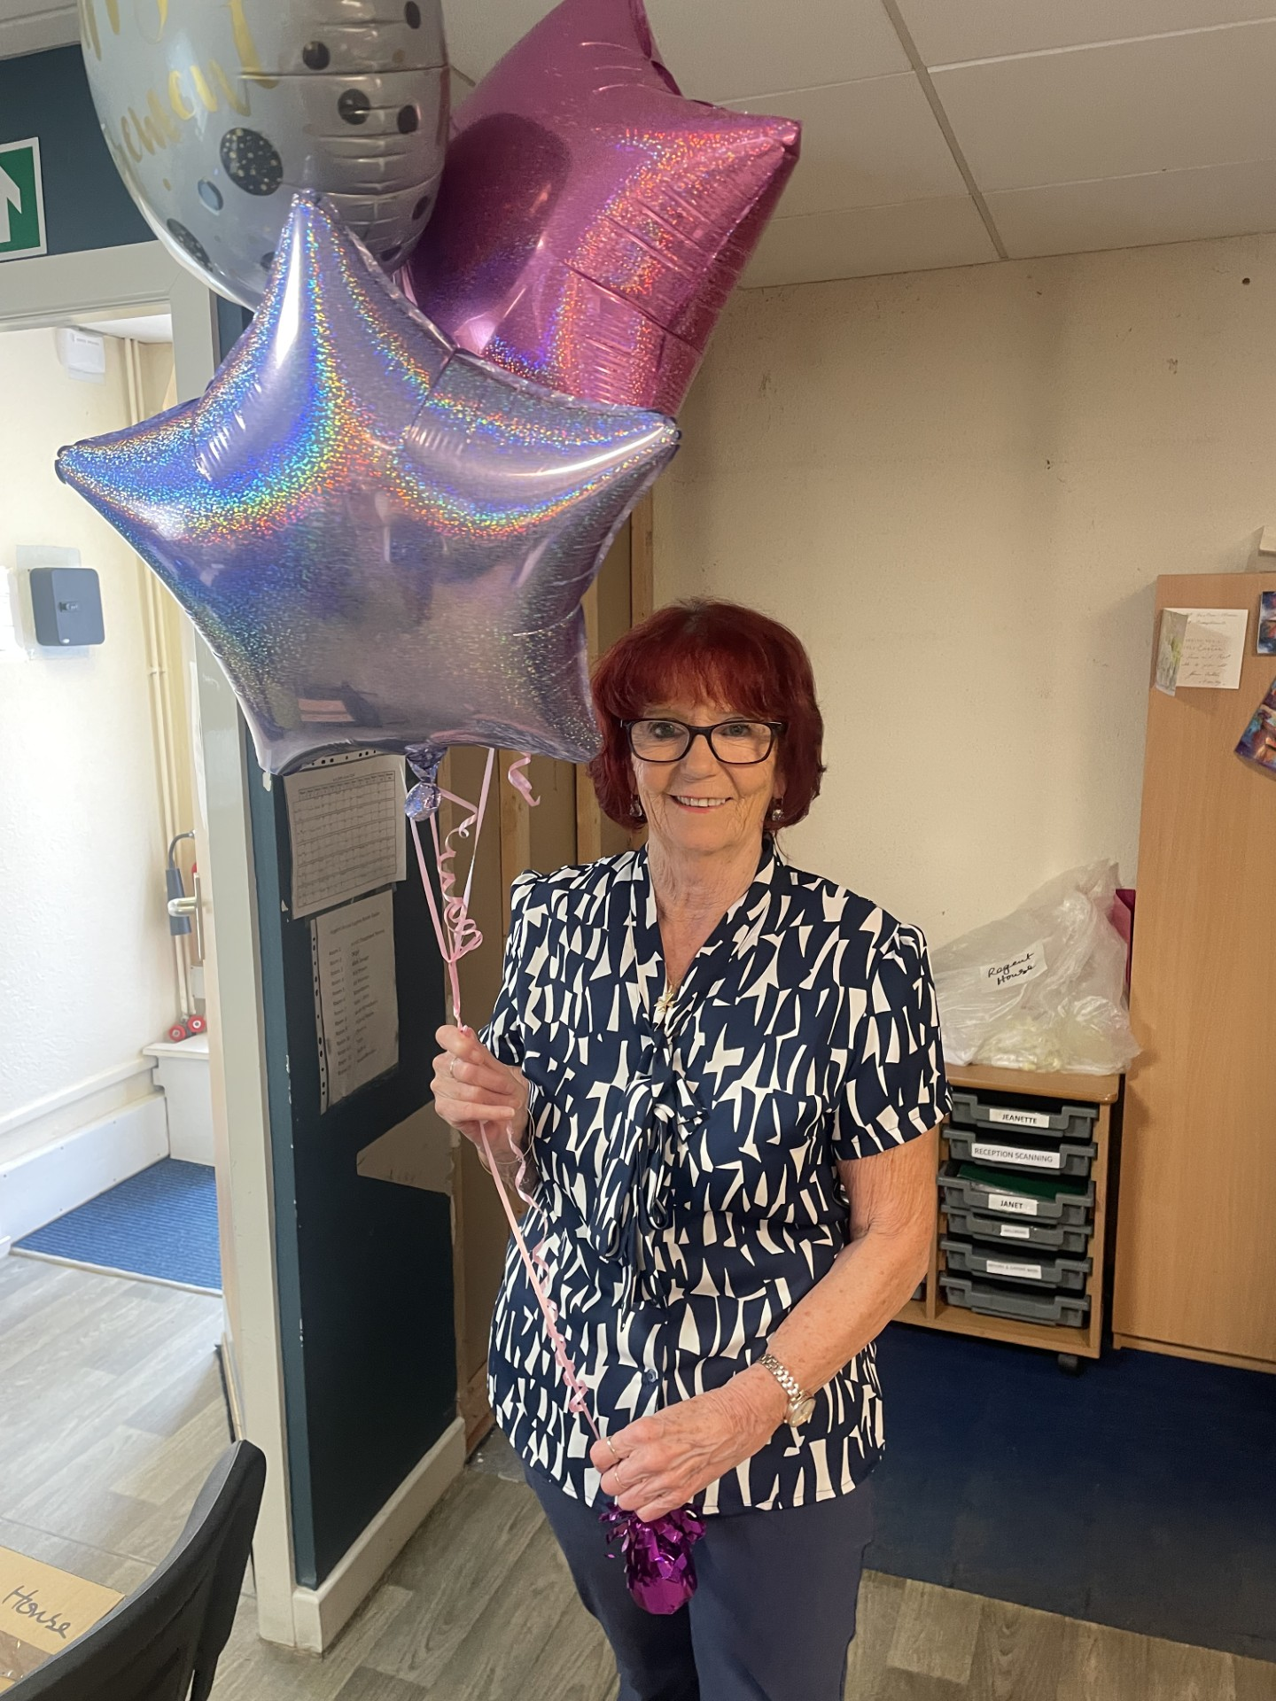

**Recruitment** – No current vacancies

***Staffing and Service Updates***

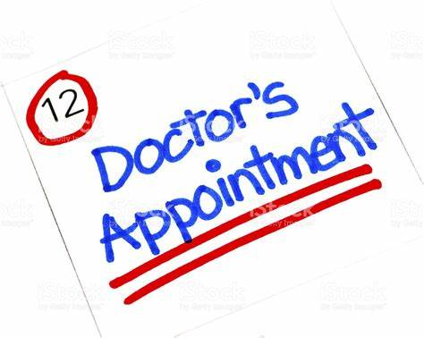

***Your Feedback is important to us!***

***Upcoming Health Campaigns***

**At the end of June, we said goodbye to Margaret as she retired from the practice. Thank you for everything!**

**Together we raised awareness for Mental Health Day #wearitgreenday**

**Following on from our recent patient survey results we wanted to make you aware of our extended access appointments. We offer a limited number of face-to-face GP appointments and telephone appointments Monday to Friday; we also have GP face to face and practice nurse appointments available on a Saturday**

**Our news is not all medical, and we welcome suggestions and ideas for any future editions**!

**We are currently accepting new patients; you can collect a registration form from reception or now register via the online GP registration service.**

**Welcome to our August 2024 Newsletter**

**To provide professional, accessible, and comprehensive healthcare in a friendly environment with our patients at the centre of the service**

***General News***



