



WHAT IS SOCIAL PRESCRIBING?

Many things affect your health and wellbeing. GPs tell us that a lot of people visit them feeling isolated or lonely. Or they might be stressed out by work, money or housing problems. Sometimes it may be the stress of managing a long-term condition.

That is where Social Prescribing comes in. It starts with a conversation. It might be the conversation you have just had with your doctor, or with another person in the practice team. They will refer you to a Social Prescribing Link Worker.
The Link Worker is there to listen to you and put you in touch with the people and activities that might help you to feel better.

Your Link Worker could introduce you to a community group, a new activity such as volunteering or a local club. They might help you find legal advice or debt counselling. They might just help you find information and guidance: a bit of inside knowledge on your situation or what local resources there are. They could even support you to create something new such as a walking group, sports club, gardening club, a fishing group, a ‘men’s shed’ lunch or knit and natter group.
Social Prescribing can help you to gain more control over your own health and find ways to improve how you feel in a way that suits you.
It is open to everyone, whatever your age, gender, circumstances or background.
Studies show that people get better and feel better faster than those treated with medicine alone. And because it works, it is happening more and more – including here on The Fylde Coast.
For more information about Social Prescribing speak to your GP Practice.


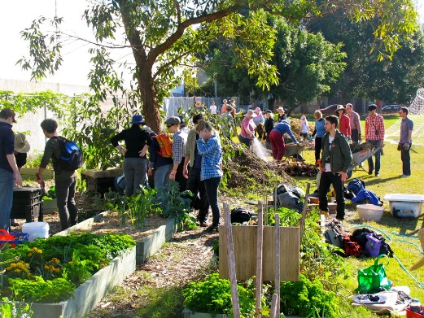
“I thought I was just nothing.
Now I feel really good.

Every morning I wake up

with a smile. I think I’ve got

a bright future as well.”
AS – on her experience of social prescribing

