PATIENT REGISTRATION FORM
AUGHTON SURGERY
19 TOWN GREEN LANE, AUGHTON, LANCASHIRE, L39 6SE
Please use BLOCK CAPITALS and answer all questions.
PT No: …………………………
The details provided will be included in your medical record.
PERSONAL DETAILS
Mr
Mrs
Miss
Ms
Surname: ………………………………………..
Previous Surname: …………………………….
First Names(s): ………………………………
Date of Birth: …………………………..........
NHS No (If known): ..……………………….
Town & Country of Birth: …………………..
Email Address: …………………………......
Current Address: ……………………………................
…………………………………………………………….
…………………………………………………...............
Post Code (compulsory): ……………......................
Home Telephone: …………………………....…........
Mobile Telephone: …………………………………….
Work Telephone: ………………………………………
PREVIOUS GP DETAILS
Have you ever been registered with a GP in the UK?
Yes
No
Name & Address of your previous GP (compulsory): ………………………………………………….........
………………………………………………………………………………………………………………………
Your previous address in the UK (compulsory): ……………………………………………………………...
………………………………………………………………………………………………………………………
………………………………………………………………… Post Code (compulsory): …………………….
IF you are from abroad the date you came to live in UK: …………………………………………………...
Your first address in the UK: …………………………………………………………………………………...
Date you first came to the UK: …………………………………………………………….............................
Date you left the UK if previously resident in the UK: ……………………………………………………….
Have you ever been registered or attended a GP in the UK?
Yes
No
If YES Name & Address of GP: ………………………………………………………………………………..
Military Veteran Details




Are you a Military Veteran? Yes No
Details of service history:………………………………………………………………………………………..

Are you registering a child under 5 years of age?
I wish the child above to be registered with the practice for child health surveillance.
Important information please read our privacy notice before signing the below. This can be accessed via www.aughtonsurgery.nhs.uk – by signing you are agreeing to the terms detailed in the notice. If you are unable to view online, we can provide a printed copy.
Consent to join Aughton Surgery:
Signature of Patient: …………………………………………………...….… Date:…….…………………
Signature on behalf of Patient: …………………………………….………. Date:…….…………………
Name of signatory: ,,,,,,,,,,,,,,,,,,,,,,,,,,,,,,,,,,,,,,,,,,,,,,,,,,,,,,,, Relationship to Patient: …………………………
(all persons over the age of 16 must sign their own form)
Health & Lifestyle
Do you take regular medication?
Yes - please make a routine appointment with the practice nurse before your next prescription is due,
bringing with you details of your medication.
No – please make an appointment with our Healthcare Assistant for a routine health check.
Do you have any long term illness or health problem?
Do you live alone?
Yes (please see below)
No
Yes
No
Are you single / married / divorced / separated / widowed? (please circle)
Are you a carer?
Yes
No
(person who looks after someone who is ill, frail, disabled or mentally ill)
Do you smoke?
never smoked
I smoke
I smoke a
….. cigarettes per day
Do you want to stop
smoking and require
support/advice
pipe
ex-smoker
Do you drink alcohol?
Yes
No
Alcohol units
Pint of beer/lager = 2
Alcopop/bottled larger = 2
Single measure spirit = 1
175ml glass of wine = 2
Bottle of wine = 9
Questions - Scoring System
How often do you have a drink that
contains alcohol ?
0
1
2
3
2-3
times
per week
4
Score
Never
Monthly
or less
2-4 times
Per month
4+ times
per
week
How many standard alcoholic drinks do
you have on a typical day when you are
drinking?
1-2
3-4
5-6
7-8
10+
How often do you have 6 or more
standard drinks on one occasion?
Never
Less
than
Monthly
Weekly
monthly
Fitness please tick which best describes your level of fitness.
I do avoids exercise light exercise moderate exercise
Diet please tick which of the following best describes your diet
Normal Healthy Weight reducing Diabetic
More than three times per week
Vegetarian Other ………………….

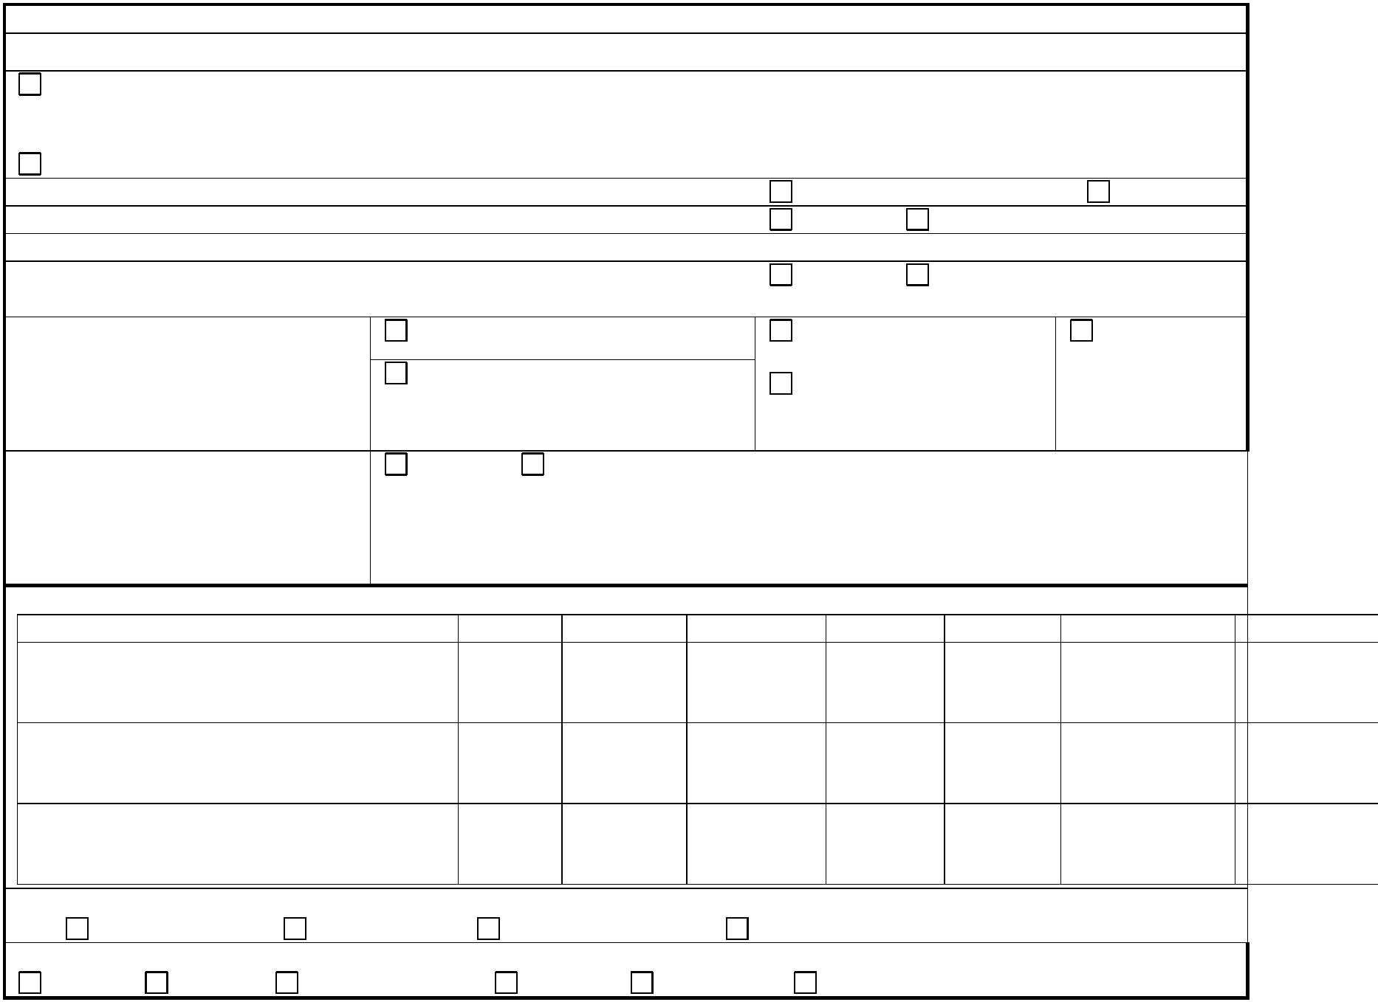

Your ethnic group
Please choose one of the sections below and tick your group
(Please tick one box only)
The ethnic group descriptions are a
national standard taken from the 2001
census
White
Mixed
White and Black Caribbean
White British
White Irish
White & Black African
White & Asian
White Other
Other ………………………
Chinese or other
Asian/Asian British
Indian
Black/Black British
Black Caribbean
Black African
Somali
Chinese
Pakistani
Middle Eastern
Any other
Bangladeshi
Any other
Language:
Main spoken language
Do you have any problems understanding & speaking
English ?
Yes
No
Family History
Do or did any of your immediate family i.e. parents/grandparents/brothers/sisters/children suffer
from any of the following
High blood pressure
Which family member
Diagnosed at age
Stroke
Heart attack
Diabetes
Asthma
Major Illnesses Please list here –

Allergies Please list here -

Height -

Weight -

