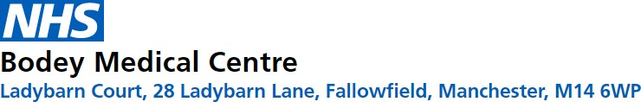

Our Pharmacy Team

**Clinic Times**

Monday – Friday

---------------------------------------------

Telephone and Face to Face appointment Available.

**What are the benefits of a Clinical Pharmacist?**

* Rapid access to an expert
  + Reduces GP workload
  + Frees up GP resources
* Reduces avoidable hospital

admission

* + Reduces medicines waste
    - Improved patient understanding and safety

of medication

* Improved quality of patient

care

**What does a Clinical Pharmacist do?**

* Highly skilled medicines

expert

* Manage long term health

conditions

* + Medication reviews
* Medication queries e.g., side effects, interactions,

medicines safety

* + Prescription queries
    - Minor Ailments
* Hospital Discharge reviews

**Meet the team**

Hunaiza Khan – Clinical Pharmacist

Maryam Azam – Clinical Pharmacist