**Measles is extremely infectious. One person with measles can infect 15 to 20 unimmunised people. 15 minutes in direct contact with someone infected with measles is sufficient to transmit virus.**

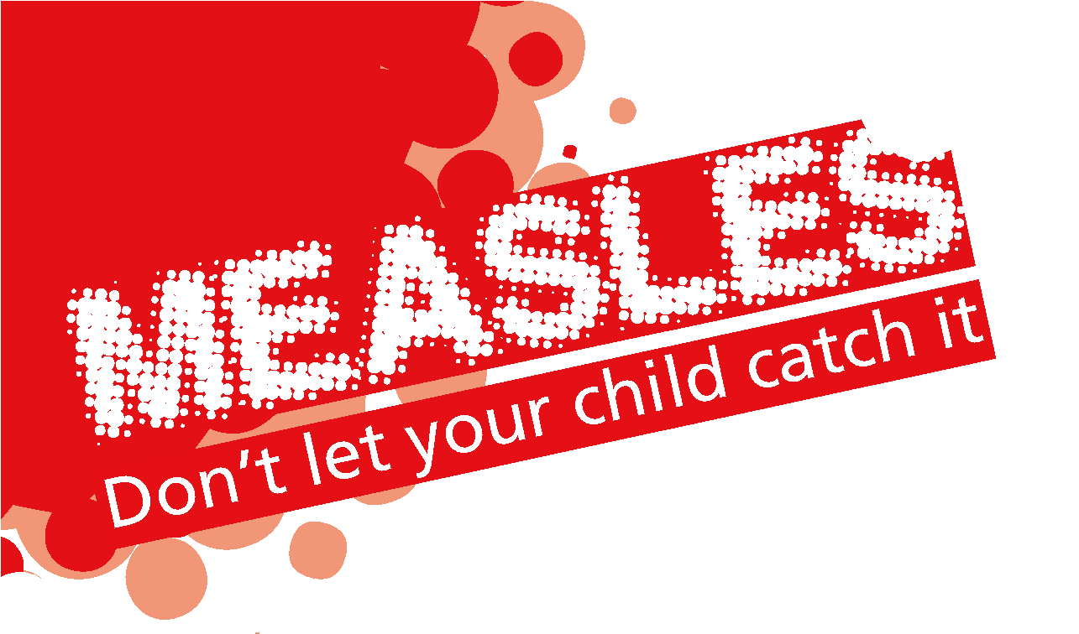

**Typical clinical symptoms**

* Fever > 39oC in the absence of antipyretics
* Conjunctivitis
* Cough and/or coryza
* Generally very unwell
* Koplik spots (small red spots with bluish-white centres) inside the mouth
* Generalised maculopapular rash – appears after prodromal phase usually on the face and upper neck and spreads to the rest of the body.

The appearance of a rash varies with skin tone. On darker skin tones, a rash may be purple, grey or white.

Some redness may appear, but typically not very much. In lighter skin colours, the rash is red. In darker skin colours, the redness may be harder to see,

or it may appear purple or darker than surrounding skin.

* unless confirmed measles is endemic - widely circulating within the region.

**Important Information**

Measles is spread through coughing and sneezing, close personal contact or direct contact with infected nasal

or throat secretions.

Measles is infectious from **4 days before rash onset until 4 full days** after the rash appears.

# Prevent transmission

In health care settings, **suspected measles cases should be triaged and isolated** immediately to protect other patients.

Ensure Infection Prevention and Control measures are in place.

# Risk factors for measles

To inform clinical diagnosis consider: -

* Age of the case
* Vaccination (two doses measles mumps rubella (MMR) vaccine = fully immunised)
* Travel within and outside the UK
* Member of an under-vaccinated population group
* Link with a confirmed case of measles

# Diagnostic testing

Clinicians should take an urgent diagnostic PCR test*.This supports management of cases, and minimises impact on close contacts, the community and health care services.

# How to take a sample for measles PCR:

**Notification**

Measles is a notifiable disease and clinicians must inform local UKHSA health protection teams of suspected cases to facilitate

timely public health action and urgent risk assessment of any vulnerable contacts.

# Contact UKHSA North West Health Protection on:

0344 225 0562 (both in and out of hours)



**Important Information**

- Greater Manchester Option 3

All suspected cases will be sent an Oral Fluid Test by UKHSA (via HPT), regardless of what local diagnostic testing is undertaken.

* A throat / mouth swab (ideally in viral transport medium; usually available from your local laboratory) OR
* A dry swab can be used to swab the inside of the throat / mouth, use the swab from

a charcoal transport medium pack but DO NOT place in the charcoal transport medium. Please use a plain sterile container such as a universal container used for urine samples OR...

* Where throat / mouth swabs or dry swabs are not available, a urine sample; please use a plain sterile urine container without preservative.

Please send these samples urgently to the UKHSA Virology laboratory at Manchester Foundation Trust via your local laboratory. Results will generally be available within 48 hours of sample receipt in the laboratory.

To obtain urgent results please contact the Virology Results line on: 0161 276 8854 Monday - Friday 8.30am - 5pm and Saturday 8.30am - 12.00pm

The Oral Fluid Test is a non-urgent test and used for surveillance not rapid diagnosis.

# Exclusion

* Suspected cases should be excluded from school, nursery or work for **4 days after the onset of rash.**
* Avoid contact with unvaccinated young children, susceptible pregnant women and immunocompromised persons during the infectious period.

# Complications

**The most common complications of measles infection are:**

* Ear infections (otitis media)
* Pneumonia
* Severe diarrhoea and related dehydration.

# Less common complications include:

* Convulsions and encephalitis

Serious consequences are more common in immunocompromised individuals.

# MMR vaccination

Measles is vaccine preventable. Children receive two doses of the MMR vaccine as part of the routine childhood immunisation programme.

Continue to identify children and adults who are not fully immunised and advise them to contact their GP to arrange vaccination.

**1**

**2**

**1. Measles spots in the mouth 2. Measles spots on the forehead**

**3**

**4**

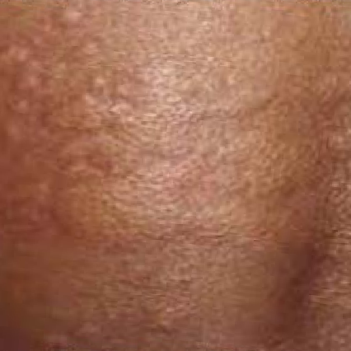

**5**

**3 Measles spots on the face**

1. **Measles spots - raised rash**
2. **Measles spots joined together**

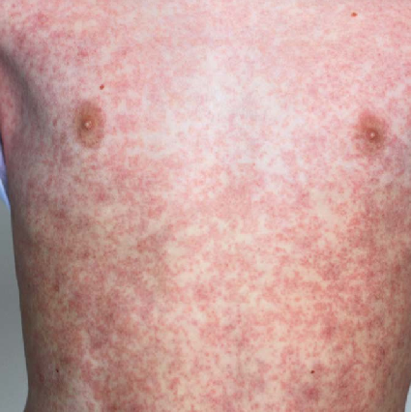

**6**

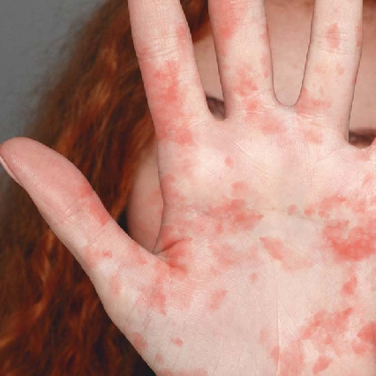

**7**

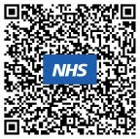

1. **Measles spots on the torso**
2. **Measles spots on the palm of the hand**

**Scan above for further information**

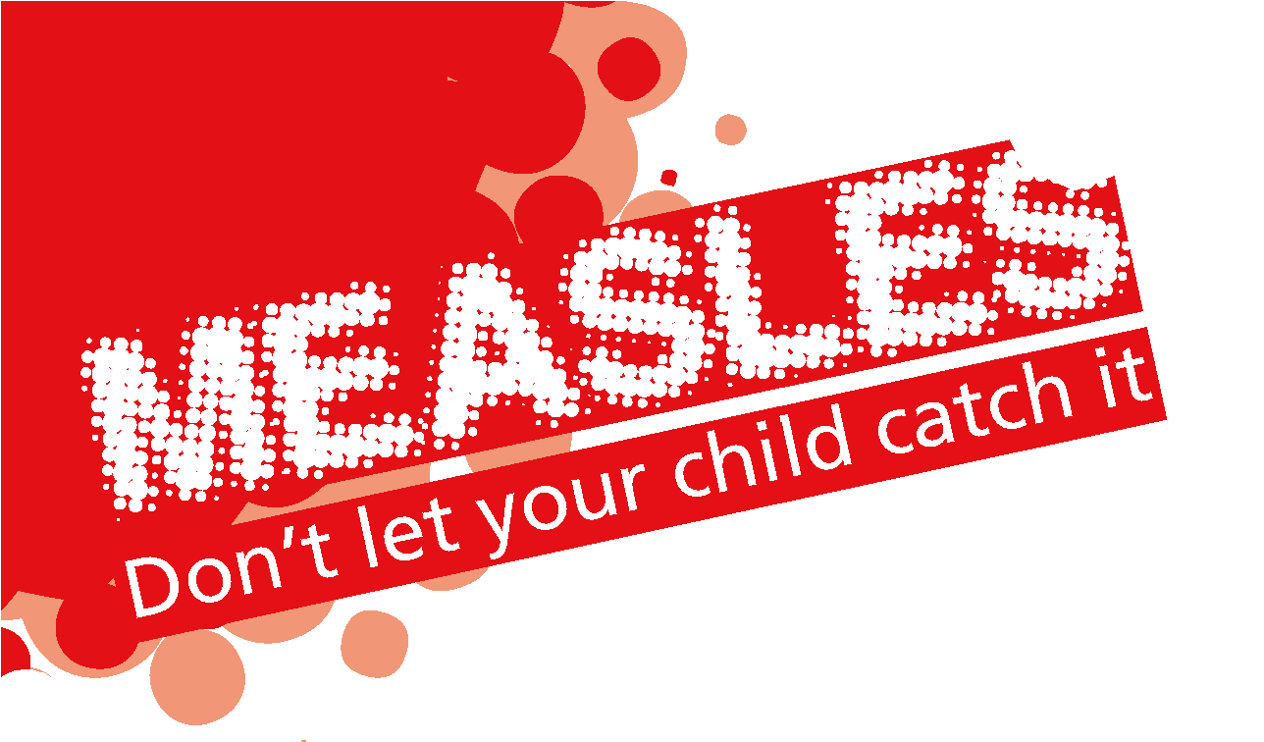

**Important Information**